

Observer – Data Analysis Suite

User Manual



Affirmed by Declaration
of Conformity

Document No. 102153
Revision A
September 22, 2025
© 2025 Digitex Systems
Prashka 23
Skopje, Macedonia
www.digitex.me

The information contained in this document is subject to change without notice. No part of this manual may be reproduced, or transmitted in any form or by any means, electronic or mechanical, including photocopying and recording, for any purpose without the express written permission of Digitex Systems.

Unless expressly set forth in a written agreement signed by an authorized representative of Digitex Systems, Digitex Systems makes no warranty or representation of any kind with respect to the information contained herein, including warranty of merchantability and fitness for a particular purpose. Digitex Systems assumes no responsibility of any kind for errors contained herein or in connection with the furnishing, performance, or use of this document.

Software described in Digitex Systems documents is furnished under an Application Program License Agreement and may be copied or used only as expressly permitted under the terms of the license.

Copyright © 2025 Digitex Systems. International copyright law prohibits illegal reproduction and distribution of this document.

Table of Contents
1. General Information 8
Observer General Information 8
Introduction 8
Points of Contact 8
Purpose and Audience 9
System Configuration 9
Supported Operating Systems 9
Recommended Hardware 9
Licensing and Activation 9
2. Signal & Graphs 10
First Screen Overview 10
Signal Panels and Tabs 11
Signal Properties Section 11
Signal Statistics Tab 13
Signal Information Tab 14
Graph Properties & Controls 15
Core Functions 15
Axis & Scaling Controls 15
Cursor and Navigation Tools 15
Chart Display Settings 15
View Modes 15
Home Tab 16
Toolbar Functions 16
Typical Workflow 16
3. Signal Analysis 17
Analysis Tab (Basic Processing) 17
Signal function 17
Integrate function 19
Frequency function 20
Response Spectrum function 21
Auto Correlation function 22
Cross Correlation function 23
Model Tab (OMA and Advanced Analysis) 24
Introduction to OMA 26
How does it work 27
Available Methods 28
Initialization TAB 31
Measurements Panel 33
Geometry Workspace 35
Geometry Editor 36
Geometry Properties 38
Toolbar 41
Apply Changes and start OMA Calculation 42
Analysis (OMA) 43
Analysis Main Menu 45
Using Frequency Domain Decomposition (FDD) method 46
Using Enhanced Frequency Domain Decomposition (EFDD) method 48
Using Frequency Spatial Domain Decomposition (FSDD) method 50
Using Stochastic Subspace Identification Data method 52
Using Stochastic Subspace Identification Covariance method 54
Using Polyreference Least Squares Complex Frequency (PLSCF) method 56
Verification 58
Auto-Correlation 60
PSD – (Power Spectral Density) 62
Probability Density 64
Normal Probability 66
STFT Magnitude 68
Voyager Export 70
Generate Report (automated report generation) 72
4. Configuration 74
View Tab (Customization) 74
Show/Hide Panels (Properties, Information, Statistics) 75
Settings (Application Settings) 76
General 77
Charts 77
Signal Processing 78
Analysis 80
Operational Modal Analysis 81
View 83
Reporting 84
5. Installation, Help, Troubleshooting & Appendices 85
Observer Setup Installation 85
Observer Registering License 89
Help Menu 91
Unregister License 91
Help 91
About (version info) 92
Troubleshooting & Support 92
FAQs 93
Contact Resources 95
Appendices 96
Glossary of SHM/OMA Terms 96
Sample Geometry File 99
Sample PDF Report 108
Algorithm References 131

Table of Figures and Tables

Figure 1 – Observer Start Screen 8
Figure 2 – Observer First Screen 10
Figure 3 – Observer Signal Properties Section 12
Figure 4 – Observer Signal Statistics Section 13
Figure 5 – Observer Signal Information Section 14
Figure 6 – Observer Home TAB Section 16
Figure 7 – Observer Signal Graph – preprocessed 18
Figure 8 – Observer Integration Graph 19
Figure 9 – Observer FFT/PSD Graph 20
Figure 10 – Observer Response Spectrum Graph 21
Figure 11 – Observer Autocorrelation Graph 22
Figure 12 – Observer Cross correlation Graph 23
Figure 13 – Observer Modal TAB 25
Figure 14 – Observer Open Project Notification 27
Figure 15 – Observer OMA Initialization 31
Figure 16 – Observer OMA Single and Multi-setup measurements 33
Figure 17 – Observer OMA Geometry Workspace 35
Figure 18 – Observer OMA Geometry Editor 36
Figure 19 – Observer OMA Geometry Properties 38
Figure 20 – Observer OMA Initialization Toolbar 41
Figure 21 – Observer OMA Analysis TAB 44
Figure 22 – Observer OMA Analysis TAB 45
Figure 23 – Observer OMA Analysis – Using FDD 47
Figure 24 – Observer OMA Analysis – Using EFDD 49
Figure 25 – Observer OMA Analysis – Using FSDD 51
Figure 26 – Observer OMA Analysis – Using SSI-Data 53
Figure 27 – Observer OMA Analysis – Using SSI-Cov 55
Figure 28 – Observer OMA Analysis – Using PLSCF 57
Figure 29 – Observer OMA Analysis – Verification 59
Figure 30 – Observer OMA Analysis – Auto- Correlation 61
Figure 31 – Observer OMA Analysis – PSD 63
Figure 32 – Observer OMA Analysis – Probability Density 65
Figure 33 – Observer OMA Analysis – Normal Probability 67
Figure 34 – Observer OMA Analysis – STFT Magnitude 69
Figure 35 – Observer Analysis – Report Generation 73
Figure 36 – Observer – View TAB 74
Figure 37 – Observer View TAB - Settings 76
Figure 38 – Observer View TAB - Charts 78
Figure 39 – Observer View TAB – Signal Processing 79
Figure 40 – Observer View TAB – Analysis 80
Figure 41 – Observer View TAB – OMA Settings 82
Figure 42 – Observer View TAB – View Settings 83
Figure 43 – Observer View TAB – Report Settings 84
Figure 44 – Observer Setup Welcome Screen 85
Figure 45 – Observer EULA Screen 86
Figure 46 – Observer Customer Information 86
Figure 47 – Observer Setup Type 87
Figure 48 – Observer Ready to Install 87
Figure 49 – Observer Setup Progress 88
Figure 50 – Observer Setup Finish 88
Figure 51 – Observer License Dialog 89
Figure 52 – Copy Hardware ID 89
Figure 53 – Observer Load License Dialog 90
Figure 54 – Observer Register License 90
Figure 55 – Observer Unregister License 91
Figure 56 – Observer Unregister Done 91
Figure 57 – Observer About Window 92

1. General Information

Observer General Information

Introduction

Observer® is Digitex Systems’ advanced post-processing software for Structural Health Monitoring (SHM). It provides engineers and researchers with powerful tools for signal processing, Operational Modal Analysis (OMA), geometry-based visualization, and reporting. Observer is designed for both permanent monitoring campaigns and short-term vibration measurements. It supports a wide range of analysis methods, including FFT, PSD, correlation functions, and multiple OMA algorithms.

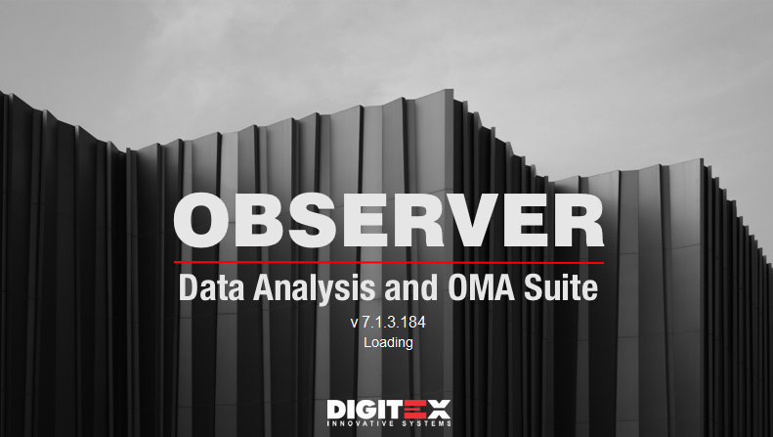

Figure 1 – Observer Start Screen

Points of Contact

For technical support, licensing, or product inquiries, users may contact Digitex Systems at:

- Website: www.digitexsystems.com
- Support Email: support@digitex.me
- Address: Prashka 23, Skopje, North Macedonia
- Phone: +389 (0)2 3109262

Note: Customers with maintenance contracts have access to priority support and updates.

Purpose and Audience

This user manual is intended for:

- Structural engineers performing vibration analysis.
- Researchers conducting Operational Modal Analysis on civil and industrial structures.
- Operators of SHM systems who need to process, visualize, and report sensor data.

It assumes basic knowledge of vibration theory and modal analysis concepts.

System Configuration

Supported Operating Systems

- Microsoft Windows 10 and Windows 11 (64-bit recommended).

Recommended Hardware

- CPU: Quad-core processor, 3.0 GHz or faster
- RAM: 8 GB minimum (16 GB recommended for large datasets)
- GPU: OpenGL-compatible graphics card with 2 GB VRAM (for 3D visualization)
- Storage: SSD with at least 10 GB free space for project files
- Display: Full HD (1920 × 1080) or higher resolution

Licensing and Activation

Observer requires a valid Digitex Systems software license.

- On first startup, the license dialog will prompt for activation. Copy the provided Hardware key and send it to support@digitex.me. After verification Digitex team will reply back with appropriate license file.
- Internet connection is not required for automatic license verification.
- Licenses can be transferred between machines via the “Unregister License” option in the Help menu.

Refer to section Observer Registering License for details regarding this process.

2. Signal & Graphs

First Screen Overview
When Observer Data Analysis Suite is launched, the user is presented with a clean workspace designed for efficient navigation and signal analysis. (Figure 2) The interface is divided into three primary areas:

1. Menu and Toolbar (Top) - Located at the top of the screen. Provides access to the main functions of Observer:
  - Home – Create, open, save, and manage signal files.
  - Analysis – Access preprocessing, FFT/PSD.
  - Model – OMA algorithms, Geometry creation, editing, and mode shape visualization.
  - View – Customize the workspace layout, report settings, and visualization options.
  - Help – License management, About window, and user documentation.
2. Main Graph Area (Center) - Occupies most of the screen.
- Displays plots, FFT/PSD diagrams, stabilization charts, or geometry visualizations depending on the selected workflow.
- Provides interactive tools such as zoom, cursors, slicing, and overlays for detailed signal inspection.
3. Signal Panels and Tabs (Right) - Docked on the right-hand side.
- Includes collapsible tabs such as:
  - Signal Properties – Lists attributes of the currently loaded signal (e.g., name, sampling rate, units).
  - Signal Statistics – Displays RMS, skewness, kurtosis, and other statistical measures.
  - Signal Information – Metadata about source, length, and preprocessing steps.
4. Simplified Layout toggle
- OFF (Default): Displays the standard ribbon with smaller icons and full labels.
- ON (Simplified): Switches to larger icons with shorter labels, making the toolbar easier to navigate and more touch-friendly.
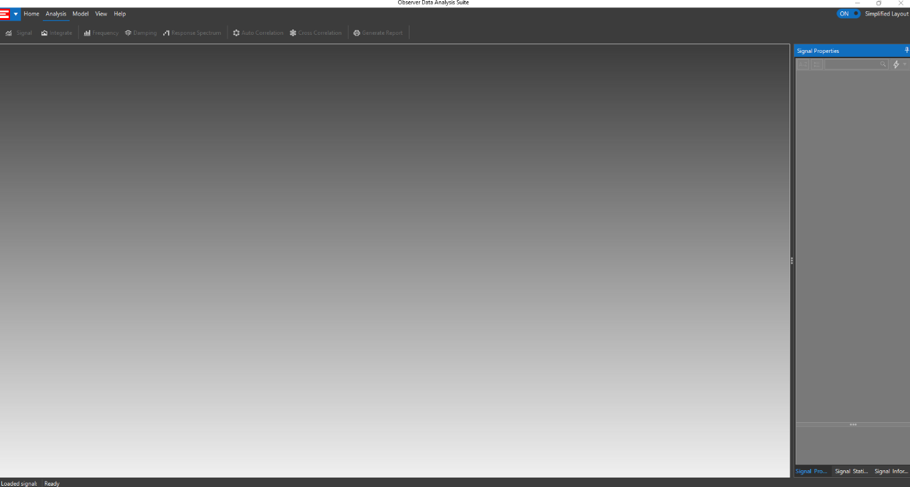

Figure 2 – Observer First Screen

Signal Panels and Tabs

Signal Properties Section

The Signal Properties panel (Figure 3) provides a centralized location where users can configure all processing parameters related to basic signal analysis that affect how signals are analyzed and displayed. These settings control preprocessing (such as filtering and detrending), frequency analysis, integration, correlation, and response spectrum calculations. Each property can be adjusted manually, with live update options available to apply changes in real time.

Time Domain Properties

- Detrending – Removes linear or polynomial trends from the signal to eliminate offset drifts and ensure zero-mean data.
- Decimation – Reduces the effective sampling rate by a specified factor, enabling faster processing of long datasets while preserving key features.
- Filter Method – Selects the filtering approach (e.g., IIR, FIR). When set to Off, no filtering is applied.
- Filter Type – Defines the filter shape (LowPass, HighPass, BandPass).
- Filter Order – Sets the steepness of the filter’s transition band. Higher order increases selectivity but may introduce phase distortion.
- Low Cut-Off / High Cut-Off – Frequency boundaries for the filter, expressed in Hz. For example, a BandPass filter may be set between 0.15 Hz and 40 Hz.
- Signal Live Changes – When enabled, any adjustment to filtering or preprocessing parameters is applied immediately to the displayed signal.

Frequency Domain Properties

- FFT Window – Defines the window function applied before computing the FFT (e.g., Hanning, Hamming). The choice of window affects leakage and frequency resolution.
- FFT Method – Selects the type of FFT computation (standard FFT or other implemented methods).
- FFT Start Frequency / End Frequency – Limits the FFT calculation to a frequency range of interest. This reduces noise outside the specified range and focuses on structural modes.
- Frequency Live Changes – Enables real-time updates to FFT calculations as parameters are modified.

Integration Properties

- Integration Filter – When active, applies filtering during numerical integration to reduce low-frequency drift.
- Integration Live Changes – Updates integration results (acceleration → velocity → displacement) immediately when parameters are modified.

Auto Correlation Properties

- Auto Correlation Live – Enables automatic calculation and display of auto-correlation functions in real time, allowing users to evaluate periodicity and signal similarity over lag intervals.

Cross Correlation Properties

- First Channel / Second Channel – Defines the two channels used for cross-correlation.
- Cross Correlation Live – Enables real-time calculation of the cross-correlation function, used to identify relationships and phase shifts between different sensors.

Response Spectrum Properties

- Method – Specifies the response spectrum method used in the background processing.
- Damping – Defines the percentage of critical damping to be applied.
- Time Increment – Sets the time step for the response spectrum calculation.
- End Frequency – Defines the maximum frequency of the calculated response spectrum.
- Pseudo – Toggles pseudo-spectrum generation for comparative analysis.
- Response Live Changes – Applies changes immediately to the generated response spectrum.

OMA Geometry Settings

- Magnification – Controls the scaling factor applied to mode shape animations for visualization clarity.
- Show Static Object – Displays a static reference geometry alongside animated mode shapes.
- Static Object Color – Defines the display color of the static reference object.
- Static Object Transparency – Adjusts the transparency level (0–100%) of the static reference object.
- OMA Live Changes – Ensures that geometry and animation updates are applied instantly when parameters are modified.
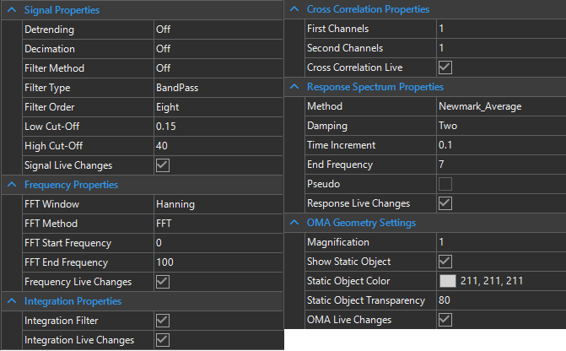

Figure 3 – Observer Signal Properties Section

Signal Statistics Tab
The Signal Statistics Tab (Figure 4) provides numerical descriptors of the signal content, both at the file level and per individual channel. These statistics help users quickly assess signal quality, detect anomalies, and validate measurement conditions before performing advanced analysis.

File-Level Information

- Start Time / End Time – The precise timestamps marking the beginning and end of the recording. These are essential for correlating measurements with field events or synchronizing with other data sources.
- Total Samples – The number of recorded data points across the duration of the signal.
- Duration – The total length of the recording, expressed in seconds.
- Max Sampling – The maximum sampling frequency (Hz) used during acquisition.
- Channels – Provides access to statistical values for each individual channel.

Channel-Specific Information

Each channel entry expands to show statistical indicators calculated directly from the recorded samples:

- SPS (Samples per Second) – Confirms the effective sampling rate of the channel.
- MAX – The maximum observed amplitude within the dataset. Useful for detecting peak loads or transient events.
- MIN – The minimum observed amplitude within the dataset.
- AVG (Average) – The mean value of the signal, ideally close to zero for accelerometer data after detrending.
- STDev (Standard Deviation) – Measures the spread of the data around the mean, indicating variability or noise level.
- RMS (Root Mean Square) – Represents the effective energy of the signal, commonly used in vibration analysis.
- SKEW – Describes the asymmetry of the signal distribution. Positive skew indicates longer right tails; negative skew indicates longer left tails.
- KTS (Kurtosis) – Indicates the “peakedness” of the signal distribution. High kurtosis can signify transient impulses or spikes.
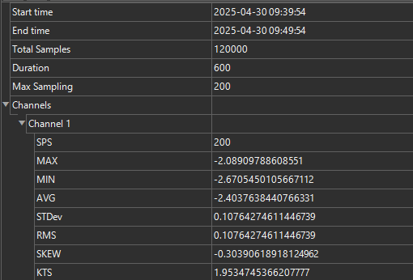

Figure 4 – Observer Signal Statistics Section

Signal Information Tab

The Signal Information Tab (Figure 5) provides detailed metadata for each loaded measurement file and its individual channels. This tab is essential for verifying acquisition parameters, ensuring consistency between signals, and applying the correct scaling and calibration before analysis.

File-Level Information

- File Name – Displays the full name of the imported measurement file. This often encodes acquisition time, sensor setup, or campaign identifiers.
- Signal ID – A unique identifier for the dataset, ensuring traceability across processing steps.
- Total Channels – The number of recorded channels contained in the file.
- Signal Status – Indicates the current condition of the file (e.g., F - full with data, or I - incomplete e.g. some sensors were offline).
- Date Created – The original recording timestamp, useful for synchronization with field notes and monitoring campaigns.
- Calibration – Reference to the calibration dictionary or calibration coefficients associated with each channel. This ensures that physical units (e.g., acceleration in m/s²) are applied correctly.

Channel-Specific Information

Each signal file may contain multiple channels (e.g., sensors or measurement directions). The tab lists the following properties for each channel:
- SPS (Samples per Second) – The sampling rate of the channel, expressed in Hz.
- Type – Defines the signal type, e.g., acceleration (A), velocity (V), or displacement (D).
- Scale – The scaling factor applied to convert raw digital counts into physical units. For accelerometers, this converts counts into cm/s².
- Offset – Any baseline offset correction applied to the signal. Typically set to zero but may be adjusted for sensor bias removal.
- Name – A user-defined or automatically assigned channel label. This is useful for identifying sensor location or orientation (e.g., Pier 1 – Vertical).

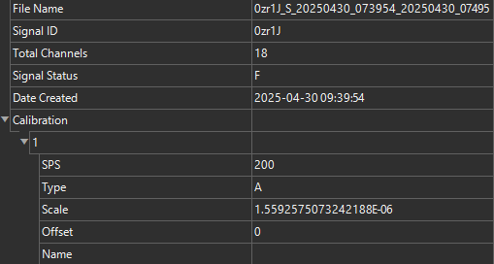

Figure 5 – Observer Signal Information Section

Graph Properties & Controls

The Graph Properties & Controls toolbar is shared across all chart types in Observer (time history, frequency spectrum, PSD, OMA diagrams, etc.). It provides quick access to essential tools for refreshing, exporting, adjusting axes, customizing chart appearance, and switching between display modes.

Core Functions

- Refresh - Reloads the graph to apply recent processing changes or restore the default view.
- Export ASCII - Saves graph data in ASCII format. Two modes are available:

  - Export Visible Series – Saves only the data series currently shown on the graph.
  - Export Visible Range – Saves only the portion of data currently within the zoomed or visible axis range.
- Export Image - Captures the active graph as an image (PNG) for use in reports and presentations.
- Import ASCII (if enabled) - Allows comparison of external datasets with currently displayed data by importing ASCII files.

Axis & Scaling Controls

- Configure Axis - Opens a dialog for axis configuration (linear/logarithmic scale, numeric formatting).
- X Axis Flip / Y Axis Flip - Inverts axis direction for custom visualization needs.

Cursor and Navigation Tools

- Cursor & Vertical Slice Tool - Activates cursors for precise reading of values at a selected point in the dataset. Useful for identifying modal frequencies, damping, or transient peaks.

Chart Display Settings

- Chart View Options (numeric dropdown) - Adjusts chart density or display resolution (e.g., 6, 8, 12, 14, 16). Higher values allow finer resolution, while lower values simplify the view.
- Display Chart Title (T button) - Toggles the chart title on or off. The title text can be edited by the user.
- Legend Position - Controls where the chart legend is displayed: Off, Left, Right, Top, Bottom.

View Modes
- Switch View - Toggles between different chart layouts: stacked, overlay, or alternative display modes depending on the selected graph type.

Home Tab

The Home Tab (Figure 6) provides fundamental file management and export options. It is typically the starting point when working with Observer, allowing users to create, open, save, and close datasets, as well as export results in image and ASCII formats.

Toolbar Functions

- New - Creates a new workspace for importing and processing signals.
- Open - Loads existing measurement files (ASCII or MiniSEED). Multiple files can be opened simultaneously.
Tip: For MiniSEED files, ensure calibration files (.dxm) are stored in the same folder for correct scaling.
- Save - Stores the current state of the active project. Overwrites the existing file.
- Save As - Saves the active project under a new name, preserving the original file.
- Close - Closes the active file window, removing it from memory.
- Close All - Closes all loaded files and clears the workspace.
- Image - Exports the active graph as an image (PNG) for inclusion in reports and presentations.
- ASCII Full - Exports the entire dataset of the active graph in ASCII format. This format is suitable for external analysis in software such as MATLAB, Python, or Excel.
- ASCII Visible - Exports only the portion of the dataset currently visible on the graph (e.g., zoomed range). This is useful for targeted export of smaller data segments.

Typical Workflow

- Start a new session with New or open a dataset with Open.
- Process and analyze signals as needed.
- Save your work with Save or create a copy with Save As.
- Export results using Image for graphical reporting or ASCII Full/Visible for data sharing.
- Close the active project with Close or all open files with Close All.

Figure 6 – Observer Home TAB Section

3. Signal Analysis

Analysis Tab (Basic Processing)

The Analysis Tab provides access to core signal-processing functions in Observer. Each function is closely linked to the parameters configured in the Signal Properties Section. When a function is invoked via its toolbar button, a new graph window is generated, displaying the processed results. This modular approach allows users to conduct multiple analyses in parallel, compare results, and adjust processing options dynamically.

Signal function

The Signal function (Figure 7) generates a time-domain representation of the selected signal. It displays raw acceleration versus time or initially processed using the Signal Properties Section, providing a fundamental overview of the dataset.

Before advanced analysis, Observer provides several preprocessing options that ensure raw vibration signals are correctly prepared. These settings directly influence the accuracy of frequency-domain analysis, integration, and OMA. Time-domain inspection is the first step in every vibration analysis. It ensures that the acquired data are valid before applying frequency-domain or modal methods.

Detrending:

Detrending removes unwanted trends or offsets from the signal, ensuring a zero-mean dataset. This prevents spurious low-frequency components from appearing in the FFT or PSD.

- Off – No detrending is applied. Suitable when the signal is already centered around zero.
- Mean – Subtracts the average value of the signal, removing constant DC offsets.
- Linear Trending – Fits and subtracts a straight line, removing slow linear drift.
- Polynomial – Fits and subtracts a higher-order polynomial, useful for correcting more complex drift patterns in long-duration measurements. Polynomial detrending is particularly effective in long ambient vibration records, where sensor drift can accumulate gradually.

Decimation:

Decimation reduces the sampling rate of the signal by discarding data points. This decreases data volume and speeds up analysis while preserving essential frequency content (according to the Nyquist theorem). Decimation is valuable when working with long-duration data, such as dam or building monitoring, where high sampling resolution is not necessary for modal analysis.

- Off – No decimation applied; full sampling rate is used.
- Half – Reduces the sampling rate by 2.
- Quarter – Reduces the sampling rate by 4.
- Eight – Reduces the sampling rate by 8.

Filter Method:

Defines the type of digital filter used for preprocessing.

- Off – No filter is applied.
- Butterworth – Maximally flat frequency response in the passband, widely used in SHM. Butterworth filters are most common for vibration data, balancing smoothness and selectivity. Bessel filters are preferred for preserving signal shape.
- Chebyshev I – Allows steeper roll-off but introduces ripple in the passband.
- Chebyshev II – Provides steep roll-off with ripple in the stopband instead of passband.
- Bessel – Preserves waveform shape and phase, suitable for transient signal analysis.
- Elliptic – Achieves very sharp cutoffs but introduces ripple in both passband and stopband.
Filter Type:

Specifies the filter category depending on the frequency band of interest.

- LowPass – Allows frequencies below the cut-off frequency to pass; attenuates higher frequencies.
- HighPass – Allows frequencies above the cut-off frequency to pass; attenuates lower frequencies. It is used for removing sensor drift or gravity effects in accelerometer data.
- BandPass – Passes frequencies within a defined range (between low and high cut-off). Used to isolate structural modes within a frequency range of interest.

Low Cut-Off / High Cut-Off:

Defines the boundary frequencies for filters:
- Low Cut-Off – The lowest frequency preserved by the filter. Eliminates long-period drift or offsets.
- High Cut-Off – The highest frequency preserved by the filter. Removes high-frequency noise beyond the structural response.

Note: For ambient vibration monitoring of civil structures, typical ranges are 0.1 Hz – 40 Hz (suppressing ultra-low drift and very high sensor/electrical noise).
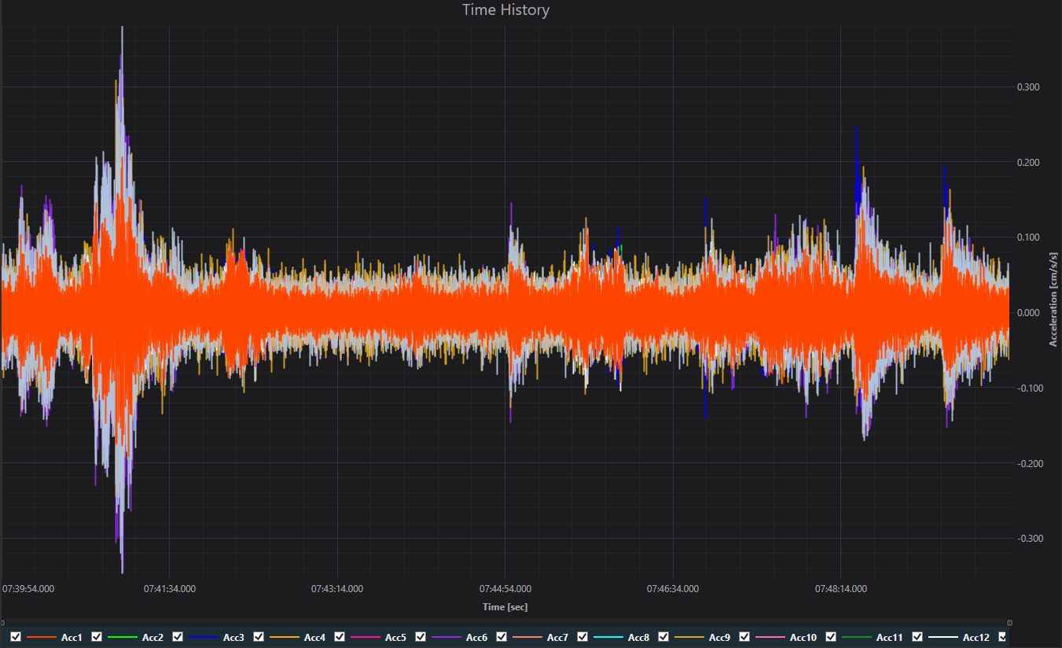

Figure 7 – Observer Signal Graph – preprocessed

Integrate function

The Integrate function (Figure 8) converts signals between acceleration, velocity, and displacement by numerical integration.

Purpose:
- Derive velocity or displacement from accelerometer data, which is often the primary measurement in SHM.
- Apply integration filters to suppress low-frequency drift and improve accuracy.

Why it matters:

- Structural response is often expressed in terms of displacement or velocity, not only acceleration.
- For serviceability checks (e.g., bridge deflection, building sway), displacement is the key parameter.
- For energy-based analyses, velocity is often preferred.

Note: Integration must be performed carefully due to cumulative drift from sensor bias and low-frequency noise. Observer uses dedicated filtering (as configured in Signal Properties) to minimize these effects.

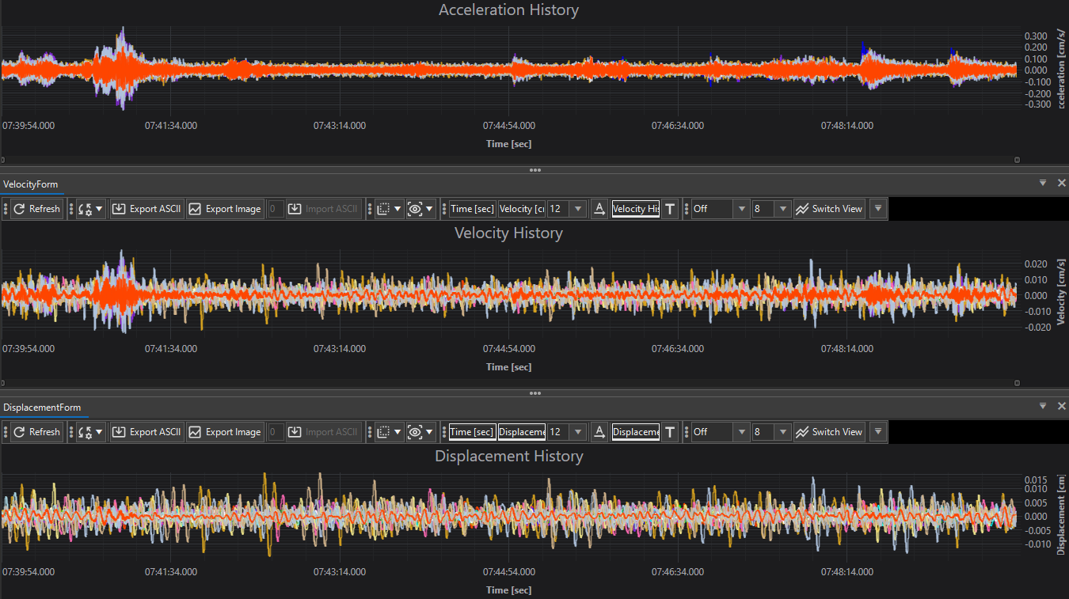
Figure 8 – Observer Integration Graph

Frequency function
The Frequency function provides spectral analysis of the signal. Depending on the selected method in the Signal Properties Section, users can compute either a Fast Fourier Transform (FFT) or a Power Spectral Density (PSD). This is used for detecting modal frequencies of the structure, tracking frequency shifts over time (which may indicate stiffness changes or damage) and to differentiate between operational harmonics (e.g., machinery-induced vibrations) and natural structural modes. (Figure 9)

FFT (Fast Fourier Transform) is used for Quick identification of resonance frequencies:
- Converts the time-domain signal into the frequency domain.
- Reveals the dominant frequencies and harmonics of the structure.
- Useful for identifying natural frequencies and resonance peaks.
- Controlled by FFT parameters such as window function, start/end frequency, and resolution.

PSD (Power Spectral Density) is a more robust statistical analysis under long-term monitoring and low-level ambient excitation:
- Provides a measure of signal power distribution across frequencies.
- Unlike FFT, PSD normalizes energy by frequency bandwidth, making it suitable for comparing signals of different lengths.
- Helps quantify energy content and noise levels.
- Commonly used for ambient vibration analysis, where low-amplitude, broadband inputs excite structural modes.

Window Functions:

Windowing reduces spectral leakage by tapering the signal before applying FFT. Observer provides the following window options:
- Hanning – The most widely used window in structural dynamics. Provides good frequency resolution and effective leakage suppression.
- Hamming – Similar to Hanning but with slightly less leakage suppression; useful when sidelobe reduction is prioritized.
- Blackman – Offers very strong leakage suppression at the cost of frequency resolution. Preferred when high dynamic range is required.
- Bartlett – A triangular window, useful for reducing discontinuities but less effective in leakage suppression compared to Hanning/Blackman.
Note: In SHM applications, the Hanning window is the standard choice for modal analysis, while Blackman may be used for detecting weak modes in noisy environments.

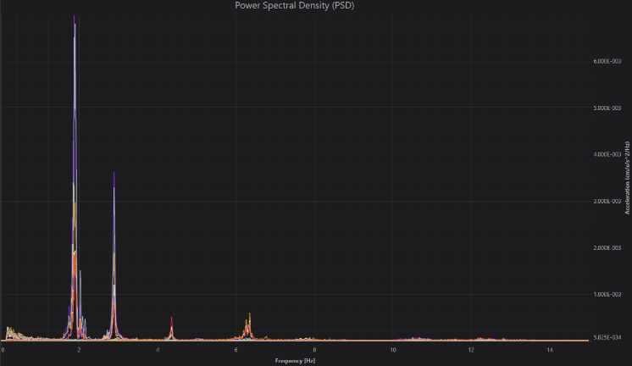
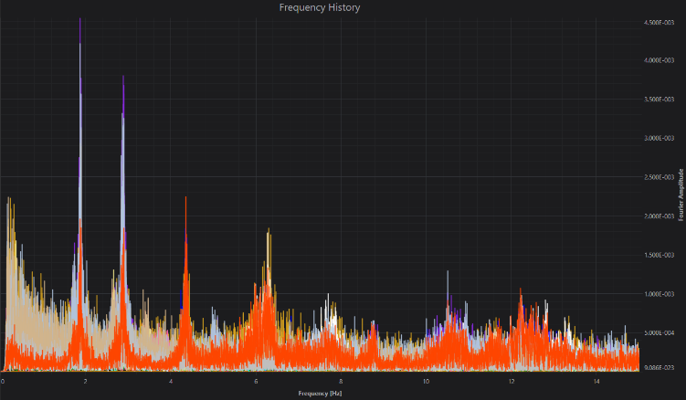
Figure 9 – Observer FFT/PSD Graph

Response Spectrum function

The Response Spectrum (Figure 10) calculation simulates the response of a set of idealized single-degree-of-freedom (SDOF) oscillators subjected to the measured signal. The following options allow the user to configure the calculation:

Damping: Defines the critical damping ratio applied to each oscillator in the response spectrum calculation.
- Options: 1%, 2%, 3%, 4%, 5%, 10%
- Meaning: Damping is expressed as a percentage of critical damping. Lower damping values emphasize resonance peaks, while higher damping smooths the spectrum.
- Use in SHM:
  - 2%: Common for steel structures.
  - 5%: Typical design value for reinforced concrete.
  - 10%: Used in soil-structure interaction studies or heavily damped systems.

Note: Selecting multiple damping values provides engineers with a more complete understanding of structural performance across different damping assumptions.

Time Increment: Specifies the numerical integration step used during spectrum calculation.

- Smaller increments yield higher resolution and accuracy in the response calculation but require more computation time. Larger increments reduce computation load but may smooth out fine details.

End Frequency: Defines the maximum oscillator frequency considered in the spectrum.

- Limits the frequency range to structural modes of interest, avoiding unnecessary calculations at higher frequencies dominated by noise.

Note: For civil structures such as bridges or buildings, an end frequency of 7–10 Hz is common, as higher frequencies often correspond to local or non-structural modes.
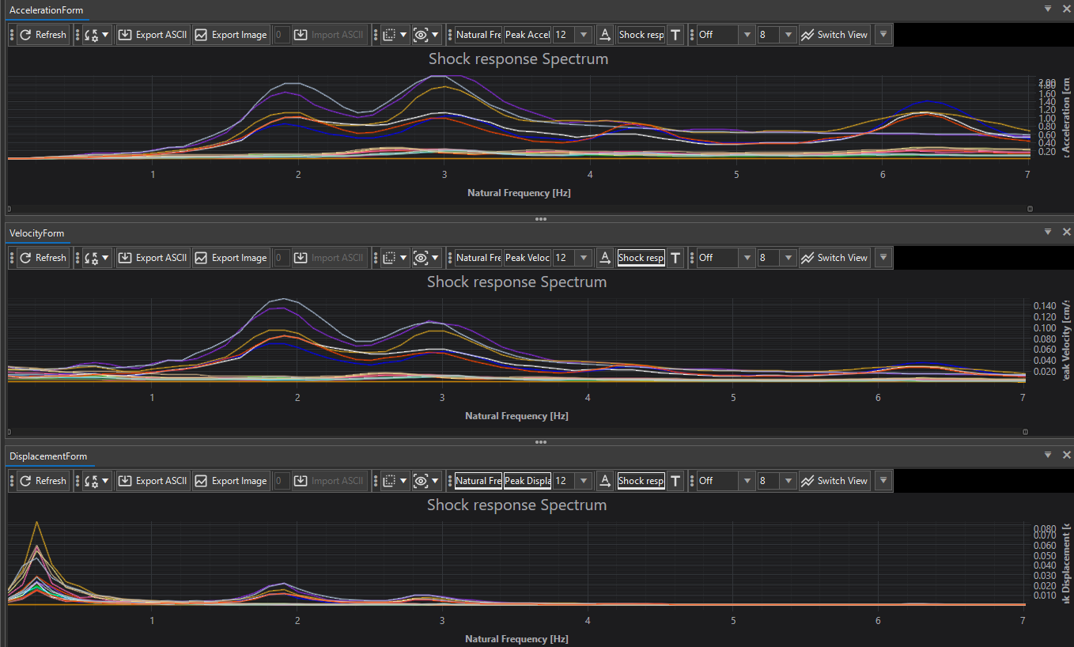

Figure 10 – Observer Response Spectrum Graph

Auto Correlation function

The Auto Correlation function (Figure 11) generates a correlation plot of a signal with itself, shifted in time by different lags. This analysis is useful for detecting repeating patterns and extracting structural dynamics from random excitation. In Observer, the auto correlation function is computed based on the parameters defined in the Signal Properties Section and displayed as a new graph when the function is invoked.

The purpose of this type of analysis is to identify periodicities in vibration data, reveal natural frequencies and damping characteristics of a structure or to estimate the impulse response of a system when only random input (ambient vibrations) is available.

This function works by measuring how similar a signal is to a delayed version of itself:

- At zero lag, correlation is maximum (signal compared with itself).
- At positive lags, the correlation function reveals how the signal repeats over time.
- Peaks in the correlation function correspond to repeating cycles (structural modes).
- The decay of peaks indicates damping in the system.

In structural health monitoring, auto correlation is particularly powerful because:

- Structures under ambient vibrations (traffic, wind, microtremors) can be analyzed without controlled excitation.
- Structural natural modes appear as oscillatory patterns in the correlation plot.
- Comparing correlation functions over time allows detection of stiffness degradation or damage.

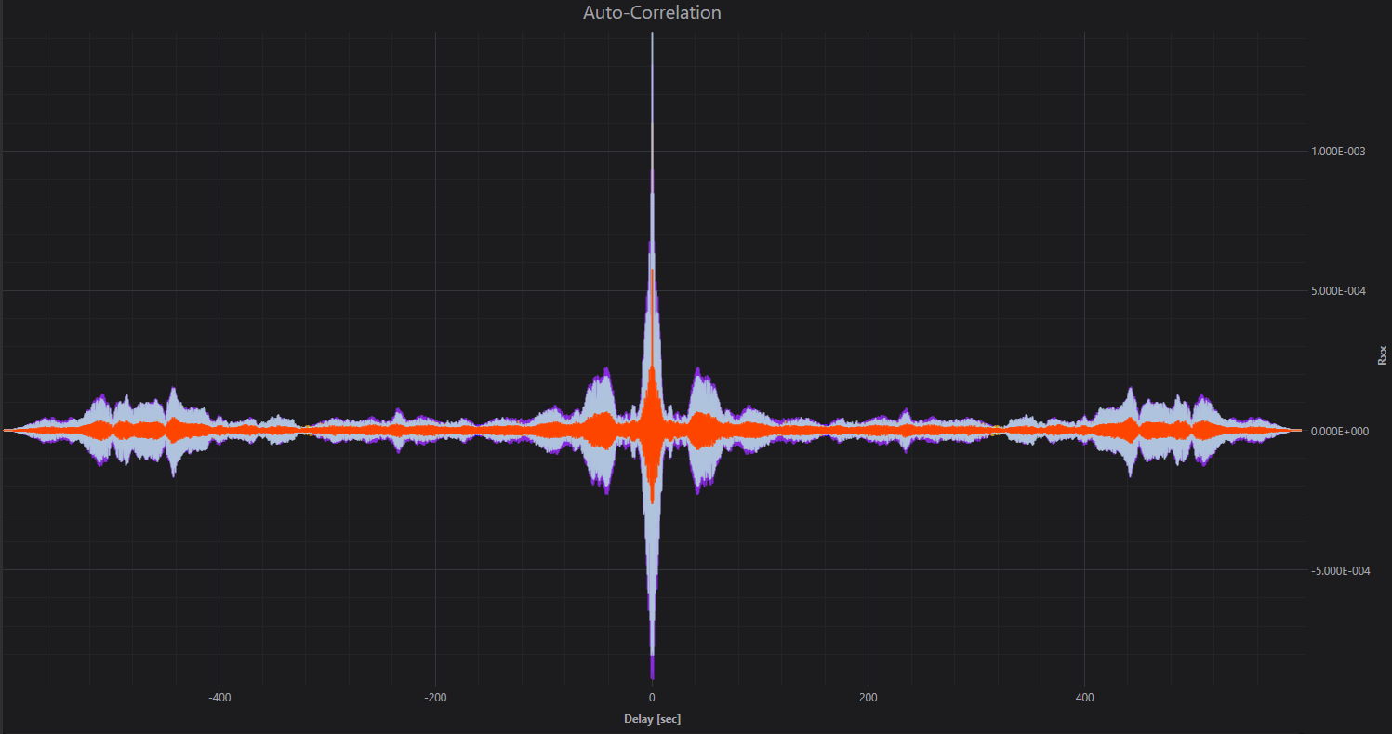

Figure 11 – Observer Autocorrelation Graph

Cross Correlation function

The Cross Correlation function (Figure 12) calculates the similarity between two different signals as one is shifted in time relative to the other. In Observer, this function is typically used to analyze how vibrations propagate between sensor locations. The calculation parameters (First channel, Second channel, live updates) are configured in the Signal Properties Section, and results are displayed in a new correlation graph when the function is invoked.

The purpose of this type of analysis is to detect time delays between responses at different sensor locations, identify phase shifts or lead/lag relationships between signals and to determine the propagation speed of vibrations through a structure.

In structural health monitoring, cross correlation is particularly powerful because:

- Reveals how vibrations travel across a structure, highlighting connectivity and stiffness distribution.
- Identifies sensor synchronization issues or time delays in acquisition systems.
- Enables modal analysis in large-scale monitoring campaigns, where input forces are not controlled.

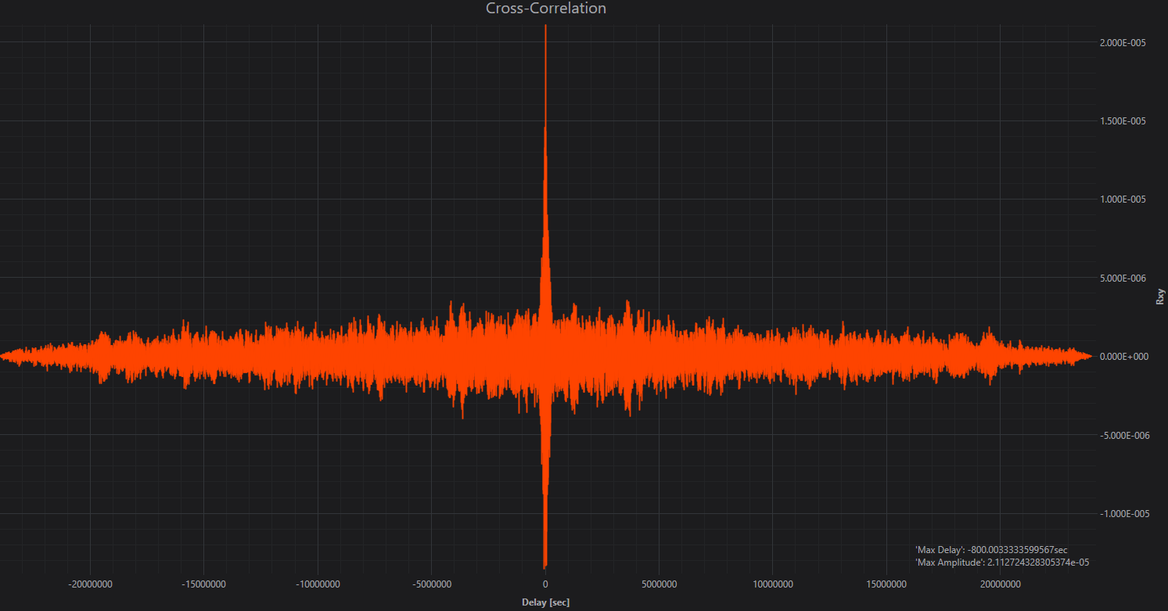

Figure 12 – Observer Cross correlation Graph

Model Tab (OMA and Advanced Analysis)
The Model Tab in Observer provides a complete environment for performing Operational Modal Analysis (OMA). OMA techniques are used to extract modal parameters (natural frequencies, mode shapes, and damping ratios) of structures based solely on their response to ambient or operational excitation (e.g., traffic, wind, seismic microtremors). Unlike traditional Experimental Modal Analysis (EMA), OMA does not require a controlled input force, making it highly suitable for large civil structures.

Operational Modal Analysis is used at the following scenarios:

- Non-intrusive/Non-destructive testing: No need for artificial excitation; structures can be analyzed under normal operating conditions.
- Applicability to large structures: Bridges, dams, tunnels, pipelines, and high-rise buildings cannot realistically be tested with shakers or other controlled sources. OMA allows their modal parameters to be extracted without interrupting service.
- Safety and performance monitoring: Tracking changes in modal parameters over time can indicate structural degradation, stiffness loss, or damage progression.
- Validation of numerical models: Finite Element (FE) models can be compared or updated with measured OMA results to improve accuracy of predictive simulations.
- Seismic and vibration assessment: OMA provides reliable inputs for safety checks against seismic codes, wind-induced oscillations, and operational vibration limits.

By applying OMA methods, end users can determine:

- Natural Frequencies: The resonance points where the structure tends to vibrate most strongly.
- Mode Shapes: The deformation patterns of the structure at each natural frequency.
- Damping Ratios: The rate at which vibrations decay, indicating how quickly energy is dissipated.

These parameters form the foundation for evaluating the health, safety, and performance of civil and industrial infrastructure.

Below are listed some of the benefits that Digitex users can gain when using Observer for Operational Modal Analysis in SHM:

- Continuous Monitoring: Combined with Observer’s integration into Voyager, OMA can be performed continuously for real-time modal tracking.
- Early Damage Detection: Even small frequency shifts or damping changes can signal cracks, loosened joints, or foundation issues.
- Cost-Effectiveness: Eliminates the need for expensive and disruptive testing equipment.
- Universal Application: From long-span bridges and dams to industrial plants and towers, OMA can be applied across a wide range of assets.

The Model Tab menu (Figure 13) in Observer provides direct access to all key functions needed during the OMA workflow. Each button is tailored to a specific step in modal analysis, ensuring a structured and efficient process.
- Initialization – Opens the geometry and parameter initialization window. Here, the user sets up the structural geometry, associates channels, defines OMA filter and analysis parameters, and prepares the dataset for analysis.
- Analysis – Launches the analysis window, where users select the desired OMA method (FDD, EFDD, FSDD, SSI-Data, SSI-Cov, or pLSCF) and perform modal identification using stabilization charts, SVD diagrams, or frequency–damping clustering.
- Verification – Allows comparison of results from multiple OMA methods. Tools such as Modal Assurance Criterion (MAC) matrices and side-by-side mode shape animations are available for validation and cross-checking of identified modes.
- Auto-Correlation – Opens the auto-correlation function tool, enabling users to study the statistical properties of the signals in the time domain, often used to highlight periodicities or confirm signal quality before or after OMA.
- PSD (Power Spectral Density) – Provides spectral estimates of the signal energy distribution across frequencies, useful for identifying dominant vibration components and validating ambient excitation adequacy.
- Probability Density – Displays the probability density function (PDF) of the signal, enabling the user to check amplitude distributions and statistical assumptions, e.g., Gaussian distribution of ambient vibration data.
- Normal Probability – Plots the signal against a theoretical normal distribution to verify whether the response follows Gaussian behavior, a common assumption in OMA theory. Deviations may indicate non-linearity or abnormal events.
- STFT Magnitude – Short-Time Fourier Transform (STFT) tool for time–frequency representation of signals. Useful for detecting transient events, frequency shifts, or non-stationary behavior during long recordings.
- Voyager – Provides export functionality to Digitex Voyager, where identified modal parameters can be tracked in real-time monitoring environments. By exporting *.ovy files, Observer results can be seamlessly integrated with live SHM dashboards.

Figure 13 – Observer Modal TAB

Introduction to OMA

Observer implements a wide range of industry-standard OMA methods, each offering unique advantages depending on the signal quality, structure type, and monitoring objectives. The platform also integrates visualization, geometry creation, and verification tools to ensure robust identification and validation of modal parameters.

In practice, Operational Modal Analysis (OMA) is the backbone of modern Structural Health Monitoring (SHM). It enables engineers to identify how a structure behaves dynamically while it is in service, without the need for artificial excitation. This means that real-world operating conditions — such as traffic loads on a bridge, water fluctuations in a dam, or wind on a tall building — can be directly used to extract dynamic properties.

Observer provides an environment where these tasks are streamlined and repeatable. Users can start with raw acceleration signals, apply preprocessing (filtering, detrending, decimation), and directly launch OMA workflows. Advanced visualization, such as singular value decomposition (SVD) diagrams, stabilization charts, and clustering tools, make it possible to confidently pick modal parameters even in noisy conditions or with closely spaced modes.

Another strength of Observer is the ability to combine signal processing with geometry-based modeling. Engineers can create a digital representation of the monitored structure, associate channels with specific points, and animate identified mode shapes in 3D. This not only makes results easier to interpret but also provides a powerful way to communicate findings to non-specialists such as asset owners, safety authorities, or project stakeholders.

To ensure accuracy, Observer also incorporates verification features, such as Modal Assurance Criterion (MAC) matrices, cross-method comparisons, and direct mode shape animation overlays. This allows results from different algorithms (e.g., FDD vs. SSI) to be compared side-by-side, improving confidence in the final set of modal parameters.

Finally, the platform is designed with real-world workflows in mind. Projects can be saved in Observer’s .dxp format, which contains raw data, geometry, settings, and previous results, allowing analyses to be repeated, extended, or shared without re-importing files. Results can also be exported to PDF reports for documentation or as .ovy project files for integration with Voyager, enabling real-time OMA tracking in continuous monitoring campaigns.

In summary, Observer combines the scientific rigor of advanced OMA algorithms with the practical needs of SHM engineers, offering a complete solution for transforming raw vibration data into actionable structural insights.

How does it work

Operational Modal Analysis (OMA) in Observer follows a structured workflow to ensure consistent and reliable results. All steps can be performed either from raw measurement files (MiniSEED / ASCII) or directly from an Observer project file (.dxp).

Working with Project Files (.dxp):

- An Observer Project File (.dxp) contains all information needed for an OMA session:

  - Signal data (original MiniSEED or ASCII inputs)
  - Preprocessing and analysis settings
  - Geometry definitions and channel associations
  - Previous OMA results and visualizations

- Opening a .dxp file means users do not need to reload raw data or recreate geometry.
- On startup, when opening a .dxp file, Observer displays a notification (Figure 14):

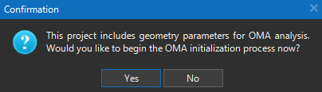

Figure 14 – Observer Open Project Notification

Selecting Yes opens the Initialization window directly, skipping manual setup steps. This feature makes .dxp files ideal for long-term projects, repeated analyses, and collaborative work where consistent project configuration is critical.

The typical workflow of performing OMA analysis in Observer is as follows:

- Initialization
  - Start a new OMA session (from raw data or .dxp project).
  - Define or review preprocessing and OMA parameters.
  - Select which methods to be included in the OMA analysis, by selecting appropriate checkbox for each group (FDD, SSI or pLSCF)
- Geometry Setup
  - Create or load a structural geometry.
  - Associate channels with geometry nodes.
- Analysis
  - Select OMA method(s).
  - Perform mode picking on SVD or stabilization diagrams.
- Click Apply Changes to compute modal parameters.
  - Inspect and analyze calculated modal shapes with their frequencies and damping ratios
  - Visualize and inspect generated animated 3D mode shapes.
- Verification
  - Compare at least two OMA results.
  - Generate MAC matrices and mode shape comparisons.
- Post-Processing and Export
  - Visualize animated 3D mode shapes.
  - Export to PDF reports or .ovy files for Voyager integration.

Available Methods

Observer offers several OMA methods for performing OMA analysis. They are distributed among time and frequency domain groups.

1. Frequency Domain Decomposition (FDD)
- Description:
Uses Singular Value Decomposition (SVD) of the cross-power spectral density (PSD) matrix. Peaks in the first singular value indicate structural modes.
- Advantages:
  - Very simple and intuitive.
  - Good for quick modal frequency estimation.
  - Works well for lightly damped structures.
- Disadvantages:
  - Does not provide damping values.
  - Accuracy decreases for closely spaced modes.

2. Enhanced Frequency Domain Decomposition (EFDD)
- Description:
Builds on FDD by applying inverse FFT to extract time-domain free decay functions from selected frequency bands, allowing damping estimation.
- Advantages:
  - Reliable damping estimation.
  - Still relatively simple to apply.
  - Better accuracy for lightly damped systems compared to FDD.
- Disadvantages:
  - Requires user interaction to select appropriate frequency bands.
  - Less robust for closely spaced or heavily damped modes.

3. Frequency-Spatial Domain Decomposition (FSDD)
- Description:
Improves FDD by introducing spatial correlation across sensors and using frequency-spatial singular value decomposition.
- Advantages:
  - Handles closely spaced modes better than FDD.
  - Provides improved mode separation.
- Disadvantages:
  - More computationally intensive.
  - Still limited in damping estimation accuracy.

4. Stochastic Subspace Identification – Data (SSI-Data)
- Description:
A time-domain method based on state-space models. Directly estimates modal parameters from raw time data without covariance matrices.
- Advantages:
  - Provides accurate frequencies, damping, and mode shapes.
  - Handles noisy data well.
  - Works for both lightly and heavily damped systems.
- Disadvantages:
  - More complex and computationally heavy than frequency-domain methods.
  - Requires stabilization diagram for mode selection.

5. Stochastic Subspace Identification – Covariance (SSI-Cov)
- Description:
Variant of SSI using covariance-driven algorithms. Constructs covariance matrices before applying subspace projection.
- Advantages:
  - High robustness against noise.
  - Good for short-duration recordings.
  - Provides reliable modal damping estimates.
- Disadvantages:
  - Can be less efficient for very long datasets.
  - Requires stabilization diagram interpretation.

6. Polyreference Least Squares Complex Frequency (PLSCF)
- Description:
A parametric frequency-domain method using least squares fitting of transfer functions across multiple references.
- Advantages:
  - Effective for structures with high modal density.
  - Provides consistent modal parameters when many sensors are used.
  - Strong performance with multi-setup campaigns.
- Disadvantages:
  - Computationally demanding.
  - Requires experienced user interpretation to avoid overfitting.

Below is a summary table providing a side-by-side comparison of all OMA methods available in Observer. It should help you, the end-user, to decide which algorithm to apply based on their data quality, structural type, and project requirements:

Method | Frequency Accuracy | Damping Accuracy | Closely Spaced Modes | Computational Cost | Ease of Use
FDD | High | Low (approximate) | Poor | Low | Very Easy
EFDD | High | Medium | Moderate | Medium | Easy
FSDD | High | Low–Medium | Good | Medium | Medium
SSI-Data | High | High | Excellent | High | Medium
SSI-Covariance | High | High | Excellent | High | Medium
PLSCF | High | High | Excellent | Very High | Complex

Initialization TAB

The Initialization Window (Figure 15) is the central workspace where users prepare their data and geometry before starting Operational Modal Analysis in Observer. It combines data management, geometry creation, and parameter configuration into a single interface.

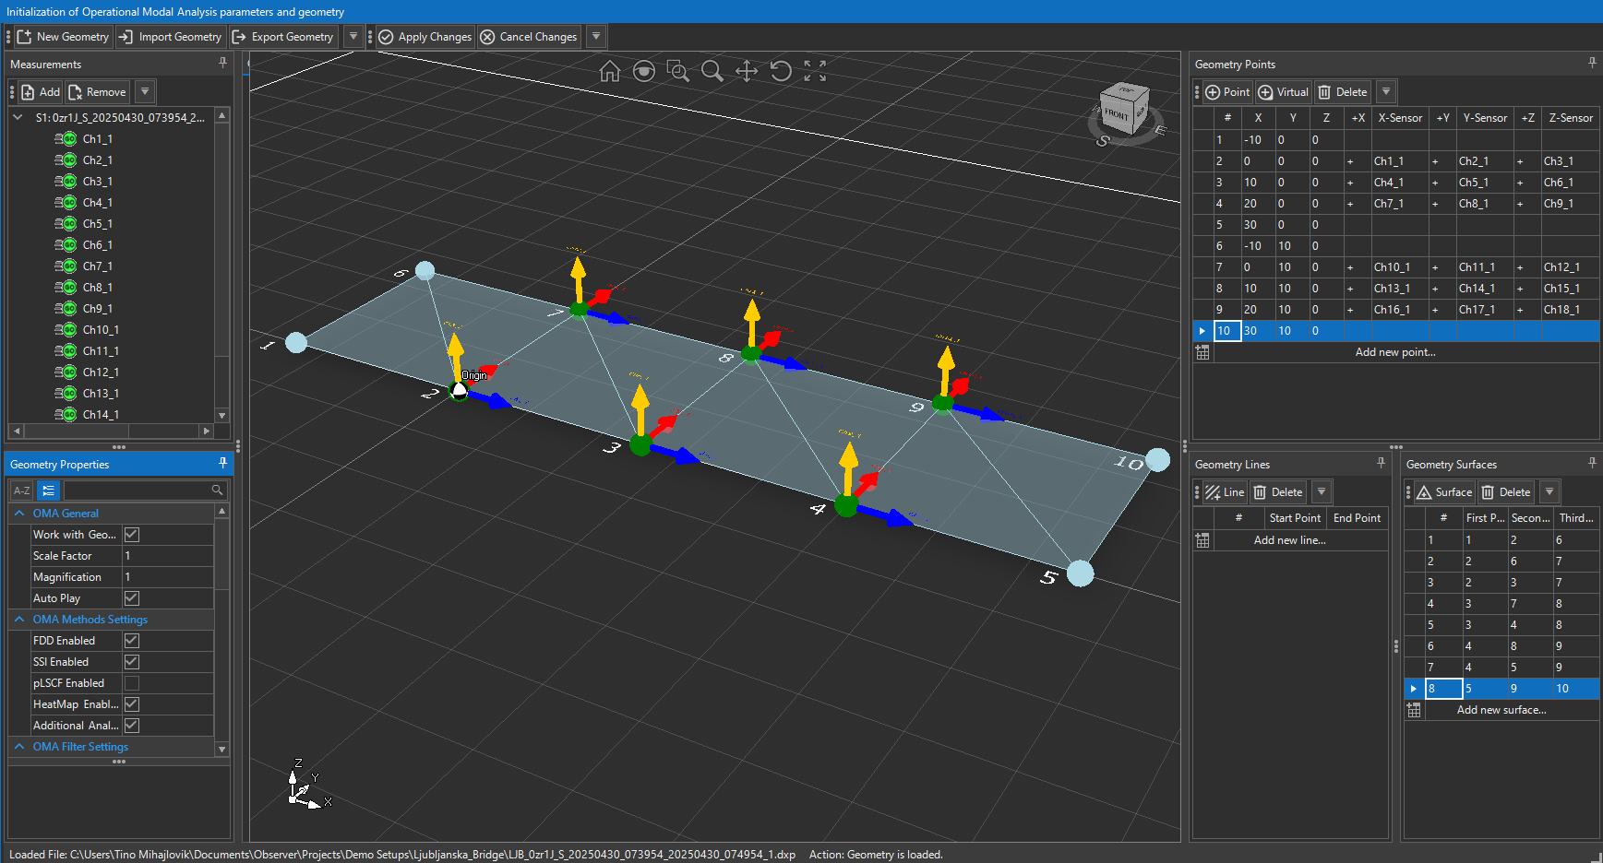

Figure 15 – Observer OMA Initialization

When an OMA session is started (either from raw measurement files such as MiniSEED/ASCII, or from a saved project file .dxp), this window opens (Figure 15) and displays the tools needed to set up the analysis. The workspace is divided into several functional areas:

Measurements Panel (top left side):

- Displays the loaded dataset and all associated channels.
- Channels can be expanded or collapsed to view individual measurements.
- Each channel can later be linked to a geometry point to represent sensor placement.
- Functions are available to add or remove datasets if multiple files are analyzed together.

Geometry Workspace (center):

- A 3D canvas where the structure is represented using points, lines, and surfaces.
- The geometry can be built manually (new points/lines/surfaces) or imported from external files.
- Geometry elements are used to visually link measurement channels to structural locations.
- Tools above the workspace allow rotation, zoom, panning, and resetting the view for navigation.
- The origin marker shows the coordinate system reference point.

Geometry Editor (right side):

- Geometry Points: Create and manage structural points.
  - Points may be real (linked to measurement channels) or virtual (geometrical only, without channel data).
- Geometry Lines: Define structural members by connecting points (e.g., beams, edges, or boundaries).
- Geometry Surfaces: Define planes or areas (e.g., bridge decks, slabs, dam faces) by grouping multiple points.

These panels allow incremental building of geometry with full control over node placement and connectivity.

Geometry Properties Panel (lower left corner):

Contains all parameter settings for OMA initialization.
- Organized into sections:
  - OMA General (animation, scaling, geometry usage)
  - OMA Methods Settings (method selection)
  - OMA Filter Settings (signal preprocessing)
  - OMA Analysis Settings (numerical parameters for FFT/SSI)
  - OMA Geometry Settings (visualization options such as colors, labels, and transparency)

Each section can be expanded or collapsed for easier navigation.

Toolbar (top):

Provides functions for creating, importing, and exporting geometry, as well as applying or canceling parameter changes.
- Key functions:
  - New Geometry – Start a new model from scratch.
  - Import Geometry – Load geometry from a file.
  - Export Geometry – Save current geometry for reuse.
  - Apply Changes – Confirm all parameter settings and proceed to OMA analysis (generating SVD and Stabilization Diagrams).
  - Cancel Changes – Discard modifications and return to the previous state.

Measurements Panel

The Measurements Panel, located (Figure 16) on the left side of the OMA Initialization Window, provides an organized list of all loaded measurement datasets and their corresponding channels. This is where the user manages the input signals that will later be linked to geometry points for OMA analysis.
When a measurement file (e.g., MiniSEED, ASCII, or a .dxp project file) is loaded, the panel automatically lists all channels included in that file. Each channel entry typically contains identifiers such as station code, channel number, or acquisition name, making it easy to match data to sensor locations on the structure.

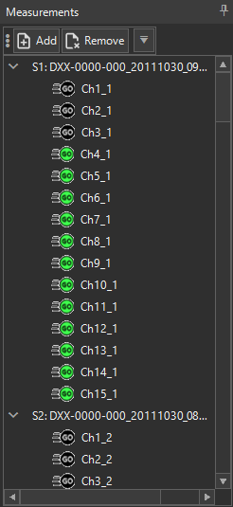
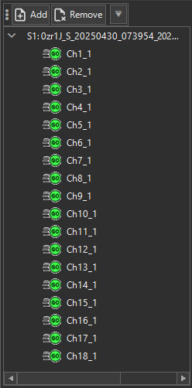

Figure 16 – Observer OMA Single and Multi-setup measurements

Core Functions:

- Expand/Collapse Datasets:
Users can expand a dataset to view its channels or collapse it for a cleaner interface.
- Channel Management:
  - Channels can be associated with geometry points to represent sensor locations.
  - Channels can remain unassigned if they are not relevant for the current geometry setup.
- Multi-Setup Campaigns: In large monitoring campaigns (multi-setup measurements), specific channels can be defined as Reference Channels to ensure consistency across setups.

Channel Color Coding:

To provide quick visual feedback, Observer uses color coding for channels in the Measurements Panel:
- Grey (Default): The channel is not associated with any geometry point. It is available for use but has not yet been mapped.
- Green: The channel is successfully associated with a geometry point in the Geometry Editor. This indicates that the signal is linked to a physical measurement location.
- Black: The channel is designated as a Reference Channel, which is used in multi-setup measurements to align and merge results across different test setups. Reference channels ensure continuity and comparability of modal parameters.

Geometry Workspace

The Geometry Workspace, (Figure 17) located in the center of the OMA Initialization Window, is a 3D environment where the structure is modeled for Operational Modal Analysis. Here, users can create and manipulate points, lines, and surfaces, link them to measurement channels, and prepare a structural representation for mode shape visualization.

The workspace is grid-based, with the global coordinate system axes (X, Y, Z) shown in the corner for orientation. Users can zoom, rotate, and pan the view to inspect the geometry from any perspective.

Toolbar Buttons (Top of Workspace):

From left to right:

- Home (Reset View) – Resets the camera to the default orientation and zoom, centering the geometry.
- Magnifying Glass (Magnifier Tool) – Opens a circular “magnifier lens” overlay. Moving the lens across the workspace allows closer inspection of local details without changing the global zoom level.
- Zoom Window – Enables the user to draw a rectangle around a region of interest; the camera view automatically zooms to that region.
- Pan (Hand Icon) – Moves the view horizontally or vertically while keeping the current orientation.
- Rotate (Curved Arrows) – Rotates the view around the geometry in 3D space.
- Zoom Fit – Adjusts the zoom so that all geometry objects are visible and centered in the workspace.

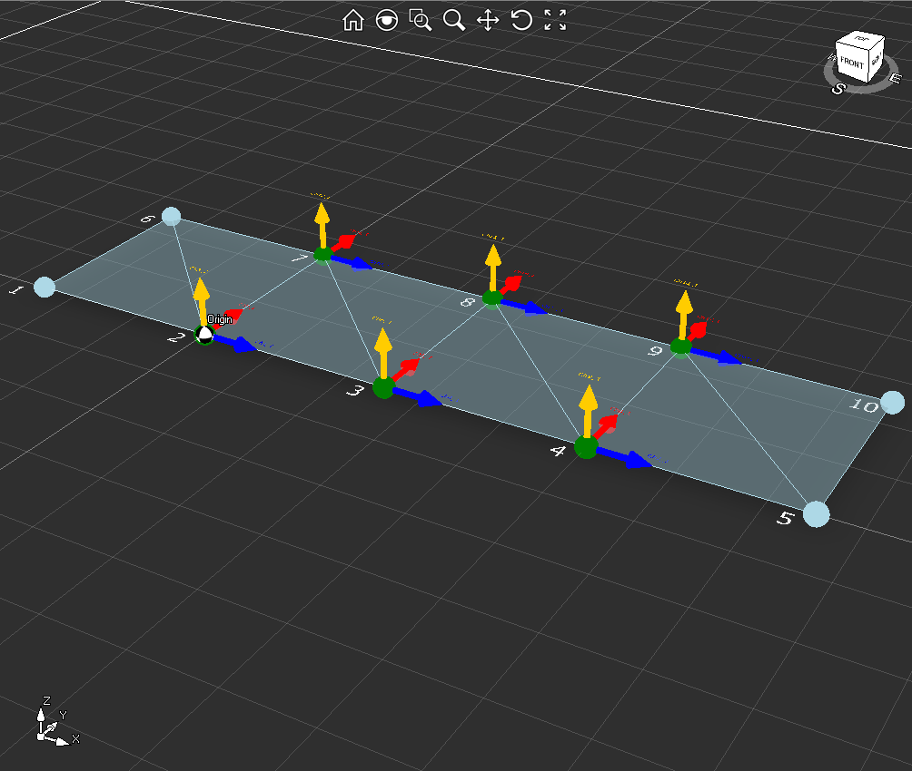

Figure 17 – Observer OMA Geometry Workspace
Navigation Cube (Top Right Corner):

The cube navigation tool in the upper-right corner allows intuitive orientation control:
- Faces Labeled S, E, W, N – Clicking on one of these rotates the view to align with the South, East, West, or North face of the model.
- Corner or Edge Clicks – Clicking on a corner or edge of the cube rotates the camera to a diagonal or oblique angle for better perspective.
- Drag Interaction – The cube can be rotated with the mouse to freely reorient the view.

This cube is particularly useful when working with complex geometries, ensuring that mode shapes can be inspected from consistent orientations.

Geometry Editor

The Geometry Editor in Observer (Figure 18) is where the structural model is created for OMA visualization and analysis. It allows users to define points, lines, and surfaces, and to associate sensor channels with these elements. The resulting geometry provides the framework for displaying mode shapes in 3D animations and for interpreting the relationship between measured data and the structure.
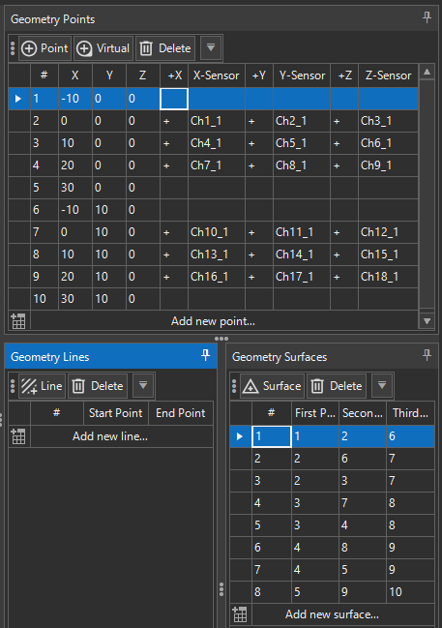

Figure 18 – Observer OMA Geometry Editor
The Geometry Editor is divided into three main panels: Geometry Points, Geometry Lines, and Geometry Surfaces.

GEOMETRY POINTS:

Points are the foundation of the geometry model. They represent either real sensor locations or virtual structural nodes.
- Point (Real): Must be associated with at least one sensor channel (X, Y, or Z). These points correspond to actual accelerometers or sensors placed on the structure.
- Virtual Point: Defined explicitly with the Virtual button. Virtual points carry no sensor data and are used only to complete geometry (e.g., corners, midpoints, or additional visualization nodes).

Coordinates (X, Y, Z)
- Define the location of the point in 3D space (typically in meters).
- Coordinate values determine where the mode shape deformation will be displayed.

Orientation (+X, +Y, +Z)
- Defines the axis direction of the assigned sensor channel.
- Double-click to toggle between positive (+) and negative (–).
- Orientation arrows appear in the workspace with a consistent color scheme:
  - Red = X-axis
  - Blue = Y-axis
  - Yellow = Z-axis

Sensor Assignment (X-Sensor, Y-Sensor, Z-Sensor)
- Each axis can be assigned a channel from the Measurements Panel.
- Supports:
  - Single-axis (only one channel, e.g., vertical accelerometer)
  - Biaxial (two channels on different axes)
  - Triaxial (three channels, full XYZ vector)
- At least one axis must be populated for a real point.

GEOMETRY LINES:

Lines connect two points and represent structural members or edges.

- Add Line: Select two existing points as start and end.
- Delete: Removes a line from the model.
- Purpose:
  - Represent beams, edges of slabs, or vertical columns.
  - Define boundaries that will later support surface creation.

GEOMETRY SURFACES:

Surfaces are polygons defined by three or more points. They represent continuous structural elements.

- Add Surface: Choose three or more points (First Point, Second Point, Third Point, …). The program automatically draws a polygon connecting them.
- Delete: Removes a selected surface.
- Purpose:
  - Represent slabs, decks, walls, or faces of a dam or tunnel.
  - Provide realistic visualization of deformation patterns during animated mode shapes.
TYPICAL WORKFLOW FOR GEOMETRY CREATION:

- Add Points: Create real points for sensor locations and virtual points for missing geometry nodes.
- Assign Sensors: Link channels to X/Y/Z axes of real points and verify orientation arrows match installation.
- Create Lines: Connect points to represent structural members.
- Build Surfaces: Define areas from connected points to complete the geometry.
- Verify Model: Inspect the 3D workspace and confirm that the geometry matches the physical structure.

Geometry Properties

The Geometry Properties panel (Figure 19) contains all configuration settings for Operational Modal Analysis (OMA). These settings control how geometry is handled, which OMA methods are applied, how signals are filtered, how numerical analysis is performed, and how the model is displayed.

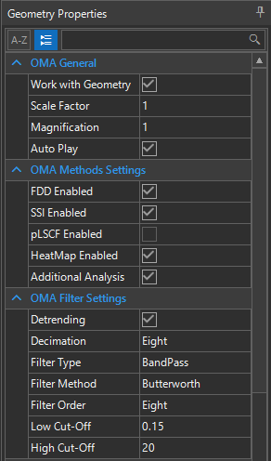

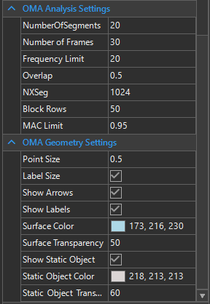

Figure 19 – Observer OMA Geometry Properties

The panel is organized into five collapsible sections:

OMA GENERAL:

- Work with Geometry
Enables or disables geometry use in OMA.
  - Enabled: Results are linked to the geometry for mode shape visualization.
  - Disabled: OMA can still be performed, but results are shown in numeric/diagram form only.
- Scale Factor - Defines the scaling of mode shape animations relative to the geometry. A higher factor exaggerates displacement for easier visualization.
- Magnification - Adjusts the visualization intensity for animations. Works together with Scale Factor to control perceived motion amplitude.
- Auto Play - Automatically starts mode shape animations after analysis is performed. If disabled, animations must be triggered manually.

OMA METHODS SETTINGS:

Determines which OMA algorithms are enabled for analysis.

- FDD Enabled - Activates Frequency Domain Decomposition group of methods (basic frequency extraction).
- SSI Enabled - Enables Stochastic Subspace Identification group of methods (time-domain, high accuracy).
- pLSCF Enabled - Activates Polyreference Least Squares Complex Frequency method (advanced frequency & damping estimation).
- HeatMap Enabled - Adds visualization of spectral density in heatmap format for advanced diagnostics.
- Additional Analysis - Enables supplementary processing functions (e.g., secondary stabilization checks, clustering tools, Hankel matrices etc.).

OMA FILTER SETTINGS:

Controls preprocessing of input signals before analysis.
- Detrending – Enables or Disables function: Removes slow trends or offsets from signals.
- Decimation - Enables or Disables function: Reduces the effective sampling rate (One to Ten or Off). Used to speed up analysis and reduce data size.
- Filter Type - Defines passband type:
  - LowPass
  - HighPass
  - BandPass
- Filter Method - Chooses digital filter design: Butterworth is used by default.
- Filter Order - Defines filter sharpness (higher order = steeper cutoff). Values: (One to Eight)
- Low Cut-Off / High Cut-Off - Defines lower and upper bounds of frequency band preserved. Typically set according to expected modal range (e.g., 0.1–20 Hz for civil structures).

OMA ANALYSIS SETTINGS:

Specifies numerical parameters for spectral and time-domain calculations.

- Number of Segments - Number of data segments used for averaging. More segments = better statistical reliability but lower frequency resolution.
- Number of Frames - Number of frames used for Animation generation. More frames more precise animation but longer time for generation.
- Frequency Limit - Maximum frequency (Hz) analyzed. Restricts OMA to relevant frequency range of the structure.
- Overlap - Percentage of overlap between consecutive segments (0–1). Typical value: 0.5 (50%).
- NXSeg - FFT segment length (number of samples per block) used when calculating the Singular Value Decomposition (SVD) spectra in frequency-domain OMA methods such as FDD, EFDD, and FSDD.
- Block Rows - defines the model order (number of block rows in the Hankel matrix) used in Stochastic Subspace Identification (SSI) methods. It directly controls how many system states are included in the estimation process. By increasing the Block Rows, higher-order models are generated and algorithm produces richer stabilization diagrams but increases computation time.
- MAC Limit - Threshold for Modal Assurance Criterion. It is a statistical measure of the similarity between two mode shape vectors. In Observer, it is used not only for verifying results between different OMA methods, but also within a single method to ensure consistency of mode identification. For frequency-domain methods MAC is used to check the consistency of mode shapes across adjacent frequency bins, ensuring that only frequency ranges with highly correlated shapes are grouped into a single mode. For time-domain MAC is used in stabilization diagrams to verify that estimated modes remain stable across increasing model orders, filtering out spurious poles and confirming true physical modes.

OMA GEOMETRY SETTINGS:

Controls the appearance of geometry and animations in the 3D workspace.
- Point Size - Defines the display size of geometry points. Useful for large models where points overlap.
- Label Size - Sets the font size of point/channel labels.
- Show Arrows - Toggles display of orientation arrows (X=Red, Y=Blue, Z=Yellow).
- Show Labels - Toggles channel/point labels in the 3D workspace.
- Surface Color - Defines the color of geometry surfaces for mode shape visualization.
- Surface Transparency - Sets transparency (0 = opaque, 255 = fully transparent). Helps reduce visual clutter in dense models.
- Show Static Object - Displays a reference geometry in its undeformed state alongside animated mode shapes.
- Static Object Color - Defines the color of the static (undeformed) geometry.
- Static Object Transparency - Adjusts transparency of static geometry, allowing comparison between static and animated modes.

Toolbar
The Geometry Toolbar (Figure 20) contains essential commands for managing structural geometry during OMA initialization. These buttons allow the user to create a new geometry, reuse existing models, save progress, and apply or discard changes before proceeding to analysis.

Figure 20 – Observer OMA Initialization Toolbar

New Geometry:
- Creates a new, empty geometry model.
- Clears any existing points, lines, and surfaces.
- Used when starting a fresh OMA project from raw measurement data.

Import Geometry:
- Loads a previously created geometry from an external file (e.g., Excel, proprietary .xlsx geometry file).
- Allows reuse of geometries across projects, ensuring consistency when analyzing the same structure multiple times.

Export Geometry:
- Saves the current geometry to a file for external use or backup.
- Export formats include proprietary or Excel-based structures, depending on project requirements.
- Useful for documentation, collaboration, or reusing geometries in future analyses.

Apply Changes:
- Confirms and applies all edits made to the geometry (points, lines, surfaces, and properties).
- Once applied, OMA processing (SVD calculation, stabilization diagrams) can be performed using the finalized geometry.
- Mandatory step before starting modal analysis.

Cancel Changes:
- Discards any unsaved modifications since the last applied state.
- Returns the geometry to the last saved or applied configuration.
- Useful for undoing incorrect point placements, channel associations, or property adjustments.

Apply Changes and start OMA Calculation

When the Apply Changes button is pressed in the Geometry Toolbar, Observer validates the geometry setup and begins calculating the parameters required for Operational Modal Analysis (OMA).

Calculation Process
- A progress indicator appears with the message:
“Calculating OMA parameters …”
- During this stage, Observer:
  - Applies the filtering, detrending, and decimation settings defined in Geometry Properties.
  - Segments the data and performs FFT or correlation preprocessing for OMA.
  - Generates the cross-spectral density matrices (for frequency-domain methods) or covariance matrices (for time-domain methods).
  - Prepares the SVD (Singular Value Decomposition) spectra and stabilization diagram structures.
Cancel Option
- The calculation window includes a Cancel button, allowing the user to interrupt processing if settings were configured incorrectly or if a faster reconfiguration is needed.

Transition to Analysis Tab
- Once calculation is complete, Observer enables access to the Analysis Tab.
- In the Analysis Tab, users can:
  - Select the OMA method (FDD, EFDD, SSI, PLSCF, etc.).
  - Perform peak picking on SVD plots or stabilization diagrams.
  - Run modal analysis to extract frequencies, damping ratios, and mode shapes.

Analysis (OMA)

Once initialization is complete and OMA parameters have been applied, Observer enters the Analysis Stage by clicking the ‘Analysis’ TAB (Figure 21). This stage allows the user to perform Operational Modal Analysis (OMA) using the selected method, identify modal parameters (frequency, damping, and mode shapes), and validate them through visualization and comparison.

The Analysis workspace is divided into three key areas:

STABILIZATION CHART & SVD CURVES:

At the center of the workspace is the Stabilization Chart, which displays the results of the selected OMA method.
- Singular Value Decomposition Diagrams (for frequency domain methods):
  - Displayed as multiple curves (one per singular value).
  - Peaks in these curves indicate potential natural frequencies of the structure.
  - The first curve (Curve-1, orange) typically carries the strongest modal information.
- Stabilization Diagrams (for time domain methods):
  - Vertical markers (green/red symbols) represent poles estimated at different model orders.
  - Green circles/triangles: Stable poles (frequency, damping, and mode shapes are consistent across orders).
  - Red circles/triangles: Unstable poles (spurious, noise-driven).
  - Stable poles aligning with SVD peaks represent true physical modes.
- Frequency Axis (X-axis): Frequency in Hz.
- Magnitude Axis (Y-axis): Level of singular values or stabilization markers, typically in dB.

MODE SHAPE 3D VIEWER:

On the right-hand side, the Mode Shape 3D Viewer displays the geometry model with animated deformation shapes corresponding to the identified modes.
- Color Scale: Indicates relative displacement intensity (blue = minimum, red = maximum).
- Interactive Tools:
  - Rotate, pan, zoom to inspect geometry.
  - Compare static vs. deformed geometry (if enabled in properties).
- Animation Control: Modes can be played, paused, and looped for detailed inspection.

MODE SHAPE LIST:

At the bottom-right, the Mode Shape List stores extracted modal parameters.
- Columns include:
  - Mode ID – Sequential number of the mode.
  - Picked Frequency – Frequency selected from the SVD or stabilization diagram.
  - Calculated Frequency – Refined frequency obtained after analysis.
  - Damping (%) – Estimated damping ratio.

- Controls:
  - Up/Down: Change the order of selected modes.
  - Additional Analysis: Perform extra post-processing (e.g., MAC comparison, clustering).
  - Export: Save mode results for reporting or external tools (Excel, PDF, GIF animations).

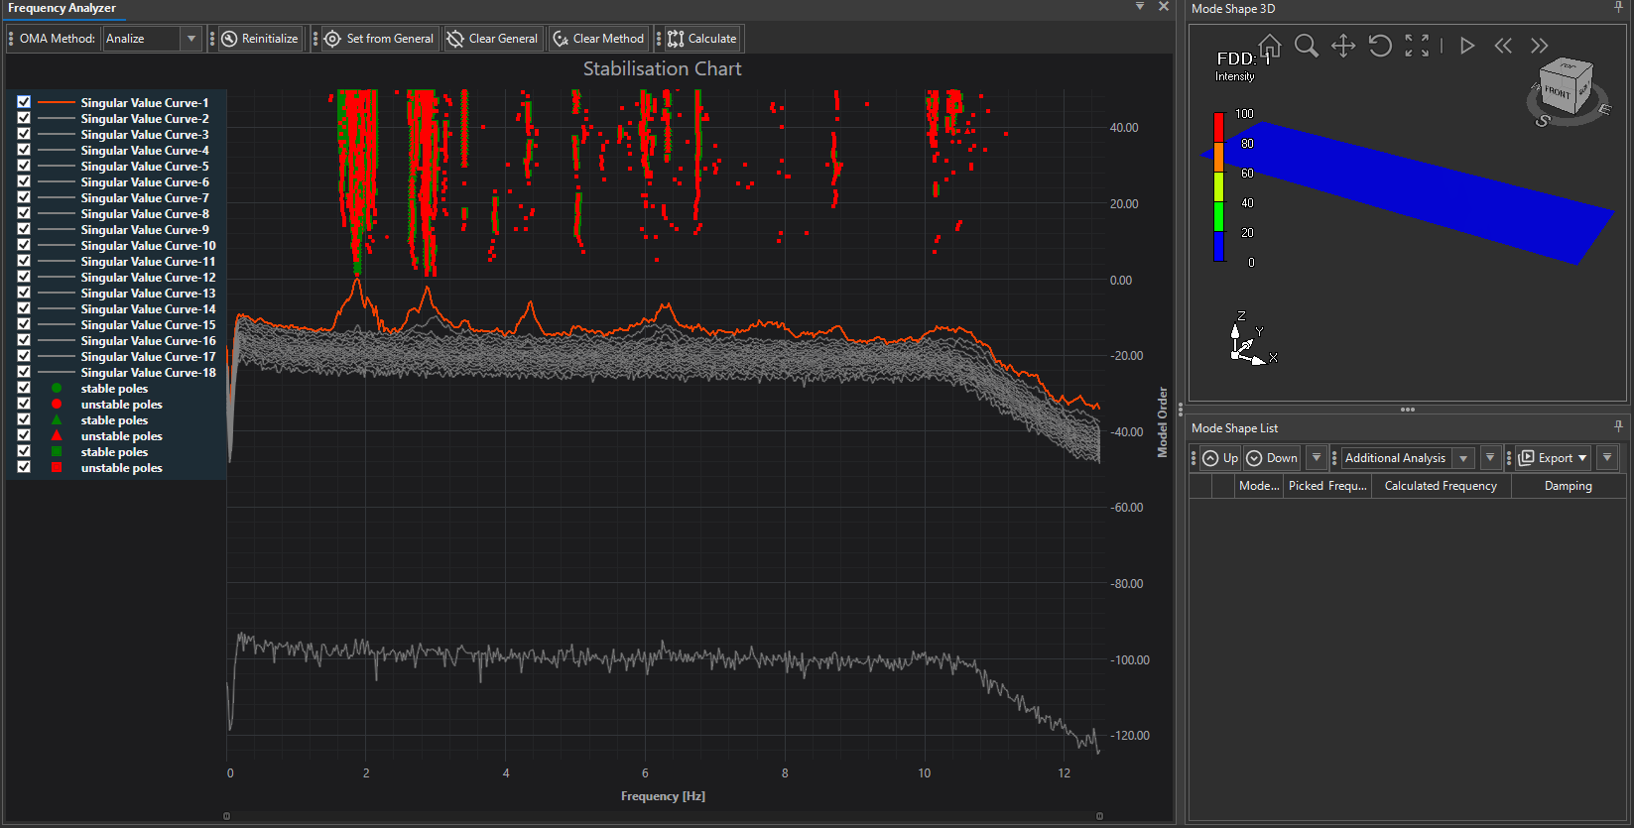
Figure 21 – Observer OMA Analysis TAB

Analysis Main Menu

The Analysis main menu provides all controls for selecting an OMA method, managing settings, and running the modal analysis. These functions are essential for switching between methods, updating configurations, and recalculating results.

MENU ITEMS:

- OMA Method
  - Dropdown list for selecting the Operational Modal Analysis method.
  - Available options:
    - Frequency-domain: FDD, EFDD, FSDD
    - Time-domain: SSI-Data, SSI-Cov, PLSCF
  - The selected method determines which diagram is displayed (SVD or Stabilization).
- Reinitialize
  - Resets the analysis workspace and reloads parameters from the Initialization stage.
  - Useful when significant geometry or filter settings were changed and a fresh start is required.
- Set from General
  - Used for preselecting and using once picked frequencies from one OMA methods to the others
- Clear General
  - Clears all globally picked frequencies.
- Clear Method
  - Removes all picked frequencies to the currently selected OMA method.
  - Typically used when re-running analysis with new peak selections or different stabilization orders.
- Calculate
  - Runs the selected OMA method with the current settings.
  - For frequency-domain methods: uses the computed SVD diagram and does modal parameter extraction for the picked frequencies.
  - For time-domain methods: uses the computed Stabilization Diagram and does modal parameter extraction for the picked frequencies.
  - After calculation, the workspace updates with plots, poles, and mode shapes and is ready for analysis and 3D visualization.

Figure 22 – Observer OMA Analysis TAB

Using Frequency Domain Decomposition (FDD) method

The Frequency Domain Decomposition (FDD) method (Figure 23) is the simplest and most intuitive OMA technique, based entirely on the frequency domain representation of signals. It identifies natural frequencies and mode shapes by examining the singular value decomposition (SVD) of the cross-spectral density matrix.

Principle of FDD:

- Measurement data is segmented and converted into the frequency domain.
- At each frequency line, an SVD is performed on the spectral density matrix.
- The first singular value curve highlights dominant modal frequencies as peaks.
- Corresponding singular vectors provide the mode shape information.

FDD does not directly estimate damping values — it is primarily used for frequency and mode shape identification.

FDD Analysis Workflow in Observer:

- Select OMA Method
  - In the Analysis Tab, choose FDD from the OMA Method dropdown.
  - Appropriate SVD diagram is shown.
- Interpret the SVD Diagram
  - Multiple singular value curves are shown (Curve-1 in red, others in gray).
  - Peaks in Curve-1 indicate candidate natural frequencies.
- Peak Picking
  - Use the cursor to select peaks in the diagram (Ctrl + Click).
  - Picked peaks appear as vertical green lines with frequency labels.
  - Each selected peak is added to the Mode Shape List with the “Picked Frequency” value.
  - Click Calculate to do the modal parameters estimation. After finished first picked frequency is automatically selected.
- Mode Shape Visualization
  - For each picked frequency (e.g. clicked from the results table), the corresponding 3D animation is shown.
  - Mode shapes are displayed in the 3D Viewer with deformation animations and intensity color scaling.
  - Visualization can be rotated, zoomed, and animated for detailed inspection.
- Mode Shape List
  - Stores all picked modes with:
    - Picked Frequency – Frequency selected by the user.
    - Calculated Frequency – Refined frequency computed by the algorithm.
    - Damping – Not available in basic FDD (NaN shown).

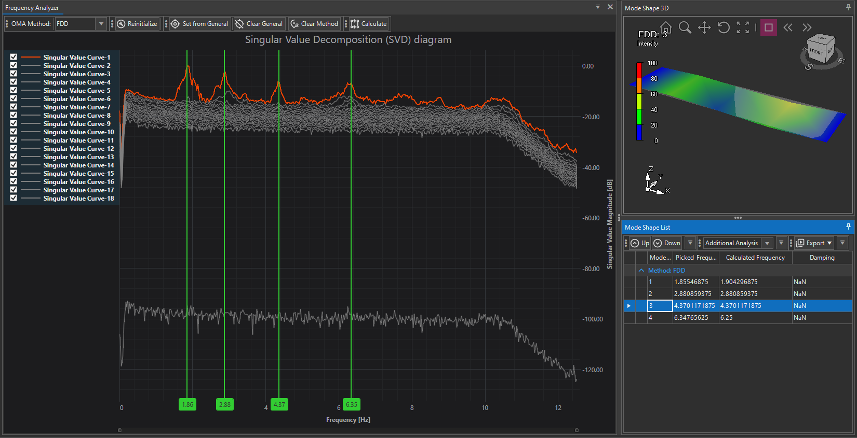
Figure 23 – Observer OMA Analysis – Using FDD

Using Enhanced Frequency Domain Decomposition (EFDD) method

EFDD (Figure 24) extends FDD by estimating damping. Around each picked SVD peak, EFDD forms a narrow SDOF “bell” (frequency band with consistent mode shape via MAC), transforms it to the time domain (IFFT) to obtain a free-decay signal, and fits an exponential decay to compute damping and a refined frequency.

EFDD ANALYSIS WORKFLOW IN OBSERVER:

- Select OMA Method
  - In the Analysis Tab choose EFDD from the OMA Method dropdown.
  - The SVD diagram is shown.
- Interpret the SVD Diagram
  - Multiple singular-value curves are displayed (Curve-1 red; others gray).
  - Prominent peaks indicate candidate natural frequencies.
- Peak Picking
  - Use Ctrl+Click on the SVD peak(s) to pick modes.
  - Picked peaks appear as vertical green lines with labels.
  - Each pick is added to the Mode Shape List under Picked Frequency.
  - Click Calculate to run EFDD; after finishing, the first picked frequency is automatically selected.
- Mode Shape Visualization
  - Click a row in the Mode Shape List to display its 3D animation (intensity color scale, rotate/zoom/animate).
  - Mode shapes come from the singular vectors at the selected peak.
- Mode Shape List
  - For EFDD you get:
    - Picked Frequency – your SVD pick.
    - Calculated Frequency – refined from the decay fit.
    - Damping (%) – estimated from the exponential decay.
  - Reorder (Up/Down), run Additional Analysis, or Export results.

EFDD method in Observer plots four (4) additional diagnostics plots for each picked/calculated frequency. These plots open automatically for the currently selected mode to help you confirm bandwidth, decay quality, and the damping fit.

SDOF Bell Function vs Frequency:
- The SDOF bell extracted around the SVD peak after MAC-based band selection.
- Shows the effective frequency range used for the mode.
- What to check: a single green colored, well-separated bell without nearby peaks; too wide a band may mix modes, too narrow may hurt damping stability.
Auto-Correlation vs Time:
- Time-domain free decay derived by IFFT of the bell.
- What to check: a clean, smooth decay without beating; persistent beating suggests neighboring modes or too-wide bandwidth.
Singular Value vs Frequency (Portion for fit):
- The bell again, with green markers highlighting the exact portion used to compute the time-series and to fit damping.
- What to check: the selected portion should cover the dominant peak and exclude contamination.
Fitted Exponential Decay (Fit: Frequency and Damping):
- The measured decay (points) with the exponential fit (line).
- The panel reports damping ratio and refined frequency from the fit.
- What to check: close overlay of fit and data in the early-to-mid decay; large deviations indicate poor bandwidth selection or noise.

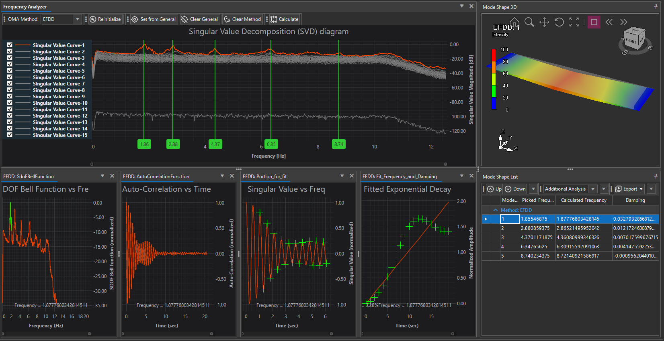

Figure 24 – Observer OMA Analysis – Using EFDD

Using Frequency Spatial Domain Decomposition (FSDD) method

The Frequency–Spatial Domain Decomposition (FSDD) method (Figure 25) improves upon FDD/EFDD by using both frequency-domain decomposition and spatial information from multiple channels to better separate closely spaced modes. Like EFDD, it allows estimation of both frequency and damping, but it is particularly powerful when two or more modes overlap in the spectrum.

Note: FSDD method in not available for Multi Setup Measurements using reference channels.

FSDD ANALYSIS WORKFLOW IN OBSERVER:

- Select OMA Method
  - In the Analysis Tab, choose FSDD from the OMA Method dropdown.
  - The SVD diagram is displayed.
- Interpret the SVD Diagram
  - Singular Value curves are displayed (Curve-1 red; others gray).
  - Peaks represent potential modal frequencies, similar to EFDD.
  - For overlapping peaks, FSDD can still extract separate modes thanks to spatial decomposition.
- Peak Picking
  - Use Ctrl+Click on peaks of interest.
  - Selected frequencies appear as green vertical markers with numeric labels.
  - Each picked frequency is added to the Mode Shape List as a candidate mode.
  - Click Calculate to process; damping and refined frequencies are then extracted.
- Mode Shape Visualization
  - Selecting a mode in the list updates the 3D Viewer with animated deformation.
  - The geometry view uses intensity scaling (blue–green–red) and directional arrows for orientation.
- Mode Shape List
  - Columns include:
    - Picked Frequency – frequency marked by the user.
    - Calculated Frequency – refined frequency from the decay fit.
    - Damping (%) – estimated damping ratio for the mode.
  - Results can be reordered, validated via Additional Analysis, and exported.

FSDD method in Observer also plots four (4) additional diagnostics plots for each picked/calculated frequency, additional verification plots, similar to EFDD but with spatial mode separation included. These plots open automatically for the currently selected mode to help you confirm bandwidth, decay quality, and the damping fit.

SDOF Bell Function vs Frequency
- Shows the narrowband SDOF function used for modal extraction.
- In FSDD, the decomposition better isolates overlapping peaks compared to EFDD.
Auto-Correlation vs Time
- The inverse FFT of the selected band produces the time-domain decay.
- Used for damping estimation.
- A smoother decay (less beating) is expected compared to EFDD when modes are close.
Singular Value vs Frequency (Portion for Fit)
- Highlights the frequency band and consistency check (MAC-based) used to isolate the mode.
- Helps confirm that only the dominant mode is included.

Fitted Exponential Decay (Frequency and Damping)
- The decay curve is fit with an exponential function.
- Provides damping ratio and refined frequency values.
- Good fit indicates reliable parameter estimation; large residuals suggest overlapping or noisy data.

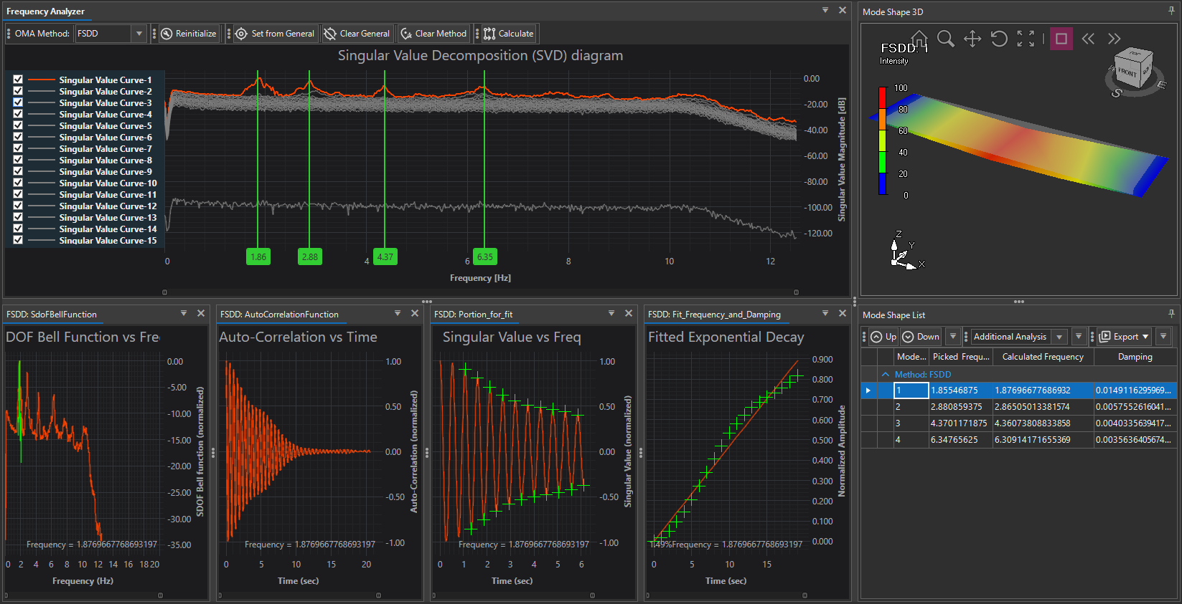
Figure 25 – Observer OMA Analysis – Using FSDD

Using Stochastic Subspace Identification Data method

The SSI-Data method (Figure 26) is a time-domain OMA technique that builds state-space models directly from raw time-series data using subspace identification. It estimates modal parameters (frequency, damping, and mode shapes) by analyzing the system matrices derived from the Hankel matrix of measurements. Unlike frequency-based methods, SSI provides robust and automated detection of stable poles, making it especially effective in noisy environments and for closely spaced modes.
This is where the workflow differs significantly from the frequency-domain (FDD, EFDD, FSDD) methods, since instead of the SVD diagram, you work with a Stabilization Diagram and additional validation plots.

SSI-DATA ANALYSIS WORKFLOW IN OBSERVER:

- Select OMA Method
  - In the Analysis Tab, choose SSI-Data from the OMA Method dropdown.
  - The Stabilization Chart is displayed instead of an SVD diagram.
- Interpret the Stabilization Chart
  - The chart plots frequency (x-axis) vs. model order (y-axis).
  - Each pole estimated at a given order is shown as a point:
    - Green = stable pole (consistent frequency, damping, and mode shape across increasing orders).
    - Red = unstable pole (spurious, noise-driven).
  - Clusters of green markers aligned vertically indicate true structural modes.
- Mode Selection
  - Use Ctrl+Click on the stable pole clusters in the stabilization chart.
  - Selected frequencies appear as vertical green markers with numeric labels.
  - Each selected mode is added to the Mode Shape List with initial estimates.
  - Click Calculate to run SSI-Data with the chosen poles and extract modal parameters.
- Mode Shape Visualization
  - Selected modes appear in the 3D Viewer as animated deformations.
  - Geometry can be rotated, zoomed, and animated with color scaling.
- Mode Shape List
  - Results include:
    - Picked Frequency – selected from stabilization chart.
    - Calculated Frequency – refined from SSI algorithm.
    - Damping (%) – estimated directly from time-domain decay.
  - SSI provides more reliable damping estimates than frequency-domain methods.

In addition to the Stabilization Chart and 3D Viewer, Observer displays validation plots specific to SSI methods:

- Frequency–Damping Clustering
  - Scatter plot of estimated poles in terms of frequency vs. damping.
  - Helps identify stable clusters of modes with consistent damping.
  - Useful for filtering out spurious poles with unrealistic damping values.
- Singular Values Plot (Hankel Matrix)
  - Displays singular values of the block Hankel matrix.
  - The “elbow” (sharp drop-off) indicates the effective system order.
  - Used to validate whether enough states are included to capture structural dynamics without overfitting.

The SSI-Data method is a robust time-domain approach that is highly effective in noisy environments and particularly suited for identifying closely spaced or lightly damped modes. Unlike frequency-domain methods, it directly provides accurate damping ratios and uses the stabilization chart to clearly distinguish true structural modes from spurious poles. However, SSI-Data requires careful interpretation of stabilization diagrams, making user expertise essential. It is also more computationally demanding than FDD/EFDD and sensitive to key parameter settings such as block rows, MAC limit, and number of segments. In practice, users rely on pole stabilization rather than SVD peaks, validating results through frequency–damping clustering and Hankel singular values before extracting reliable modal parameters, including damping, into the Mode Shape List.

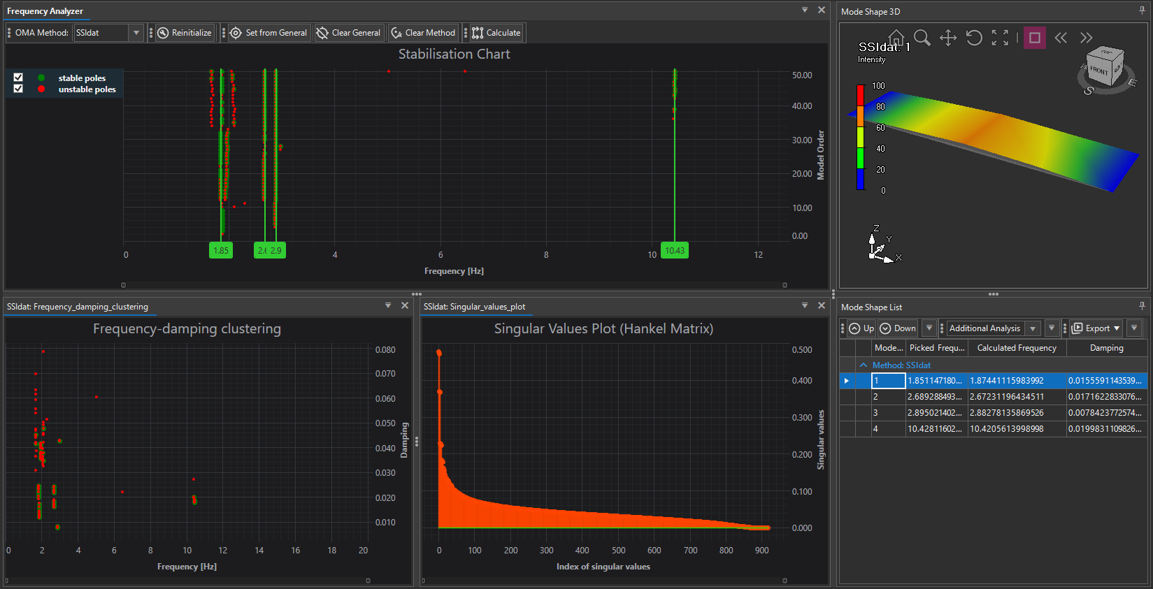

Figure 26 – Observer OMA Analysis – Using SSI-Data

Using Stochastic Subspace Identification Covariance method

The SSI-Covariance method (Figure 27) is a time-domain OMA technique based on the correlation functions of the signals instead of the raw data. By working with the covariance of the output, it filters out much of the stochastic noise and tends to produce cleaner stabilization diagrams, particularly useful for continuous monitoring data or large datasets. SSI-Cov often provides more stable identification of lightly damped modes compared to SSI-Data.

SSI-COV ANALYSIS WORKFLOW IN OBSERVER:

- Select OMA Method
  - From the Analysis Tab, select SSI-Cov from the OMA Method dropdown.
  - The Stabilization Chart is displayed.
- Interpret the Stabilization Chart
  - The chart plots frequency (Hz) on the x-axis and model order on the y-axis.
  - Poles are color-coded:
    - Green = stable poles (consistent in frequency, damping, and mode shape).
    - Red = unstable poles (discarded as spurious or noise-driven).
  - As in SSI-Data, vertical groupings of green poles represent structural modes.
- Mode Selection
  - Use Ctrl+Click on stable pole clusters to pick candidate modes.
  - Selected frequencies appear as green vertical lines with numeric values.
  - Each selected mode is added to the Mode Shape List.
  - Click Calculate to perform detailed modal parameter extraction.
- Mode Shape Visualization
  - Selected modes are displayed in the 3D Viewer as animated deformations with intensity-based color scaling.
  - Users can rotate, zoom, and play animations for mode shape validation.
- Mode Shape List
  - Stores all extracted modes with:
    - Picked Frequency – selected from stabilization chart.
    - Calculated Frequency – refined value from SSI-Cov algorithm.
    - Damping (%) – damping ratio, usually more stable than in SSI-Data for lightly damped modes.
  - Results can be reordered, validated with Additional Analysis, and exported.

In addition to the Stabilization Chart and 3D Viewer, Observer displays validation plots specific to SSI methods:

- Frequency–Damping Clustering
  - Plots poles in the frequency–damping plane.
  - Clusters of green poles with consistent damping values confirm real structural modes.
  - Outliers with excessively high or negative damping should be discarded.
- Singular Values Plot (Hankel Matrix)
  - Displays singular values derived from the covariance Hankel matrix.
  - The sharp “elbow” indicates the effective number of states needed to capture system dynamics.
  - Helps to avoid overfitting by keeping model order reasonable.

The SSI-Covariance method offers several advantages for structural health monitoring. It is more robust than SSI-Data in continuous monitoring applications and produces cleaner stabilization diagrams thanks to its inherent noise suppression. It is particularly effective for identifying lightly damped modes and is often regarded as the most reliable time-domain method for SHM.
At the same time, SSI-Cov also comes with limitations. It is computationally heavier than SSI-Data, especially when applied to large datasets, and still requires careful interpretation of stabilization diagrams. Like other time-domain approaches, it remains sensitive to parameter settings such as block rows, MAC limit, and the number of segments.

In summary: The SSI-Covariance method builds upon SSI-Data by working with signal covariance instead of raw time series, which leads to more stable results and cleaner stabilization diagrams. It is especially valuable for lightly damped structures and long-term monitoring campaigns. Users identify stable poles in the stabilization chart, validate them using frequency–damping clustering and Hankel singular values, and then extract validated modal parameters — including damping — into the Mode Shape List.

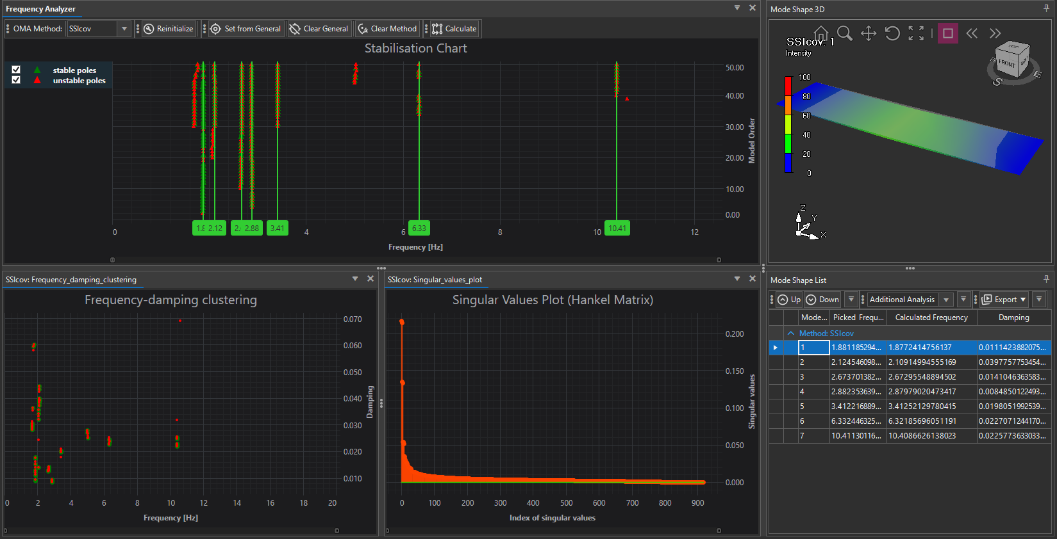

Figure 27 – Observer OMA Analysis – Using SSI-Cov

Using Polyreference Least Squares Complex Frequency (PLSCF) method

The Polyreference Least Squares Complex Frequency (pLSCF) method (Figure 28) is a parametric, frequency-domain identification technique that estimates modal parameters by fitting complex frequency response functions (FRFs) in a least-squares sense. Unlike simpler peak-picking or covariance-based methods, pLSCF works directly on multiple references (polyreference), making it powerful for analyzing large, multi-channel datasets. It is widely used in research and industrial applications requiring high precision.

PLSCF Analysis Workflow in Observer:

- Select OMA Method
  - From the Analysis Tab, choose pLSCF in the OMA Method dropdown.
  - The Stabilization Chart appears, similar to SSI methods but reflecting pLSCF’s parametric identification.
- Interpret the Stabilization Chart
  - The chart shows poles (green = stable, red = unstable) across increasing model orders.
  - Stable poles that persist across orders indicate physical modes.
  - Users select stable poles using Ctrl+Click, adding them to the Mode Shape List.
- Frequency–Damping Clustering
  - The clustering diagram helps validate poles by plotting them in the frequency–damping plane.
  - Physical modes form clear clusters of stable poles, while scattered poles indicate noise.
- Mode Shape Visualization
  - Selected modes are animated in the 3D Viewer, with intensity scaling, rotation, and zoom available.
  - pLSCF provides very accurate mode shapes, especially in complex structures with many DOFs.
- Mode Shape List
  - Stores extracted modes with:
    - Picked Frequency – initial selection from the stabilization chart.
    - Calculated Frequency – refined estimate from the least-squares fitting.
    - Damping – high-accuracy damping ratio.

In Observer, the pLSCF method includes a Frequency–Damping clustering diagram as a diagnostic tool to support mode validation. Each point on this chart represents an identified pole, plotted according to its estimated frequency (x-axis) and damping ratio (y-axis).
- Stable Poles (green) cluster together at consistent frequency–damping coordinates, indicating physical modes of the structure.
- Unstable Poles (red) are scattered, typically reflecting noise or numerical artifacts that should not be interpreted as structural modes.
- Clusters of green poles provide strong evidence of true modal parameters, and their tight grouping increases confidence in both frequency and damping estimates.

This chart is particularly valuable in pLSCF analysis, where the algorithm generates a large number of poles across different model orders. By observing which poles converge into stable clusters, engineers can separate true structural modes from spurious results. Compared with FDD/EFDD (where peaks in the SVD are picked) or SSI methods (where stabilization diagrams are dominant), the frequency–damping clustering diagram is the key validation layer in pLSCF, offering a clear and intuitive representation of how reliable each identified mode is.

The pLSCF method is the most advanced and precise OMA technique available in Observer, offering high accuracy in frequency and damping estimation and exceptional capability to resolve closely spaced modes. Unlike frequency-domain methods such as FDD, EFDD, or FSDD, which rely on peak-picking or spectral analysis, pLSCF performs polyreference least-squares fitting in the frequency domain, making it more robust and reliable, especially in noisy datasets or when multiple inputs are present. Compared to time-domain methods like SSI-Data and SSI-Cov, pLSCF is more computationally intensive but often yields clearer results, particularly for complex infrastructures with dense modal spectra such as bridges, dams, and tall buildings. It is best suited for large, multi-setup, multi-channel campaigns where other methods may fail to separate modes accurately. However, it requires expert interpretation, careful parameter tuning, and significant computational resources, making it less practical for quick, routine checks. In practice, users identify stable poles in the stabilization chart, validate them through frequency–damping clustering, and extract modal parameters into the Mode Shape List, ensuring research-grade SHM analysis and reliable results in large-scale monitoring projects.

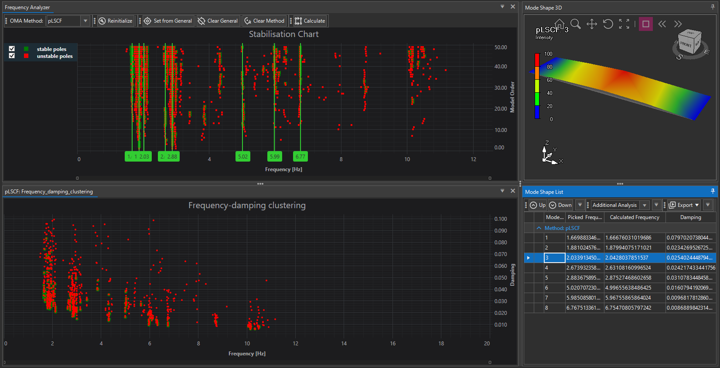

Figure 28 – Observer OMA Analysis – Using PLSCF

Verification

The Verification Tab in Observer (Figure 29) provides tools to compare, validate, and cross-check modal parameters estimated using different OMA methods. Its purpose is to confirm the reliability of identified frequencies, damping ratios, and mode shapes by examining their consistency across methods.

1. Calculated Methods Panel
- Displays all identified modes from the applied OMA methods (e.g., EFDD, FDD, FSDD, SSI).
- For each method, the following parameters are listed:
  - Picked Frequency – the frequency chosen during analysis.
  - Calculated Frequency – refined value obtained from curve fitting or stabilization.
  - Damping – estimated damping ratio (if available for the chosen method).
- This table serves as the starting point for selecting modes to compare in more detail.

2. Mode Shape Comparison (3D View)

- The right side of the interface allows direct comparison of Mode Shape A vs. Mode Shape B, taken from different OMA methods.
- Users can visually inspect whether the shapes align in terms of deformation pattern, scale, and orientation.
- The 3D viewer supports rotation, zooming, and animation, making differences in structural behavior easily detectable.

3. MAC Matrix (Modal Assurance Criterion)

- The MAC Matrix provides a quantitative comparison between two sets of mode shapes.
- Values range from 0 to 1, where:
  - 1 (red columns) indicates perfect correlation between two mode shapes.
  - 0 (blue background) indicates no similarity.
- The matrix highlights which modes from one method correspond to which modes from another, ensuring correct mode pairing.
- Example: EFDD vs. FSDD mode comparison confirms whether both methods identify the same physical mode.

The Verification Tab is essential for validating OMA results. While frequency estimates can often be cross-checked across methods, the real strength lies in comparing mode shapes using the MAC matrix. High MAC values (>0.9) between methods confirm robust modal identification, whereas discrepancies may indicate spurious poles, poor signal quality, or insufficient geometry association. Observer’s verification environment allows both visual (3D mode shapes) and numerical (MAC) checks, giving users confidence in their final set of modal parameters before exporting them to Voyager or further structural analysis.

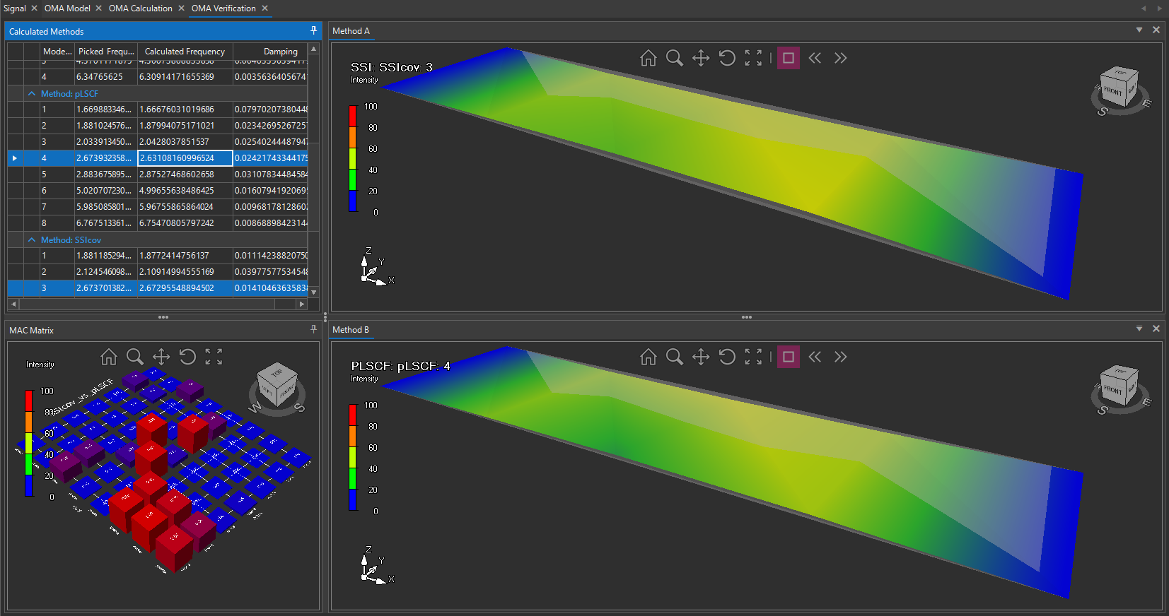

Figure 29 – Observer OMA Analysis – Verification

The Verification Tab is designed to help engineers validate the modal parameters obtained from multiple OMA methods. While each method (FDD, EFDD, FSDD, SSI, pLSCF) has its own strengths, none are perfect on their own. Verification is the step where results are cross-compared to eliminate false modes and confirm consistent modal characteristics.

Why Verification is Needed:

- Noise vs. true modes: In OMA, peaks or poles can sometimes represent noise or local numerical effects rather than real structural modes. Verification helps identify which are physical.
- Consistency check: True structural modes should appear across multiple methods, with similar frequencies and mode shapes.
- Reliability for SHM: For continuous monitoring, only verified modes should be tracked, since spurious ones can cause false alarms.

Auto-Correlation

The Auto-Correlation tab (Figure 30) in the OMA section is not a simple time-series signal check, but a core diagnostic and interpretive tool used in modal analysis.
- In OMA, the correlation function is directly related to the impulse response function of the structure.
- By analyzing auto-correlation, the system’s modal content (natural frequencies and damping) can be identified without requiring an external excitation force.
- This is fundamentally different from the “basic signal auto-correlation” (which is just a quick tool to detect periodicity or lag in raw data).
Here, correlation is applied to the measured structural response data, making it an estimator of system dynamics rather than just a signal property.

Channel Selector:

- The combo box at the top left allows the user to select a specific measurement channel (e.g., Channel 5).
- Each channel is processed individually, showing its normalized auto-correlation function.
- Normalization ensures comparability across channels with different amplitudes, scaling the correlation to a maximum of 1.

Interpretation of the Graph:

- Y-axis (Normalized Auto-Correlation): Values range from +1 (perfect correlation with itself at lag = 0) to negative values (anti-correlation).
- X-axis (Time [s]): Represents lag time, i.e., how far the signal is shifted to compute correlation with itself.

Key observations in the plot:

- Initial Peak at t=0: Always = 1, since the signal is perfectly correlated with itself at zero lag.
- Oscillations after t=0: Show the modal content of the system.
  - Frequency of oscillations corresponds to natural frequencies.
  - Rate of decay corresponds to damping ratios.
- Long-Term Decay: Ideally, auto-correlation should trend toward zero with increasing lag, showing that the system’s response dies out due to damping.
- Noise Floor: Small oscillations at later times (like in your plot after 20–30s) indicate background noise or residual energy in lightly damped modes.

The Auto-Correlation tab provides a channel-by-channel visualization of the normalized auto-correlation functions that form the mathematical foundation of OMA time-domain methods. Unlike the simpler correlation tool in the Signal section, this one is tightly coupled with modal identification. By inspecting these plots, users can assess the quality of their measurements, confirm the presence of modal oscillations, and understand how damping influences signal decay before poles are extracted in SSI-based analyses.

Why It Matters in OMA
- In SSI-based OMA methods, the auto-correlation sequences (and cross-correlations for multi-channel data) are stacked into block Hankel matrices, which form the basis for system identification.
- This tab allows users to visually inspect how “clean” the correlation is, which directly impacts stabilization diagram quality.
- Strong, slowly decaying oscillations → clear modes, reliable damping estimates.
- Fast decay or noisy oscillations → weak modes or insufficient data quality.

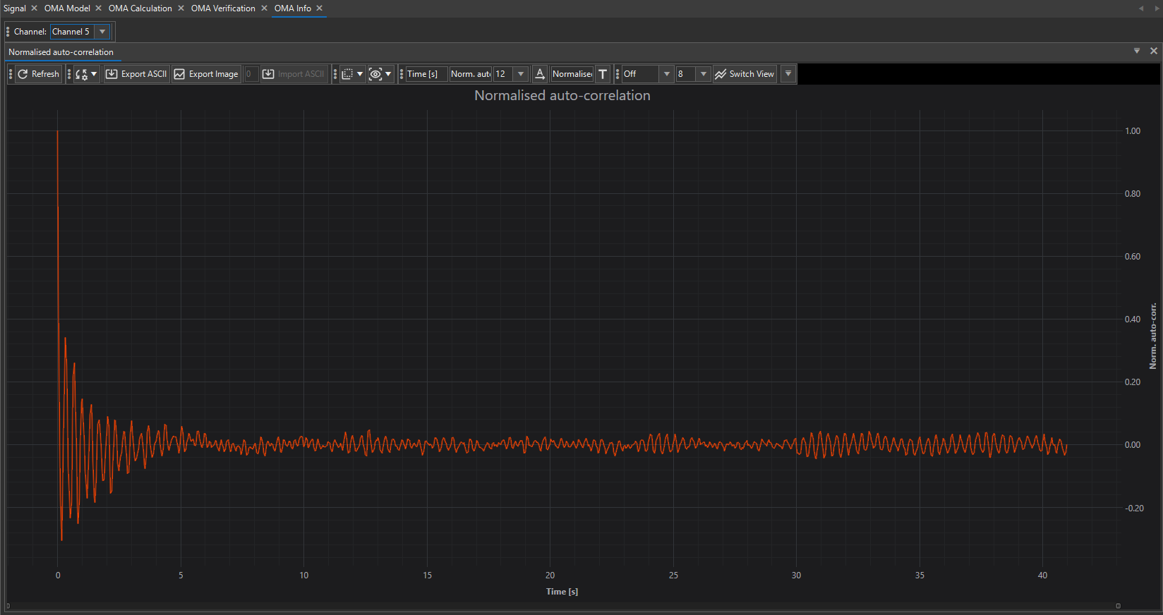

Figure 30 – Observer OMA Analysis – Auto- Correlation

PSD – (Power Spectral Density)

The Power Spectral Density (PSD) (Figure 31) provides a frequency-domain representation of the signal’s power content, normalized per unit frequency (W/Hz).

- In OMA, PSD analysis is critical because ambient vibrations are stochastic (random in time) but still carry the structure’s modal characteristics.
- PSD plots reveal where energy is concentrated in the frequency range, making it easier to spot natural frequencies, noise bands, and excitation conditions.
- Unlike a raw FFT spectrum, PSD provides a statistically stable estimate of spectral content, even when signals are noisy or long in duration.

Channel Selector:

- The combo box (top-left) allows users to choose which channel’s PSD to display (Channel 5 in your screenshot).
- Each channel’s PSD can look different depending on sensor location, orientation, and local amplification of vibration modes.
- By comparing PSDs across channels, users can detect mode localization and structural asymmetries.

Interpretation of the Graph:

- X-axis (Frequency [Hz]): The spectral decomposition of the signal. Peaks at specific frequencies correspond to potential natural frequencies of the structure.
- Y-axis (dB relative to unit): Power spectral density in decibels, referenced to the normalized unit power. This scaling allows small peaks to be seen clearly even if the dynamic range is large.

Key observations:

- Dominant Peaks: The most significant resonances (likely natural frequencies) appear as sharp increases in PSD (for example, around 2–6 Hz in your screenshot).
- Broadband Noise Floor: The relatively flat regions indicate background excitation energy.
- Roll-Off at High Frequency: PSD drops at higher frequencies, consistent with sensor/DAQ bandwidth and structural damping.
- Relative Amplitude: Channels closer to mode shape antinodes will show stronger peaks than those at nodes.

The PSD tab provides a channel-by-channel view of the signal’s energy distribution in the frequency domain, offering a statistically stable way to identify potential resonances. Unlike the basic FFT spectrum, PSD smooths random fluctuations and highlights modal peaks even under ambient noise conditions. Each channel can be inspected separately, enabling users to compare responses across different sensor locations. This makes PSD an essential diagnostic step before applying OMA frequency-domain methods such as FDD or EFDD.

Why It Matters in OMA:

- PSD forms the input basis for frequency-domain methods such as FDD, EFDD, and FSDD.
- Peaks in the PSD indicate candidate resonance frequencies, which are then validated through singular value decomposition (SVD) and mode shape estimation.
- PSD across multiple channels allows cross-spectral analysis and supports multi-reference OMA methods.

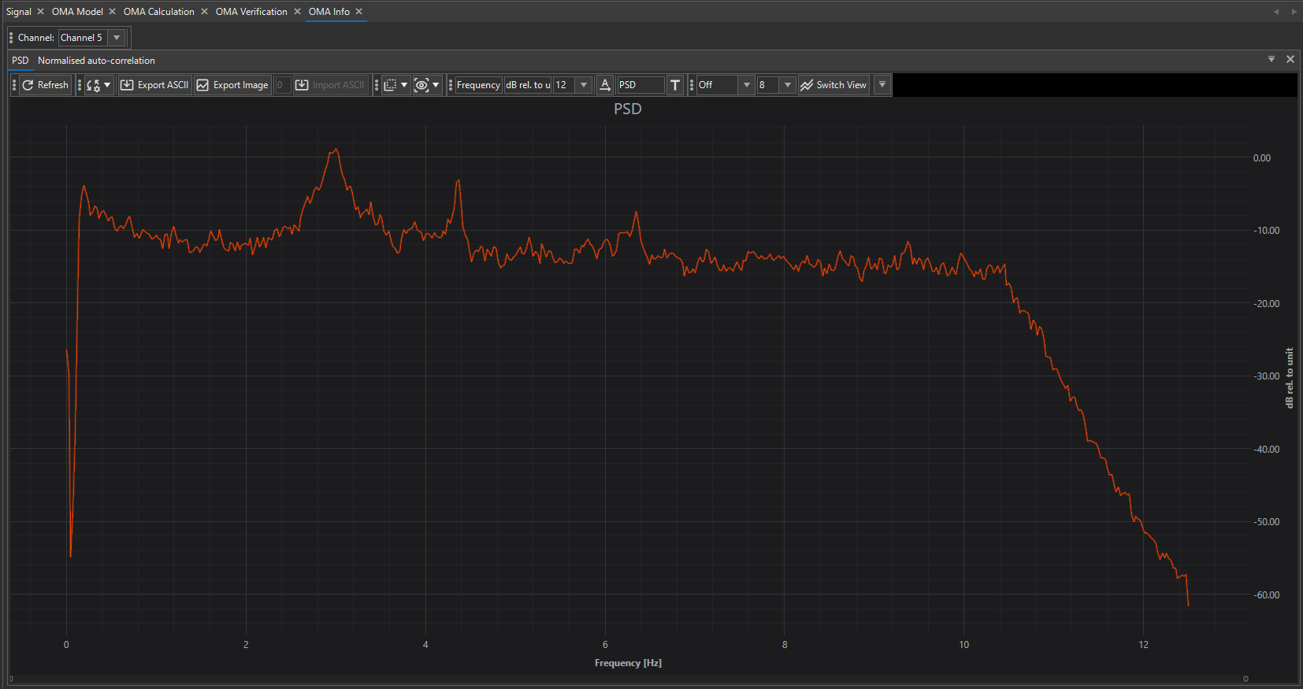
Figure 31 – Observer OMA Analysis – PSD

Probability Density

Probability Density Function (PDF) Tab (Figure 32) in the OMA environment helps evaluate the statistical properties of the raw vibration data before or alongside modal analysis.

Purpose and Context:

- The Probability Density Function (PDF) describes how the amplitude of the measured vibration data is statistically distributed.
- In structural dynamics under ambient excitation, the data is often assumed to be a Gaussian (normal) random process.
- The PDF allows engineers to check this assumption and detect whether the excitation or measurement contains anomalies, nonlinearities, or non-Gaussian behavior.

Channel Selector:

- The combo box (top-left) lets users choose which channel’s PDF to display (Channel 13 in your screenshot).
- Each sensor may show slightly different distribution shapes depending on local vibration amplification, sensor type, and noise level.
- By comparing across channels, users can identify if one sensor deviates significantly, which may indicate instrumentation issues or local nonlinear effects.

Interpretation of the Graph:

- X-axis (Normalized data): The measured acceleration/velocity/displacement samples normalized by their standard deviation (so most data lies near zero).
- Y-axis (Probability): The likelihood of occurrence of each normalized amplitude value.
Key features:
- Bell-Shaped Curve: A symmetric distribution centered around zero is expected if the excitation is Gaussian (wind, traffic, microtremors).
- Spread: The width of the distribution reflects the variance (energy content) of the signal.
- Deviations:
  - Heavy tails (flatter curve): indicate impulsive events or non-Gaussian noise.
  - Skewness (asymmetry): may suggest bias in sensors, drift, or directional excitation.
  - Sharp peaks: can point to low-noise conditions or filtered signals.

The Probability Density Function Tab provides a statistical view of each channel’s data, showing how vibration amplitudes are distributed. In most cases, users should expect a bell-shaped (Gaussian) distribution centered at zero, which validates the assumptions behind OMA methods. Deviations from this shape can signal noise issues, sensor faults, or structural nonlinearities. By checking PDFs channel by channel, users ensure that the input data is suitable for reliable modal analysis.

Why It Matters in OMA:

- Model Assumptions: Many OMA methods (FDD, SSI, pLSCF) assume linear systems under Gaussian white noise excitation. The PDF check ensures this assumption is reasonable.
- Data Quality Control: If one channel shows a strongly non-Gaussian PDF (skewed or heavy-tailed), that dataset may bias modal estimation.
- Structural Diagnostics: Sometimes deviations from Gaussian behavior are not noise but actual structural nonlinearities (e.g., contact, cracks, loosened bolts).
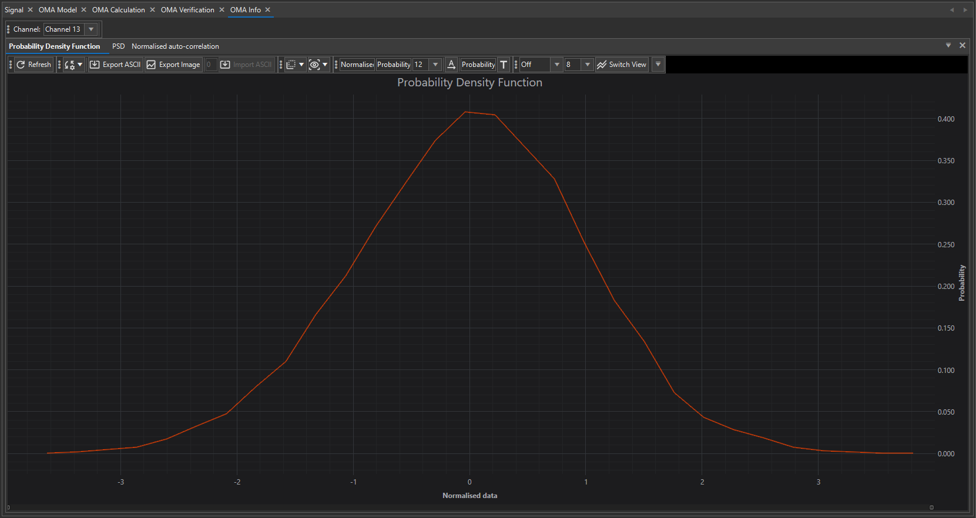
Figure 32 – Observer OMA Analysis – Probability Density

Normal Probability

Normal Probability Plot (NPP) tab (Figure 33), which is closely related to the Probability Density Function (PDF) gives an even more precise diagnostic view.

Purpose and Role in OMA:

- The Normal Probability Plot (NPP) is a graphical test for normality of the measured vibration data.
- It compares the distribution of the measured samples against a theoretical Gaussian distribution.
- In OMA, where methods (FDD, SSI, pLSCF) assume Gaussian white noise excitation, this plot is a direct validation tool: it checks if the data follows a straight-line Gaussian pattern.

Channel Selector:

- The Channel dropdown (top-left) allows selection of which sensor channel’s NPP is displayed (Channel 8 in your screenshot).
- Each sensor may deviate differently due to local conditions, so checking multiple channels ensures global data quality.

Interpretation of the Plot:

- X-axis (Normalized Data): Actual measured vibration amplitudes, normalized to mean and standard deviation.
- Y-axis (Gaussian scale): Expected quantiles of a perfect Gaussian distribution.
- Red/Orange Points/Line: The actual data distribution plotted against the theoretical line.
How to interpret:
- Straight Line Alignment: If the data lies close to a straight diagonal line, the distribution is Gaussian → assumption valid.
- Curved Tails: Deviations at the extremes (ends bending up/down) indicate heavy tails (outliers, impulsive events) or truncated distributions.
- Asymmetry: If one side deviates more than the other, the data is skewed → potential bias or drift in sensors.
- Scatter: Wide scatter indicates non-Gaussian noise or nonlinear effects in the structure.

The Normal Probability Plot Tab provides a statistical validation of the Gaussian assumption in OMA. If the data follows a straight line, modal analysis assumptions are valid, ensuring accurate results. Deviations highlight noise issues, skewness, or nonlinear structural effects. Users should check this plot for each channel to confirm the reliability of input data before applying advanced OMA methods.

Why It Matters in OMA:

- Model Validity: Confirms Gaussian excitation assumption before applying OMA.
- Error Prevention: Identifies channels with non-Gaussian behavior that may bias modal results.
- Structural Diagnostics: Non-Gaussian responses may indicate nonlinear effects (joints opening/closing, cracking, impacts).

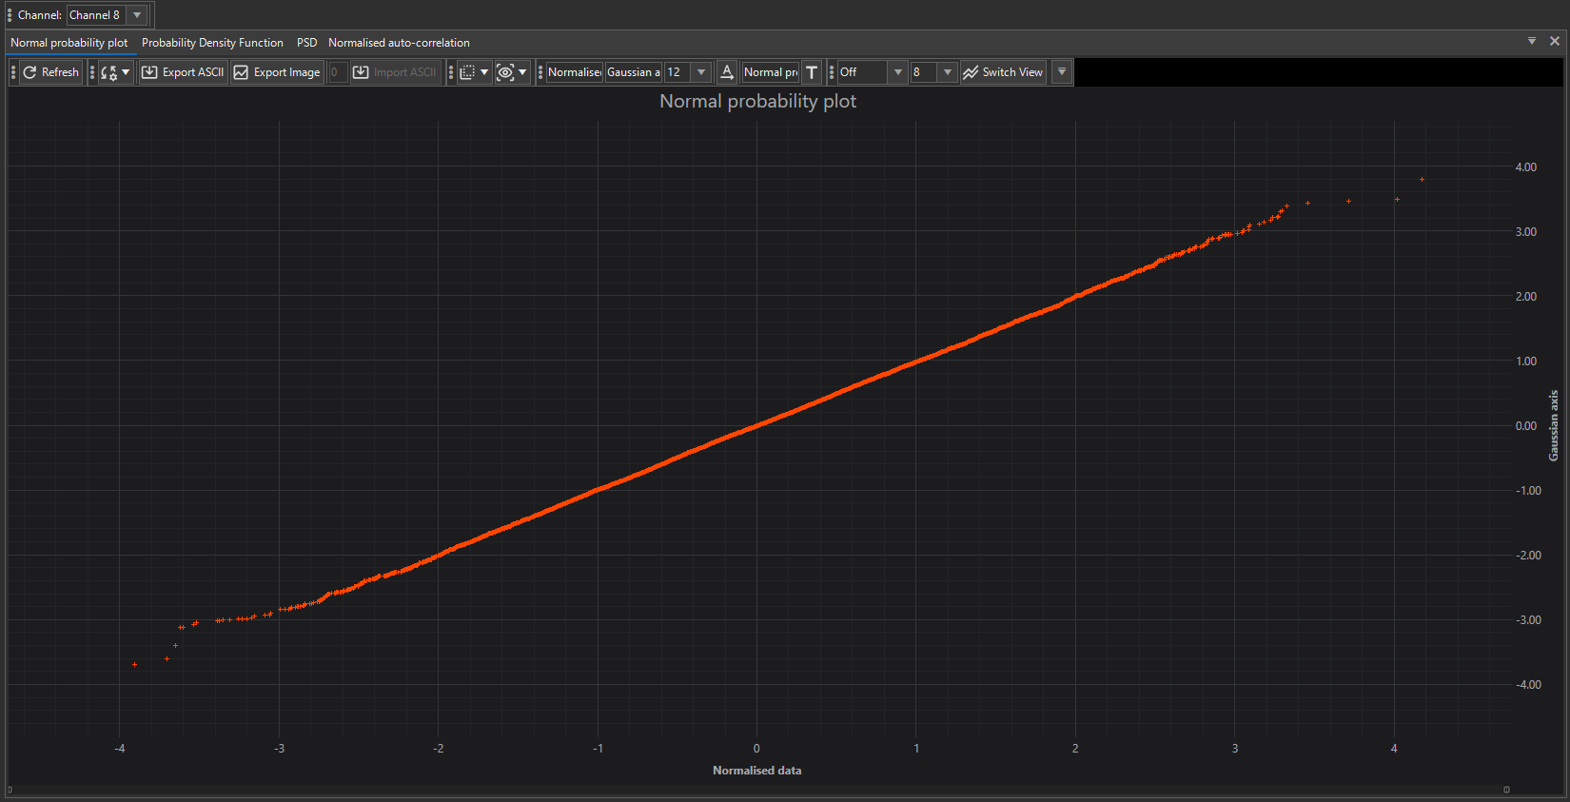

Figure 33 – Observer OMA Analysis – Normal Probability

STFT Magnitude

STFT Magnitude plot (Short-Time Fourier Transform) (Figure 34), which is a time–frequency representation of your vibration data. This tool is crucial for detecting non-stationary behavior, i.e., when vibration characteristics change over time.

PURPOSE:

- The STFT Magnitude plot decomposes the vibration signal into both time and frequency, unlike PSD (frequency only) or autocorrelation (time only).
- This allows users to detect transient events, time-varying modal behavior, or external disturbances that would otherwise be hidden in stationary analysis.

AXES:

- X-axis (horizontal, Time [sec]): Time progression of the measurement (here ~600 seconds).
- Y-axis (vertical, Frequency [Hz]): Frequency range of the analyzed channel (0–12 Hz shown).
- Z-axis (color scale, Magnitude): Signal energy/intensity at each frequency and time window.

COLORS (MAGNITUDE INTENSITY):

- Blue: Low amplitude / background noise (baseline vibration).
- Green: Medium energy content, typically operational vibration energy.
- Yellow–Red: High-energy regions, corresponding to dominant modal responses or transient events (e.g., resonance excitation, passing vehicles, sudden wind gusts).
- The color scale thus acts like a heatmap, where warm colors highlight active modes or transient disturbances.

HOW TO INTERPRET:

- Horizontal Bands (constant frequency over time):
  - Indicate structural modes (resonant frequencies) that remain stable throughout the measurement.
  - Example: A green/yellow band at ~2 Hz shows a persistent vibration mode.
- Vertical Stripes (wide-band events in short time):
  - Indicate transient impacts or impulsive loads (earthquakes, sudden shocks, traffic loads).
  - These appear as short-lived, wide-frequency flashes.
- Drift or Shift in Bands:
  - If a frequency band slowly shifts upward or downward, it may indicate stiffness changes, temperature effects, or nonlinear behavior.
- Noise vs. Modes:
  - Blue background = random operational noise.
  - Distinct green/yellow bands = structural modes.
  - Helps distinguish true modal responses from random fluctuations.

The STFT Magnitude Tab in Observer provides a time–frequency heatmap of vibration data. Blue areas show low energy, green/yellow highlight modal responses, and red marks strong excitations. Stable horizontal bands correspond to structural modes, while vertical streaks indicate transient events. This plot complements PSD by revealing when specific frequencies are active, making it a valuable diagnostic for non-stationary structural monitoring.

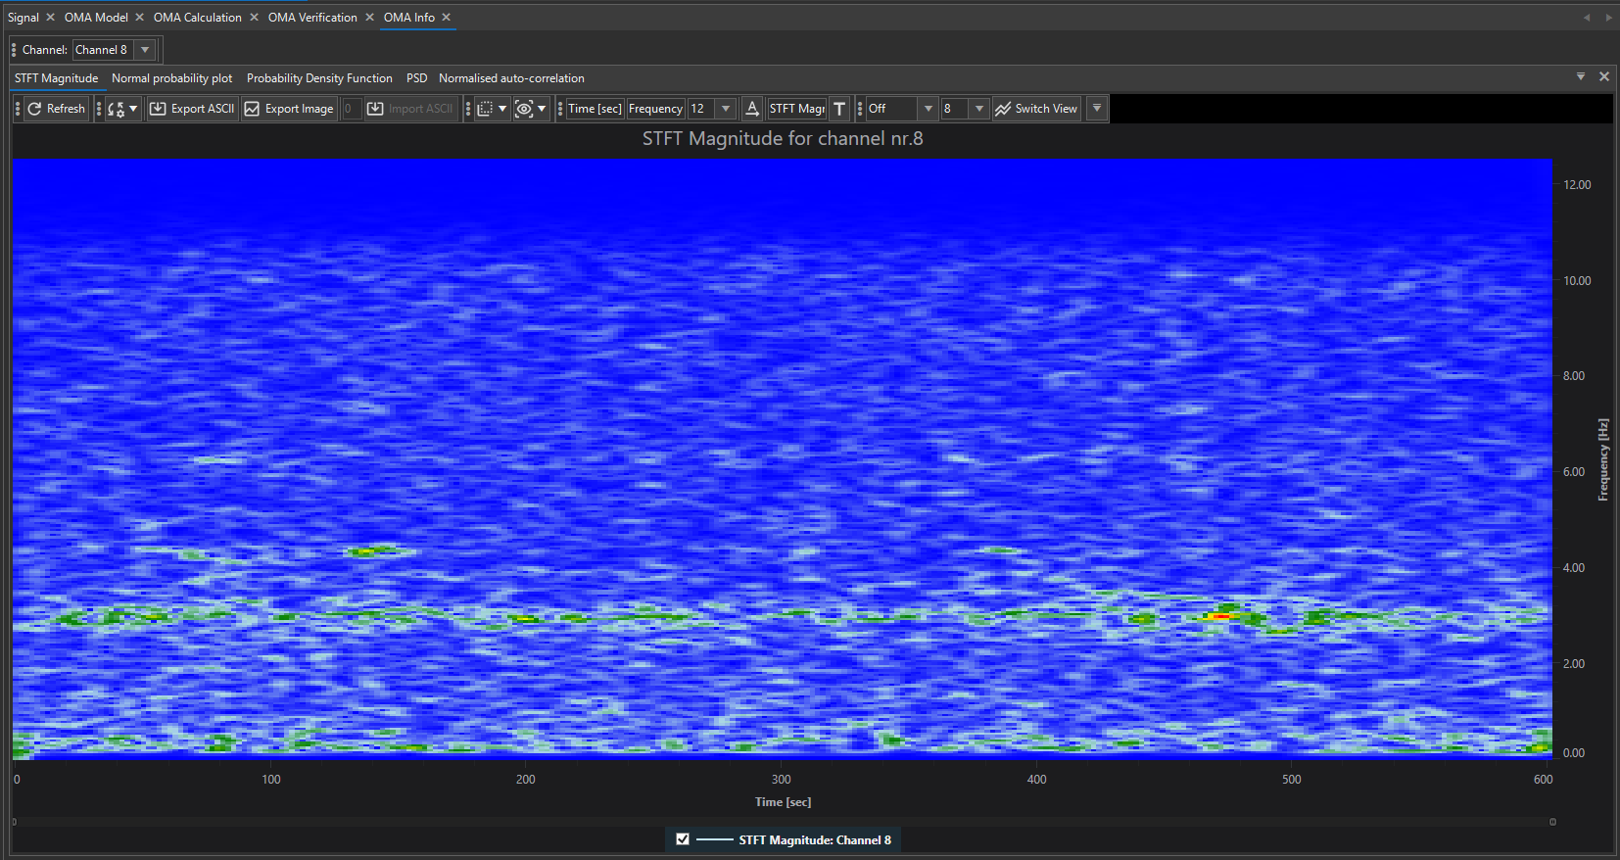
Figure 34 – Observer OMA Analysis – STFT Magnitude

Voyager Export

The Voyager Export feature in Observer is used to prepare a dedicated .ovy file that can be imported directly into the Voyager platform. This workflow bridges the gap between initial offline OMA analysis (Observer) and continuous online OMA monitoring (Voyager).

It is typically used right after the installation of a structural health monitoring (SHM) system on a bridge, building, or other infrastructure. The procedure ensures that the system is initialized with a validated modal baseline before automatic monitoring begins.

WORKFLOW:

- Initial OMA in Observer
  - Perform a dedicated measurement (e.g., a few hours of ambient vibration recording).
  - Run OMA analyses in Observer using supported methods (FDD, EFDD, FSDD).
  - Validate modal frequencies, damping ratios, and mode shapes through Verification (MAC, cross-method checks).
- Export to Voyager
  - Once the user is satisfied with the extracted modal parameters, select Voyager Export.
  - Observer generates an .ovy file containing:
    - The validated modal parameters (frequencies, damping, mode shapes).
    - The geometry mapping of sensors.
    - The OMA methods used and their results.
- Import in Voyager
  - The .ovy file is imported into Voyager’s OMA module.
  - Voyager uses this file as a reference baseline for all subsequent online OMA computations.

CONTINUOUS OMA MONITORING IN VOYAGER:

- OMA Analysis in Real Time:
Voyager automatically performs OMA every 10 minutes on the latest 10-minute data block streamed from the SHM system.
- OMA Method Selection:
Users can choose which OMA methods to run online (currently FDD, EFDD, FSDD are supported).
Multiple methods can run in parallel for redundancy and cross-validation.
- MAC Verification:
  - For each new OMA result, Voyager computes the Modal Assurance Criterion (MAC) against the imported reference modes from Observer.
  - The MAC value indicates how similar the newly estimated mode shapes are compared to the baseline.
- OMA Trigger:
  - Users can configure a trigger threshold (e.g., MAC < 95%) to detect significant deviations.
  - When triggered, Voyager notifies the user (e.g., via dashboard alerts, emails, or reports).
  - Such deviations may indicate structural changes, stiffness degradation, or evolving damage.

ADVANTAGES OF AUTOMATIC OMA IN VOYAGER:

- Baseline Integrity: Ensures that the online OMA starts from a rigorously validated offline reference.
- Seamless Transition: Moves from manual expert-driven analysis (Observer) to automated monitoring (Voyager).
- Continuous Health Tracking: Provides 24/7 modal tracking without user intervention.
- Early Warning System: OMA trigger mechanism ensures dynamic changes are detected quickly.

The Voyager Export function transforms Observer results into an .ovy baseline file for continuous online OMA monitoring in Voyager. After the initial setup and validation in Observer, Voyager’s AI-driven agent takes over, automatically analyzing real-time data (every 10 minutes), comparing results with the baseline using MAC, and alerting users if deviations fall below a set threshold. This workflow ensures both accuracy (via Observer’s manual validation) and efficiency (via Voyager’s automated monitoring).

Generate Report (automated report generation)

When you click Generate Report (from the Analysis Tab or OMA Tabs), the Report Generator Settings Window opens (Figure 35). Here you can customize what will be included in the final PDF report. Observer automatically preselects all functions and results that were actually used during your session — unused tools are left disabled to keep the report clean.

SECTIONS IN THE REPORT GENERATOR:

- Report Settings
  - Report File – Path and filename for the generated PDF.
  - Open Report – If enabled, the PDF opens automatically once generated.
  - Images per row – Controls layout (single image per row, two images per row).
  - Chart Properties – Exports graphs with their color scales, legends, and formatting.
- Signal Information
  - Signal Information – General metadata about the imported file (format, length, sampling rate, channels).
  - Signal Statistics – Min, max, RMS values, duration, and other key statistics.
- Analysis Information
Includes outputs from basic signal processing functions:
  - Signal – Time history graphs.
  - Frequency – FFT-based spectral results.
  - Integration – Acceleration → velocity/displacement plots.
  - Damping – Response spectrum damping results.
  - Response Spectrum – Earthquake engineering–style response analysis.
  - Auto Correlation – Time-domain signal correlation functions.
  - Cross Correlation – Relationship between pairs of channels.
- OMA General Information
  - OMA Settings Parameters – Lists the OMA configuration parameters (segmentation, filters, MAC settings).
  - OMA Model – Geometry with points, lines, surfaces, and sensor assignments.
  - OMA Normalized Auto-Correlation – Correlation-based diagnostics for OMA input validation.
  - OMA PSD / Probability Density / Normal Probability / STFT Magnitude – All preprocessing diagnostics used in OMA preparation.
- OMA Methods Information
Exports the results of each OMA method applied:
  - Frequency Analyzer – Initial SVD or stabilization charts.
  - FDD / EFDD / FSDD Calculations – Frequency-domain results with peaks, damping (if available), and mode shapes.
  - SSI-Data / SSI-Cov Calculations – Time-domain stabilization charts and pole clustering outputs.
  - pLSCF Calculations – High-resolution frequency-domain curve-fitting results.
- OMA MAC Matrix Information
  - Exports MAC verification results between methods (e.g., FDD vs EFDD, EFDD vs SSI-Cov, etc.).
  - This section highlights the consistency of mode shapes extracted with different techniques.
- Report Information
  - Title – Custom title for the PDF report (default: Observer – Analysis Report).
  - Company – User’s company name.
  - Logo – Company/brand logo (autoscaled to 130 px height).
  - Address fields – Company address/contact information for inclusion in the report header.

REPORT GENERATION:

- When you press Generate, Observer compiles:
  - All selected graphs (time series, FFTs, PSDs, stabilization charts, MAC matrices, etc.),
  - All mode shape animations as static frames,
  - All tables with extracted modal parameters.
- For a complete project, the report can easily exceed 100 pages (depending on number of channels, OMA methods, and selected diagnostics).
- This comprehensive output ensures traceability (every step of the analysis is recorded) and provides a ready-to-share formal deliverable for clients or project documentation.

The Report Generator is the final step of the Observer workflow, providing a fully customizable PDF export that documents everything from raw signals to advanced OMA results. It automatically adapts to what the user performed, ensuring the report is complete, accurate, and formatted for professional use in SHM and modal analysis projects.
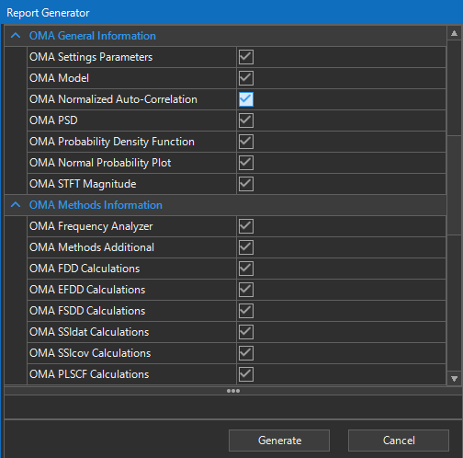
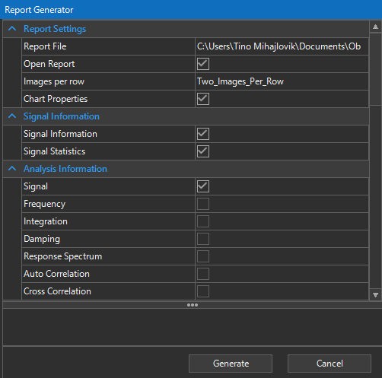

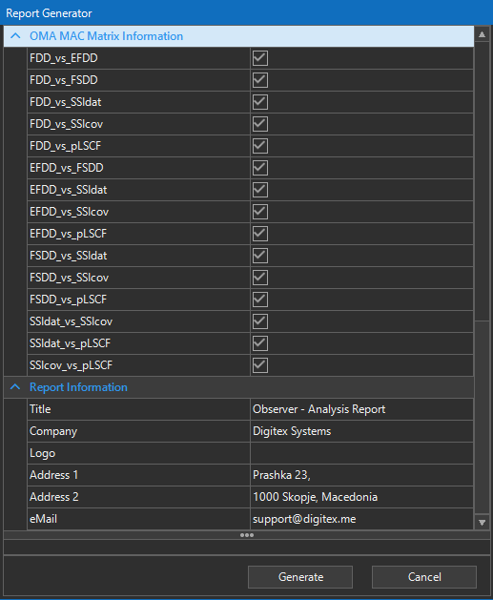
Figure 35 – Observer Analysis – Report Generation

4. Configuration

The Configuration section in Observer, accessible through the View Tab, allows users to adjust the environment and customize the behavior of the application according to their workflow. It provides the flexibility to simplify the workspace by showing or hiding panels such as Properties, Information, and Statistics, while also giving access to a wide range of application settings. Within these settings, users can modify general preferences like interface theme, startup options, and time-out parameters, as well as configure chart appearance, default signal processing methods, and analysis behavior. Dedicated options are available for Operational Modal Analysis, ensuring that default methods, filters, and geometry preferences are aligned with the user’s analysis requirements. Additional settings cover layout and panel visibility, along with reporting preferences such as document format, included content, and branding. Overall, the Configuration section makes it possible to adapt Observer to both simple monitoring tasks and advanced research scenarios, ensuring that the interface and results are always optimized for the specific project at hand.

View Tab (Customization)
The View Tab in Observer (Figure 36) provides users with tools to customize the working environment, making it easier to adapt the interface to specific workflows and preferences. This tab is mainly about customization and control of the visible panels, settings, and application behavior.

Through this section, users can:

- Show or hide panels (Properties, Information, Statistics) to declutter the workspace and focus on relevant data.
- Access the Application Settings, where a wide range of customization options are available, grouped into categories such as:
  - General – global settings including interface themes, startup behavior, menu layout, and time-out parameters.
  - Charts – controls for graph visualization and display properties.
  - Signal Processing – default filters, detrending, and preprocessing methods for loaded signals.
  - Analysis – fine-tuning of computational options and result handling.
  - Operational Modal Analysis (OMA) – default preferences for OMA workflows, such as filter parameters, enabled methods, and geometry settings.
  - View – management of panel visibility and workspace layout.
  - Reporting – options for report customization, including logos, layout, and which analysis sections are included.

By using these tools, Observer can be tailored to different project requirements: from lightweight configurations for routine monitoring to detailed, resource-intensive setups for advanced research campaigns.

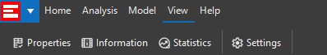

Figure 36 – Observer – View TAB

Show/Hide Panels (Properties, Information, Statistics)

The Show/Hide Panels functionality in Observer provides quick control over the visibility of three key interface panels: Properties, Information, and Statistics. These panels are essential for managing and interpreting data but can be hidden to simplify the workspace when not needed. These three panels are already described in Signal & Graphs->Signal Panels and Tabs

The Properties panel is used for adjusting parameters and settings associated with the currently active object, such as signals, geometry points, or OMA configurations. It acts as the main control hub where the user can fine-tune values, apply filters, or enable methods.

The Information panel displays contextual details about the current dataset or analysis step, ensuring the user always has access to relevant metadata, configuration notes, or descriptive information without switching windows.

The Statistics panel provides quick access to numerical summaries and performance indicators of the processed signals, such as mean, standard deviation, RMS values, or other calculated metrics.

Together, these panels form the backbone of the analytical workflow, and the ability to show or hide them at any time allows the user to tailor the workspace. For routine monitoring, panels can be hidden for a clean and focused view, while for in-depth analysis, all three can be kept visible to provide maximum insight into both raw data and analysis results.

Settings (Application Settings)

The Settings (Application Settings) window (Figure 37) in Observer provides a centralized environment where all configuration and customization options are grouped together. It governs how the software looks, behaves, and processes data, giving the user full control over interface appearance, chart visualization, signal processing defaults, analysis parameters, OMA settings, view options, and reporting preferences.

By organizing these controls into categories on the left panel (General, Charts, Signal Processing, Analysis, Operational Modal Analysis, View, and Reporting), Observer keeps the workflow structured and intuitive. This modular layout allows the user to quickly navigate to the area they want to adjust while ensuring that even advanced configuration remains clear and accessible.

At the bottom of the window, three action buttons provide direct control of the applied changes:
- Restore Defaults – resets all settings to their original factory values, useful if the user wants to undo customizations or return to a clean baseline.
- Save – confirms and applies the changes made in the current settings window, making them active for future sessions.
- Cancel – closes the window without applying any changes, preserving the previous configuration.

Together, the categorized settings and these control buttons ensure that Observer can be tailored to fit both quick field deployments and in-depth analysis campaigns, while always allowing the user to revert, confirm, or discard modifications with a single click.
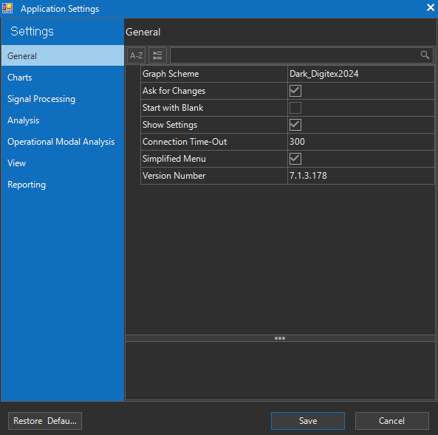

Figure 37 – Observer View TAB - Settings

General

The General panel (Figure 37) contains options that define the overall behavior and appearance of Observer, focusing on themes, startup workflow, and user interaction. These settings affect how the application looks and how it responds to user input globally across all modules.
Here’s a breakdown of each parameter:

- Graph Scheme – selects the active visual theme for charts and plots (e.g., Dark_Digitex2024). This controls background colors, grid lines, and curve styling, ensuring consistent readability in different environments (field work, office presentations, etc.).
- Ask for Changes – when enabled, Observer prompts the user to confirm changes before they are applied. This prevents accidental overwriting of analysis or configuration settings.
- Start with Blank – if checked, Observer will open with an empty workspace instead of loading the last project or default templates. Useful for users who prefer starting fresh each session.
- Show Settings – toggles whether the settings panel itself is automatically displayed on startup. Keeping it enabled is helpful for quick access to configurations, while disabling ensures a cleaner workspace.
- Connection Time-Out – defines the maximum time (in seconds) Observer waits for a connection to external sources (e.g., hardware units, databases, or services) before aborting the attempt. For field deployments, increasing this value may help in networks with unstable latency.
- Simplified Menu – enables a streamlined ribbon/menu layout, hiding advanced functions for a cleaner interface. Recommended for basic users or initial learning, while advanced users may prefer the full menu.
- Version Number – displays the currently installed version of Observer. This is useful for troubleshooting, support requests, and ensuring compatibility across different deployments.

Charts

This page (Figure 38) allows you to configure how plots and diagrams are displayed throughout Observer, ensuring that the visual environment is tailored for clarity, usability, and consistency.

CHARTS SETTINGS:

- Zoom X-axis - Enables zooming along the X-axis (time or frequency, depending on context). This makes it possible to focus on specific sections of a signal or analysis without affecting the Y-axis scaling.
- Display Cursor - Toggles the visibility of the cursor tool. When enabled, you can hover or click inside the chart to display exact numerical values of the plotted data (time, frequency, amplitude, etc.).
- Display Scrollbar - Adds a horizontal scrollbar beneath the chart. This is especially useful when working with long time-series signals or zoomed-in plots, allowing navigation without losing the zoom level.
- Display Slice - When active, this highlights a vertical slice of the chart across all channels/curves. It is used for synchronized inspection of values at a particular time or frequency.
- Legend Position - Defines where the chart legend will appear. Options include Off, Top, Bottom, Left, Right. This controls how curve labels (e.g., “Channel 1”, “Singular Value Curve-1”) are displayed.
- Maximum Charts - Sets the maximum number of chart windows that can be opened simultaneously within Observer. Default is 8, but this can be lowered (for performance) or raised (for large multi-channel work).
- Chart Colors - Opens palettes for customizing the visual appearance of plots.
  - Light Background Palette: Color scheme used when the application runs in light mode.
  - Dark Background Palette: Color scheme used when dark themes are active (e.g., Dark_Digitex2024).
Each palette is a collection where you can define colors for signals, gridlines, background, and highlighted elements.

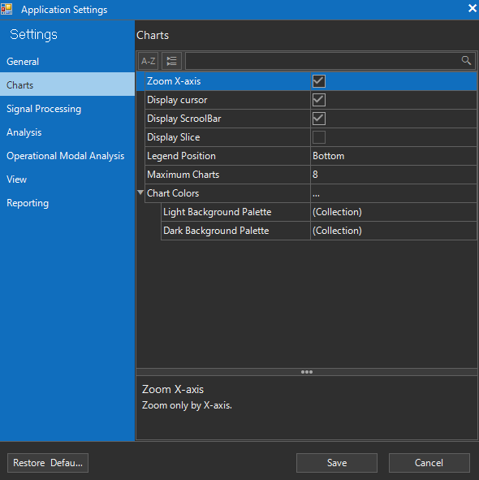

Figure 38 – Observer View TAB - Charts

Signal Processing

This page (Figure 39) provides options for configuring default Observer settings related to preprocessing raw data before analysis. These settings define the default signal conditioning steps (filtering, detrending, decimation, etc.) and frequency-domain transformations (FFT parameters).

SIGNAL SETTINGS:

- Detrending (Default: Off) – Controls whether constant or linear trends are removed. Default is Off so raw data is preserved, but users can enable detrending when dealing with baseline drift.
- Decimation (Default: Off) – No down-sampling is applied by default. If signals are oversampled, users can reduce sampling rates here.
- Filter Type (Default: BandPass) – By default, a BandPass filter is enabled to isolate the relevant frequency range for structural monitoring.
- Filter Method (Default: Off) – Filtering is disabled until explicitly chosen by the user (IIR, FIR, etc.).
- Filter Order (Default: Eight) – Default steepness is set to 8th order, providing strong filtering for structural signals.
- Low Cut-Off (Default: 0.15 Hz) – Filters out very low drift and offsets.
- High Cut-Off (Default: 40 Hz) – Ensures high-frequency noise above 40 Hz is excluded.
- Show Legend (Default: On) – Preprocessing parameters are displayed on the chart legend by default.
- Show Menu (Default: On) – Context menus are enabled, allowing users to quickly toggle preprocessing from within charts.

FREQUENCY SETTINGS:

- FFT Window (Default: Hanning) – Applies a Hanning window to reduce spectral leakage.
- FFT Method (Default: FFT) – Uses standard Fast Fourier Transform by default.
- FFT Start Frequency (Default: 0 Hz) – Analysis starts from 0 Hz.
- FFT End Frequency (Default: 100 Hz) – Frequency analysis is capped at 100 Hz.
- Calc on New (Default: Off) – FFT is not recalculated automatically on new data unless enabled.
- Show Legend (Default: Off) – Frequency parameters are hidden by default to keep charts uncluttered.
- Show Menu (Default: On) – Frequency-domain context menus are enabled by default.
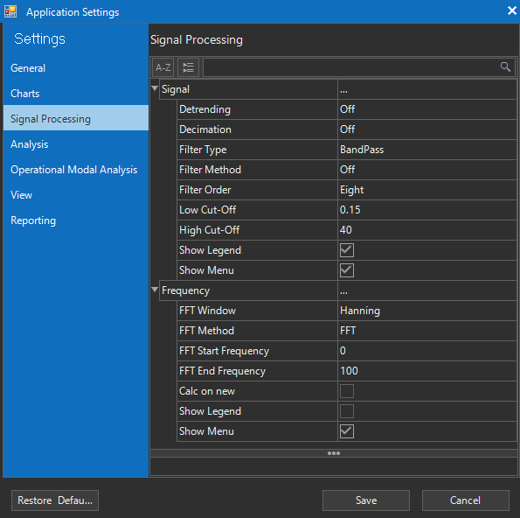

Figure 39 – Observer View TAB – Signal Processing

Analysis
This page (Figure 40) for configuring default Observer settings for different analytical computations such as integration of acceleration signals, response spectrum generation, autocorrelation, and cross-correlation. These tools allow users to extract deeper structural insights from raw time-history data.
As with previous tabs, these parameters can be saved as presets, ensuring that your chosen analysis workflow is applied automatically on every startup.

INTEGRATION:

Integration options convert acceleration data into velocity or displacement.
- Integration Filter (Default: On) – Activates a filter to suppress low-frequency drift typically amplified during integration.
- Show Legend (Default: Off) – Displays integration settings in chart legends when enabled.
- Show Menu (Default: On) – Enables right-click access to integration options inside chart windows.

RS (RESPONSE SPECTRUM):

The Response Spectrum is a fundamental tool in seismic and structural analysis, representing maximum response of a single-degree-of-freedom system to a given excitation.
- Use Filter (Default: On) – Applies filtering before computing the spectrum, ensuring numerical stability.
- Damping (Default: 2%) – Sets the modal damping ratio used in the computation. Typical structural damping values are 2–5%.
- Time Increment (Default: 0.1 s) – Step size used for the numerical integration. Smaller increments improve accuracy but increase computation time.
- End Frequency (Default: 7 Hz) – Maximum frequency for spectrum calculation. Frequencies beyond this are ignored.
- Method – Numerical integration scheme. Newmark Average is a stable, widely used method in structural dynamics. Can not be changed.
- Pseudo (Default: Off) – When enabled, computes pseudo spectrum values (e.g., pseudo-acceleration).
- Show Legend (Default: Off) – Adds spectrum computation parameters to chart legends.
- Show Menu (Default: On) – Enables quick toggling of spectrum settings via context menu.

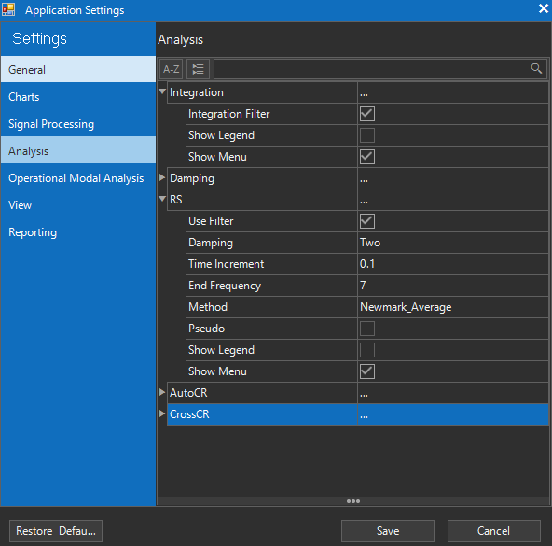

Figure 40 – Observer View TAB – Analysis

Operational Modal Analysis

This page (Figure 41) configures all options related to Operational Modal Analysis, the process of extracting modal parameters (frequencies, damping, and mode shapes) from ambient vibration data without requiring controlled excitation.
OMA in Observer is organized into several expandable panels, each covering a key aspect of the workflow:

OMA GENERAL:
Defines global parameters that apply to all OMA computations.
- Default Settings: Sampling rate handling, data segment length, overlap percentage.
- Purpose: Ensures consistent preprocessing and segmentation across methods.
- Presets: Can be stored so that every analysis starts with the same global configuration.

OMA ANALYSIS:
Controls the selection of OMA algorithms and their parameters.
- Available Methods: Frequency Domain Decomposition (FDD, EFDD, FSDD), Stochastic Subspace Identification (SSI-Cov, SSI-Dat), Polyreference Least Squares Complex Frequency (PLSCF).
- Settings: Number of singular values to retain, stabilization diagram parameters, model order ranges.
- Presets: Save your preferred analysis method (e.g., always start with EFDD or SSI-Dat).

OMA GEOMETRY:
Defines the geometry of the structure being analyzed.
- Channel-to-DOF Mapping: Assigns sensors to physical coordinates (X, Y, Z) and measurement points.
- Purpose: Ensures that identified mode shapes can be correctly animated and compared.
- Presets: Geometry can be stored and reused for recurring measurement campaigns.

OMA METHODS:
Configures the detailed parameters of each chosen method.
- FDD/EFDD: Singular value decomposition settings, peak-picking tolerances.
- SSI-Cov / SSI-Dat: Covariance block size, model order range, stabilization thresholds.
- PLSCF: Polynomial order, refinement options.
- Purpose: Fine-tunes accuracy and stability of modal estimates.

OMA FILTER:
Applies additional filtering specifically for OMA computations.
- Band Selection: Frequency range of interest (e.g., 0.1–40 Hz for civil structures).
- Filter Type: Low-pass, band-pass, etc., tailored for OMA signals.
- Purpose: Reduces irrelevant frequency content, improves mode identification clarity.

Just like with the other settings, all OMA parameters can be saved as presets. Once configured, Observer will load the last-used OMA configuration at startup, ensuring consistency in repeated analyses.

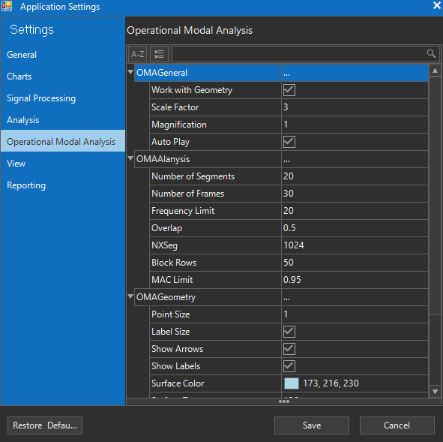

Figure 41 – Observer View TAB – OMA Settings

View

This page (Figure 42) controls whether changes made in various analysis modules are applied live to the charts and visualizations. By enabling or disabling live updates, users can balance between responsiveness and performance depending on their system resources and project size. All options can be stored as presets, ensuring Observer remembers your preferred visualization mode at every startup.

AVAILABLE OPTIONS:
- Signal Live Changes (Default: On)
Updates signal plots immediately when preprocessing parameters (detrending, filtering, decimation) are modified.
- Frequency Live Changes (Default: On)
Recomputes and refreshes frequency-domain results (FFT, PSD) automatically whenever related settings are updated.
- Integration Live Changes (Default: On)
Applies integration filters and updates velocity/displacement plots in real time as parameters are changed.
- Response Live Changes (Default: On)
Regenerates response spectrum charts immediately when damping ratios, time increments, or integration methods are modified.
- Damping Live Changes (Default: On)
Ensures damping-related parameters are reflected instantly in all associated visualizations (when damping functionality is enabled).
- OMA Live Changes (Default: On)
Applies changes to OMA methods, filters, or geometry instantly, so stabilization diagrams and singular value plots update without manual recalculation.
- Auto Correlation Live (Default: On)
Updates autocorrelation plots in real time whenever signal segments or preprocessing settings are modified.
- Cross Correlation Live (Default: On)
Recomputes cross-correlation functions on-the-fly when channels or preprocessing filters are adjusted.
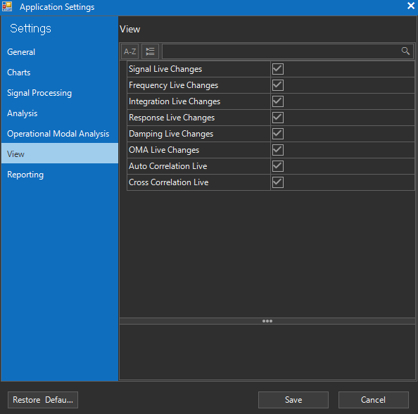

Figure 42 – Observer View TAB – View Settings

Reporting

This page (Figure 43) allows you to configure the default layout and branding information used when Observer generates PDF analysis reports. These details ensure that exported results carry consistent corporate identity and professional formatting.
All fields can be customized and saved as presets, so every generated report includes the same header, footer, and metadata unless specifically changed for a project.

AVAILABLE OPTIONS:

- Logo
  - Lets you upload or select a company logo to appear in the header of every report.
  - Default: Blank (must be set manually).
- Title (Default: “Observer – Analysis Report”)
  - The main title printed on generated PDF reports.
  - Can be customized per company or project.
- Company (Default: Digitex Systems)
  - The organization name included in report metadata and the title block.
- Address 1 / Address 2 (Default: Prashka 23, 1000 Skopje, Macedonia)
  - Contact information printed in the report header or footer.
  - Typically includes street, city, postal code, and country.
- Email (Default: support@digitex.me)
  - A support or contact email shown on the generated report.
  - Ensures recipients know where to direct follow-up questions.
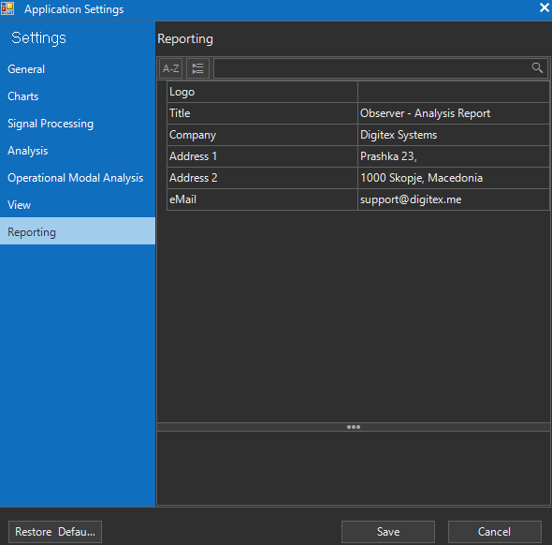

Figure 43 – Observer View TAB – Report Settings

5. Installation, Help, Troubleshooting & Appendices

Observer Setup Installation

Observer Data Analysis Suite can be installed via standard InstallShield Installation setup. After downloading the official installation package, double-click the setup executable to begin. The InstallShield Wizard will guide you through the process:

Step 1 – Welcome Screen (Figure 44)

- The wizard greets you with a Welcome window confirming that the setup will install Digitex Observer Data Analysis Suite.
- Click Next to proceed.

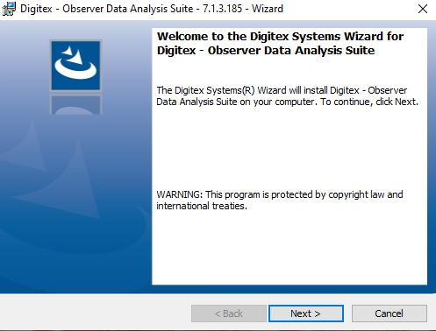
Figure 44 – Observer Setup Welcome Screen
Step 2 – License Agreement (Figure 45).
- The End User License Agreement (EULA) is presented
- Carefully review the terms.
- To continue, select I accept the terms in the license agreement, then click Next.

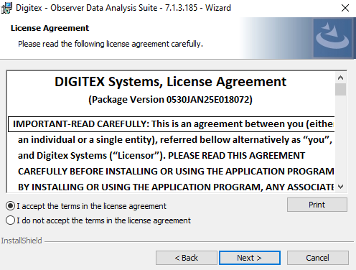
Figure 45 – Observer EULA Screen

Step 3 – Customer Information (Figure 46)
- Enter your User Name and Organization.
- These fields are used internally by Windows for program registration.
- Default values may be prefilled as Digitex Systems.
- Click Next to continue.
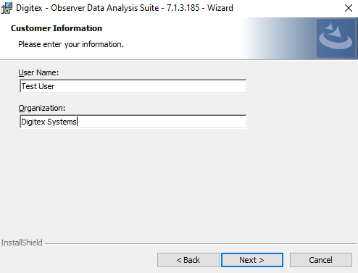

Figure 46 – Observer Customer Information
Step 4 – Setup Type (Figure 47)
- Choose the installation type:
  - Complete (Recommended): Installs all program features, including documentation and examples.
  - Custom: Allows advanced users to select components and installation folder manually.
- Unless specific customization is required, select Complete.
- Click Next.
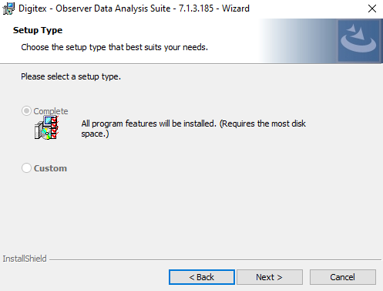

Figure 47 – Observer Setup Type
Step 5 – Ready to Install (Figure 48)
- The wizard now displays a summary of your chosen options.
- Review the information.
- Click Install to begin copying files to your system.
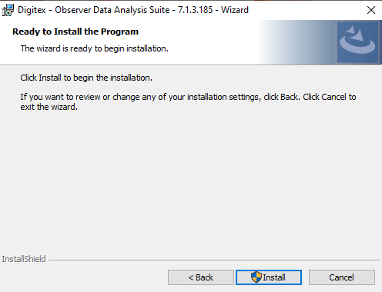

Figure 48 – Observer Ready to Install

Step 6 – Installation Progress (Figure 49)
- A progress bar shows the status as the program files are copied, fonts registered, and components validated.
- This process may take a few minutes depending on your system speed.

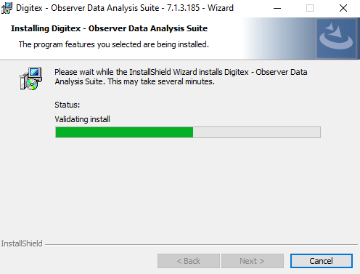

Figure 49 – Observer Setup Progress

Step 7 – Installation Complete (Figure 50)
- Once finished, a Completion window confirms that Digitex Observer Data Analysis Suite has been successfully installed.
- Click Finish to exit the wizard.
- A desktop shortcut and Start Menu entry are automatically created for quick access.
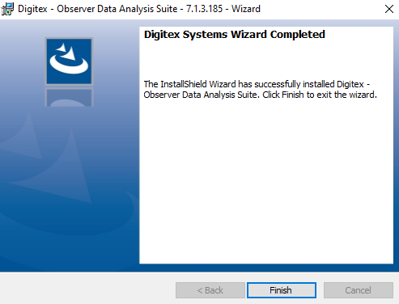

Figure 50 – Observer Setup Finish

Observer Registering License

When you launch Digitex Observer Data Analysis Suite for the first time, the software will prompt you to activate your license. The licensing dialog ensures that the application is securely linked to your machine.

Step 1 – Licensing Dialog Appears (Figure 51)

- On startup, the Authorization window displays your unique Hardware ID.
- This code identifies your PC and is required to generate your license.
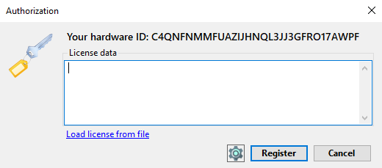

Figure 51 – Observer License Dialog

Step 2 – Copy Hardware ID (Figure 52)
- Click Copy hardware to copy the Hardware ID string to your clipboard.
- Send this ID by email to support@digitex.me.
- The Digitex Systems team will issue a corresponding license file within 24 hours (.lic).
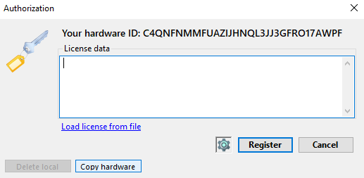
Figure 52 – Copy Hardware ID
Step 3 – Load License File (Figure 53)
- Once you receive the license file, return to the Authorization window.
- Paste the license data directly into the text box or use the link Load license from file to browse and select the .lic file.
- The file path will appear in the License data box.

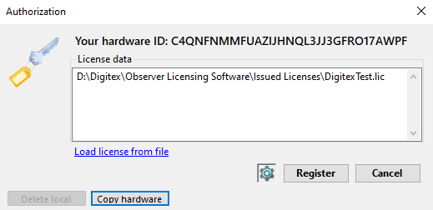

Figure 53 – Observer Load License Dialog

Step 4 – Register License (Figure 54)
- After the license data is entered, click Register.
- The system will validate the license against your Hardware ID.
- If successful, a confirmation message appears: “Your license was successfully activated.”

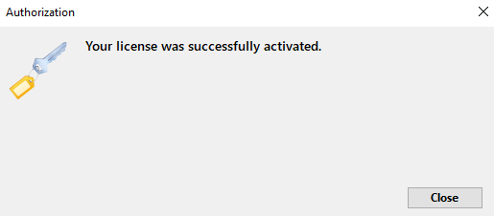

Figure 54 – Observer Register License

Step 5 – Complete and Continue
- Click Close to finish the procedure.
- Observer will now open normally.
- This activation step is only required once per machine.

Help Menu

The Help Menu is located in the top application ribbon and provides options for license management, software assistance, and version information. The menu includes the following items: Unregister, Help and About.

Unregister License

Selecting Unregister will remove the current license from the computer, allowing it for Observer to be registered on another PC.
When clicked, a confirmation dialog appears (Figure 55):
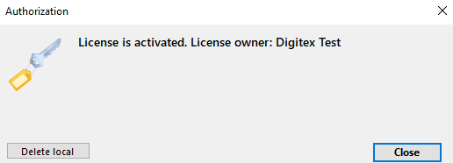
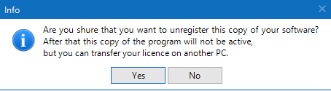

Figure 55 – Observer Unregister License

- Choosing Yes, followed by Delete Local, will unregister the license (Figure 56).
- A final message confirmation window will appear:
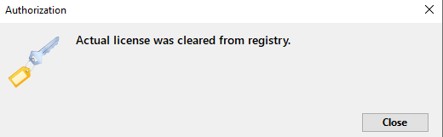

Figure 56 – Observer Unregister Done

At this point, the software will no longer run until re-registered on a new machine.

Help

Opens the help documentation window. Currently, this feature is not yet implemented and may not display content in this version.

About (version info)

Displays the splash screen with program details (Figure 57). Provides information about the installed version, build number, and copyright notice for Digitex Systems.

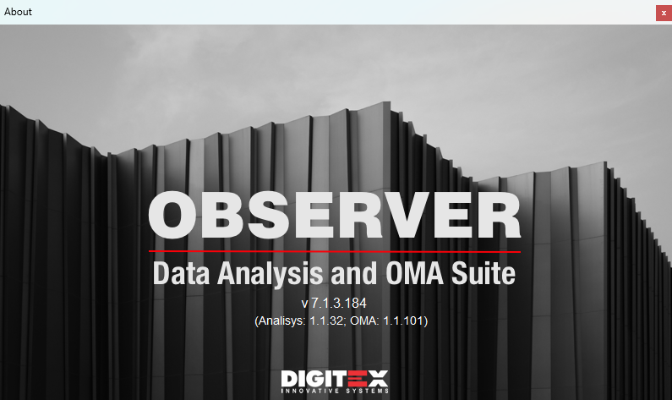

Figure 57 – Observer About Window

Troubleshooting & Support

If you encounter difficulties while using Observer Data Analysis Suite, first review the common usage included in this manual. Many problems can be resolved by checking system requirements, verifying license status, or reviewing signal processing settings.

For unresolved issues, please contact Digitex Systems Support at support@digitex.me. Customers with an active maintenance contract receive priority response and software updates.

When requesting support, please include:

- Software version and build number (available under Help → About)
- A description of the issue
- Steps to reproduce the problem
- Relevant log files, screenshots, or project data if applicable

Digitex Systems is committed to ensuring reliable performance and providing timely assistance to all users.

FAQs

Question | Answer
How do I install Observer Data Analysis Suite? | Run the setup installation package and follow the wizard. Choose Complete installation unless you need a custom setup.
Do I need internet access to activate my license? | No. Activation uses a hardware key and license file exchange via email. Internet connection is not required.
How do I transfer my license to another PC? | Select Help → Unregister License on the old PC, then reinstall Observer on the new PC and activate it with the new Hardware ID.
Observer shows a licensing dialog at first startup. What should I do? | Copy the Hardware ID, send it to support@digitex.me, and load the license file you receive. Click Register to complete activation.
The Help option does not open documentation. Is this normal? | Yes. The Help option is reserved for future versions. Please refer to the User Manual or contact support.
What does the About menu option do? | Displays the splash screen with your software version, build number, and copyright.
What preprocessing options are available? | Detrending (mean, linear, polynomial), filtering (Butterworth, Chebyshev, Bessel, Elliptic), decimation, and windowing (Hanning, Hamming, Blackman, etc.).
How can I remove low-frequency drift? | Apply linear/polynomial detrending or use a high-pass filter before integration.
Can I convert acceleration into velocity and displacement? | Yes. Observer supports single and double integration with filtering to avoid drift.
What OMA methods are available? | Frequency-domain: FDD, EFDD, FSDD, pLSCF. Time-domain: SSI-Cov, SSI-Data.
Which OMA method should I use? | Use FDD/EFDD for simple cases, FSDD for closely spaced modes, SSI for noisy data, and pLSCF for dense modal scenarios.
What is a Stabilization Diagram? | A pole vs. model order plot used in SSI and pLSCF. Stable poles = real modes; unstable = noise.
What is MAC (Modal Assurance Criterion)? | An index (0–1) comparing two mode shapes. Values close to 1 indicate strong correlation.
Can I create or edit geometry in Observer? | Yes. The Geometry Editor allows building/importing 3D models, linking sensors, and animating mode shapes.
Which export formats are supported? | Observer exports to Voyager (.ovy files) for SHM integration.
Can I customize reports? | Yes. Use View → Report Settings to select default or custom templates for PDG reports.
What information is included in reports? | Modal frequencies, damping, mode shapes, PSD/FFT plots, geometry animations, and preprocessing details.
Observer does not start after moving to another PC. Why? | The license is tied to the original PC’s Hardware ID. You must unregister it and request a new license for the new PC.
My FFT/PSD plots look noisy. What should I do? | Use averaging, apply windowing (Hanning recommended), or filter the signal to reduce noise.
Why are damping values different between EFDD and SSI? | Different algorithms use different estimation methods. Cross-verify with multiple methods for reliable results.
Why do I get “License not valid” after reinstalling Windows? | Hardware ID may change after OS or hardware updates. Contact support for a new license.
Does Observer support real-time monitoring? | Observer is designed for offline modal analysis. For real-time SHM, export results to Digitex Voyager.
What is the difference between FFT and PSD in Observer? | FFT transforms signals into frequency spectra, while PSD provides statistical estimates of power distribution across frequencies.
How can I improve mode separation in dense structures? | Use FSDD or pLSCF, which are designed for closely spaced or complex modal environments.
What if I need help with advanced analysis? | Contact support@digitex.me. Include version number (Help → About), issue description, and logs/screenshots. Customers with maintenance contracts get priority.
Where are configuration and log files stored? | Default directories are created during installation. Refer to System Configuration in the manual.
Does Observer support exporting figures for publications? | Yes. Plots and diagrams can be exported as images for reports or external use.
What happens if I unregister by mistake? | The license is cleared, and Observer will not start. Contact support with your Hardware ID to reactivate.

Contact Resources

For assistance, updates, or additional information about Digitex Observer Data Analysis Suite, please use the following resources:

Technical Support
- Email: support@digitex.me
- Phone: +389 (0)2 3109262 (Digitex Systems HQ, Skopje, Macedonia)
- Support Hours: Monday–Friday, 09:00–17:00 CET

When contacting support, please include:

- Software version and build number (Help → About)
- Description of the issue
- Steps to reproduce the problem
- Screenshots, log files, or project data if available

Product Information
- Website: www.digitexsystems.com
- Latest product news, updates, and downloads can be found on the official website.

Training & Resources
- User Manuals & Guides – Included with the installation package and available in PDF format.
- Application Notes & Case Studies – Available on request from Digitex Systems or authorized partners.
- Workshops & Training – Contact Digitex Systems for on-site or remote training options tailored to Structural Health Monitoring (SHM) and Operational Modal Analysis (OMA).

Sales & Licensing
- Email: sales@digitex.me
- Contact the sales team for license extensions, maintenance contracts, or additional software modules.

Appendices

Glossary of SHM/OMA Terms

Term | Description
Acceleration | Rate of change of velocity, measured in m/s². Captured by accelerometers to record structural vibrations.
Amplitude | Maximum deviation of a signal from its mean value, indicating vibration intensity.
Auto-Correlation | Measures similarity of a signal with itself at different time lags. Used to detect periodicities and modal parameters.
BandPass Filter | Passes only frequencies within a specified low–high range. Useful for isolating structural modes.
Bessel Filter | Preserves waveform shape and phase; ideal for transient response studies.
Blackman Window | FFT window with strong leakage suppression but lower resolution.
Block Rows (SSI) | Defines order of Hankel matrix in SSI methods; higher orders capture more dynamics.
Butterworth Filter | Popular digital filter with maximally flat passband response. Smooth and stable for SHM preprocessing.
Chebyshev I Filter | Steeper roll-off than Butterworth, with ripple in passband.
Chebyshev II Filter | Steep roll-off with ripple in stopband. Strong out-of-band suppression.
Cross-Correlation | Compares similarity of two signals with time shifts. Detects delays, propagation, and phase shifts.
Cursor & Slice Tools | Observer features for precise reading of signal values at time or frequency points.
Decimation | Reduces sampling rate to lower data volume while keeping main content. Must respect Nyquist limits.
Detrending | Removes offsets/drifts: Off (none), Mean (DC removal), Linear (slow drift), Polynomial (higher-order drift).
Displacement | Actual structural movement from equilibrium (m). Obtained by double-integrating acceleration.
Damping Ratio | Percentage of critical damping; indicates how quickly vibrations decay.
Elliptic Filter | Very sharp cutoff filter with ripple in both passband and stopband.
FFT (Fast Fourier Transform) | Converts time signals into frequency spectra to identify resonances.
Filter Order | Determines steepness of filter cutoff. Higher = sharper but more distortion.
Frequency Domain | Representation of signals by frequency instead of time. Used in modal analysis.
Frequency Resolution | Smallest resolvable frequency step in FFT/PSD. Depends on sampling and duration.
FDD (Frequency Domain Decomposition) | OMA method using SVD on spectral matrices to identify modes.
EFDD (Enhanced FDD) | Extension of FDD estimating damping by returning to time-domain decay fitting.
FSDD (Frequency-Spatial DD) | Combines frequency and spatial decomposition for better mode separation.
Geometry Workspace/Editor | Observer tool for creating 3D structure models and mapping sensor data.
Hamming Window | FFT window balancing leakage suppression and resolution.
Hanning Window | Common FFT window, good compromise between resolution and leakage.
Hankel Matrix | Constructed from covariance/data; used in SSI for state-space models.
Integration | Converts acceleration → velocity (1st integration) → displacement (2nd integration). Requires filters to prevent drift.
Kurtosis | Statistical measure of signal “peakedness”; detects transients/impulses.
MAC (Modal Assurance Criterion) | Index (0–1) comparing similarity of two mode shapes.
Mode Shape | Deformation pattern of a structure at a natural frequency.
Modal Parameters | Properties describing dynamics: natural frequencies, damping ratios, mode shapes.
Natural Frequency | Frequency at which a structure vibrates freely. Shifts indicate possible damage.
Normal Probability Plot | Compares measured distribution to Gaussian distribution for OMA validation.
OMA (Operational Modal Analysis) | Extracts modal parameters from ambient vibrations without controlled input.
Phase | Relative timing/angle between signals. Important for mode identification.
pLSCF (Polyreference Least Squares Complex Frequency) | Frequency-domain OMA method fitting FRFs across references. Handles dense modes.
Power Spectral Density (PSD) | Shows how signal power is distributed over frequency. Fundamental to OMA.
Probability Density Function (PDF) | Describes amplitude distribution of a signal. Used to confirm Gaussian assumptions.
Response Spectrum | Maximum response of oscillators across frequencies/damping. Used in seismic/SHM design.
RMS (Root Mean Square) | Effective signal energy measure. Indicates vibration strength.
Sampling Rate (SPS) | Samples per second. Higher rates give finer detail but more data volume.
Short-Time Fourier Transform (STFT) | Time–frequency method revealing transient/non-stationary behavior.
SNR (Signal-to-Noise Ratio) | Ratio of useful signal strength to noise. Higher = more accurate modal extraction.
SVD (Singular Value Decomposition) | Mathematical decomposition in FDD/EFDD/FSDD for identifying modes.
Singular Value Curves | Curves from SVD decomposition. Peaks indicate modal frequencies.
Skewness | Measure of signal distribution asymmetry; detects nonlinear effects.
SSI-Cov (Stochastic Subspace ID – Covariance) | Time-domain OMA method using covariance functions. Robust and noise-tolerant.
SSI-Data (Stochastic Subspace ID – Data) | Time-domain OMA method using raw data directly. Effective for closely spaced modes.
Stabilization Diagram | Plot of poles vs. model order. Stable poles = real modes; unstable = noise.
STFT (Short-Time Fourier Transform) | Sliding FFT that shows time-varying spectra. Useful for transient events.
Velocity | Rate of change of displacement (m/s). Obtained by integrating acceleration once.
Voyager Export (.ovy) | Function exporting Observer results to Digitex Voyager for SHM integration.

Sample Geometry File
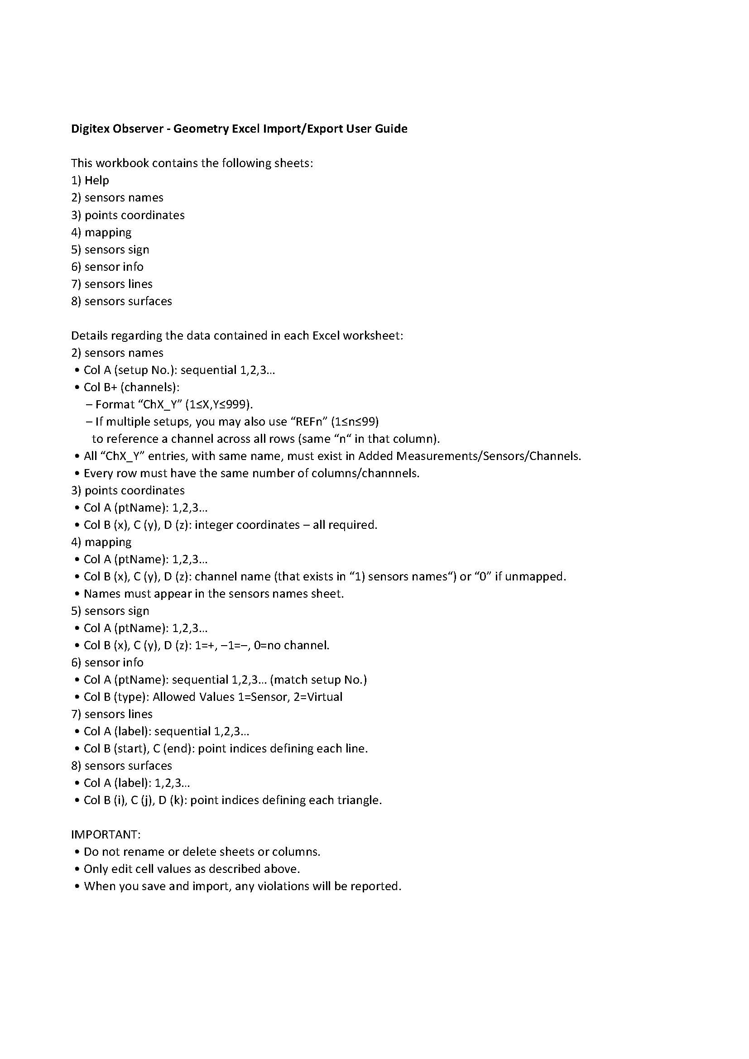
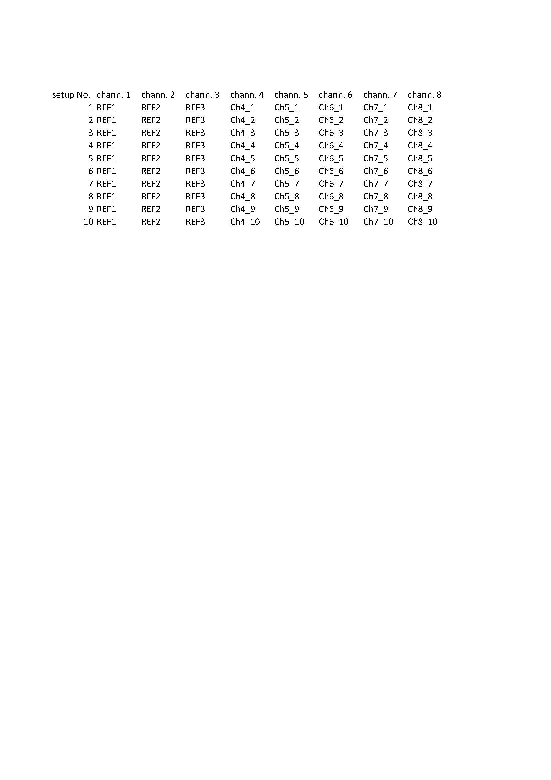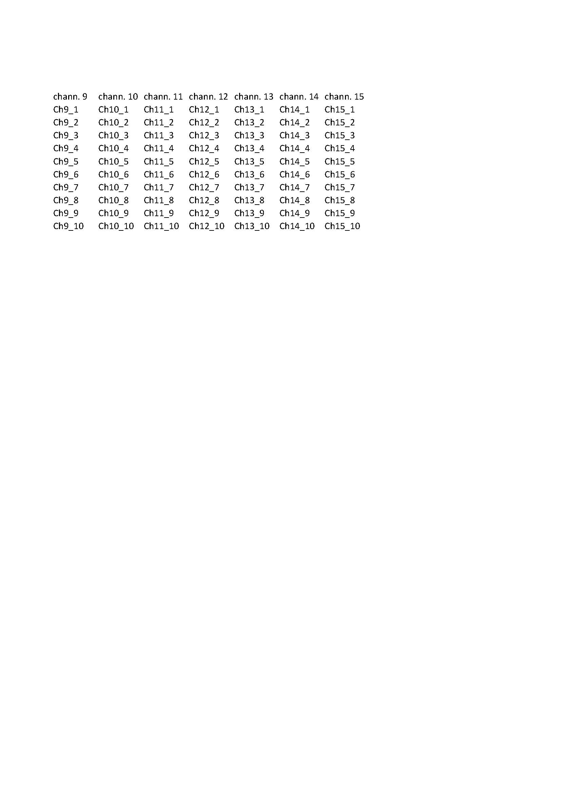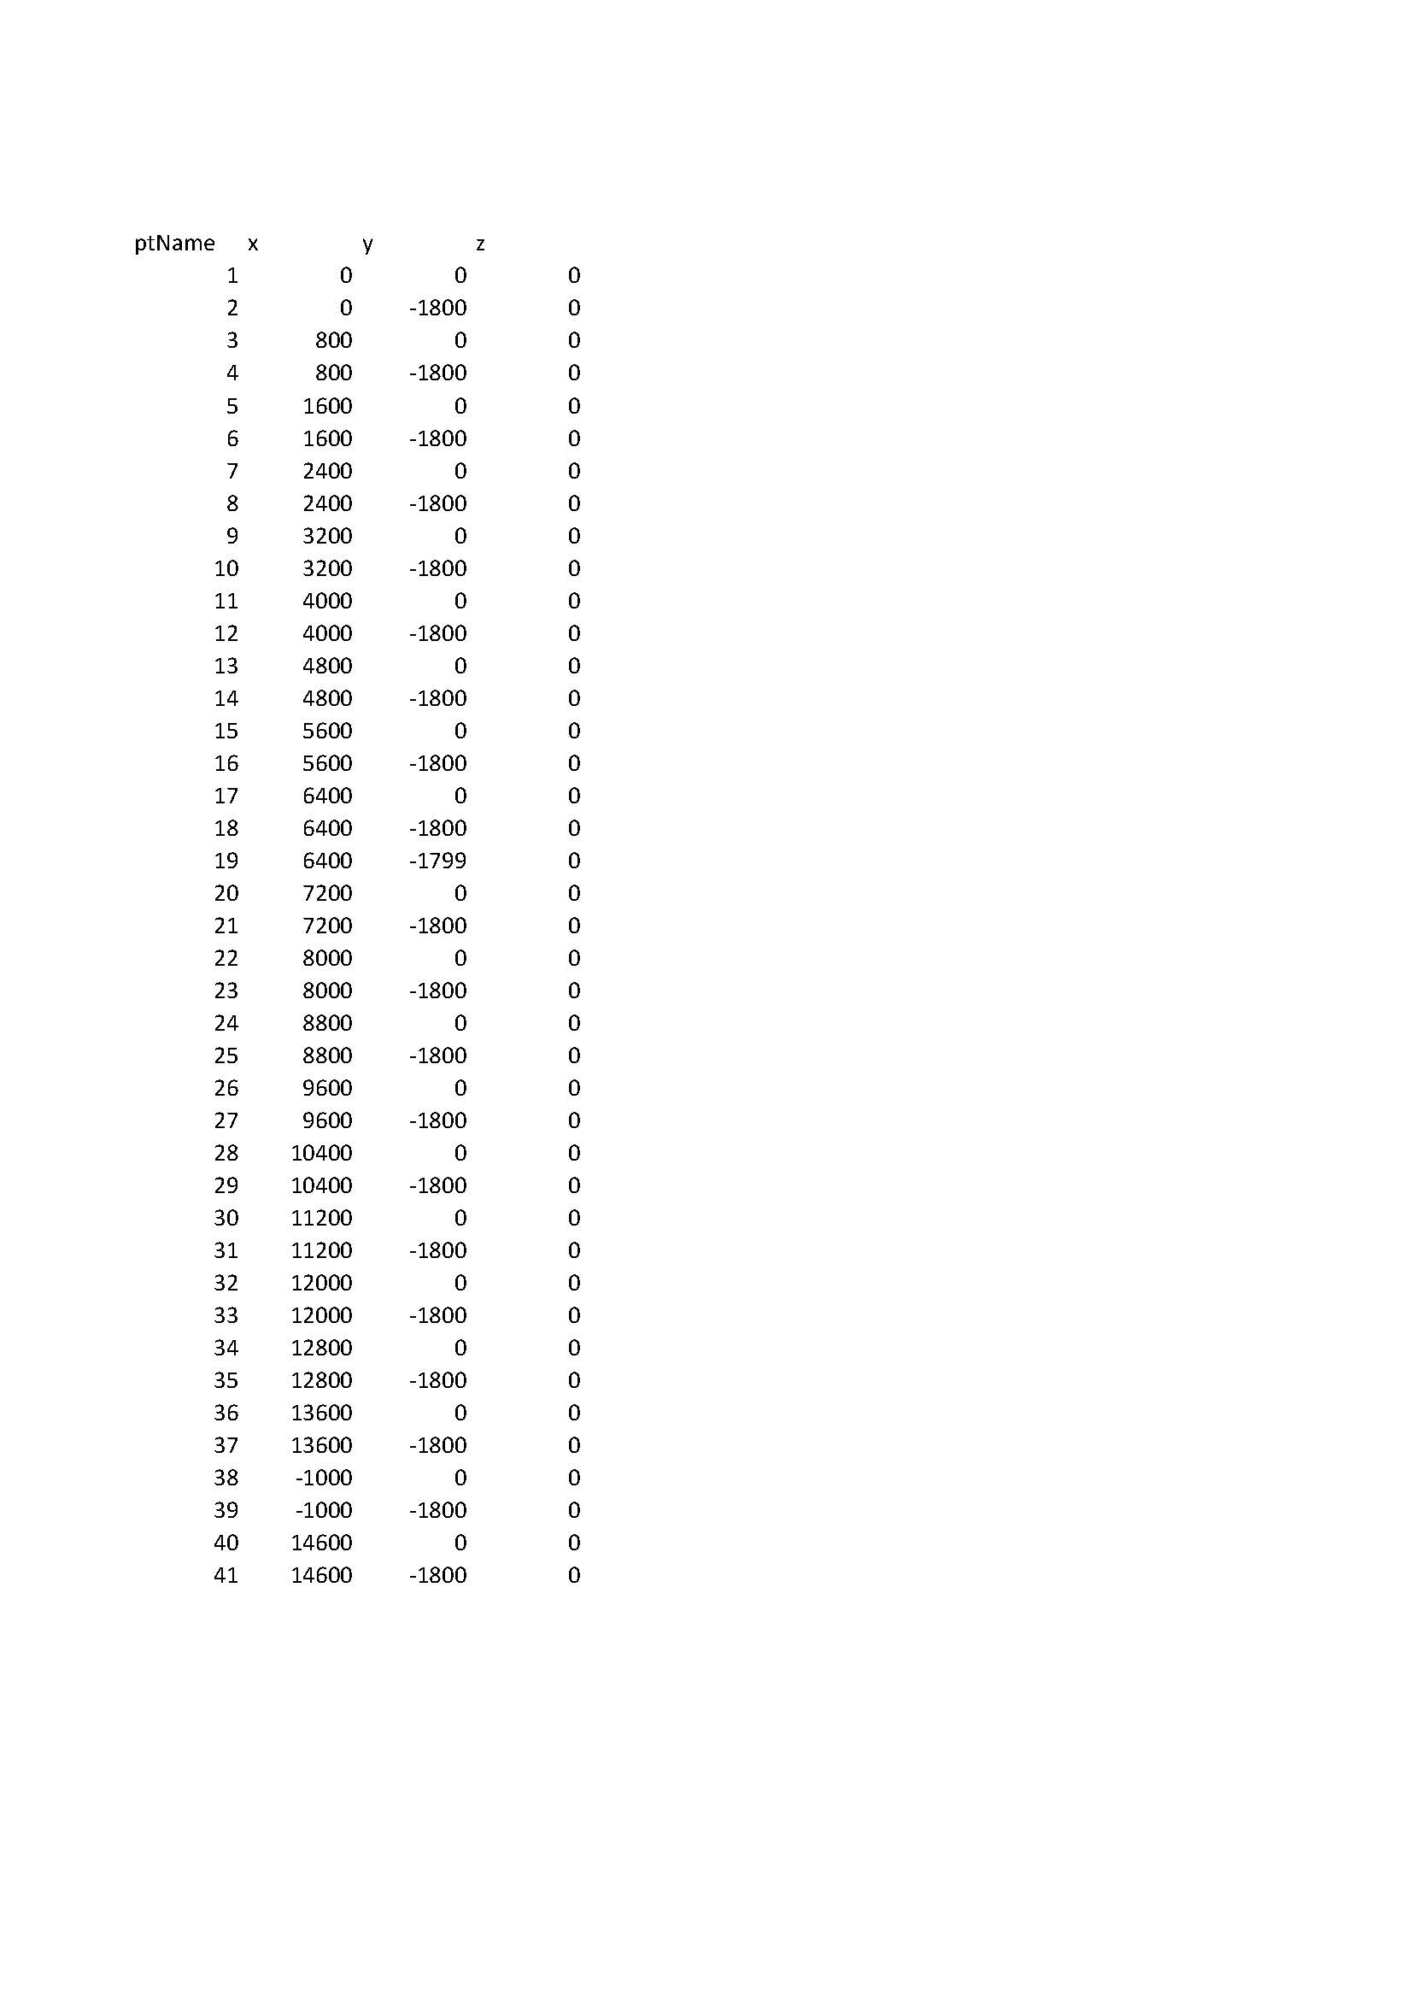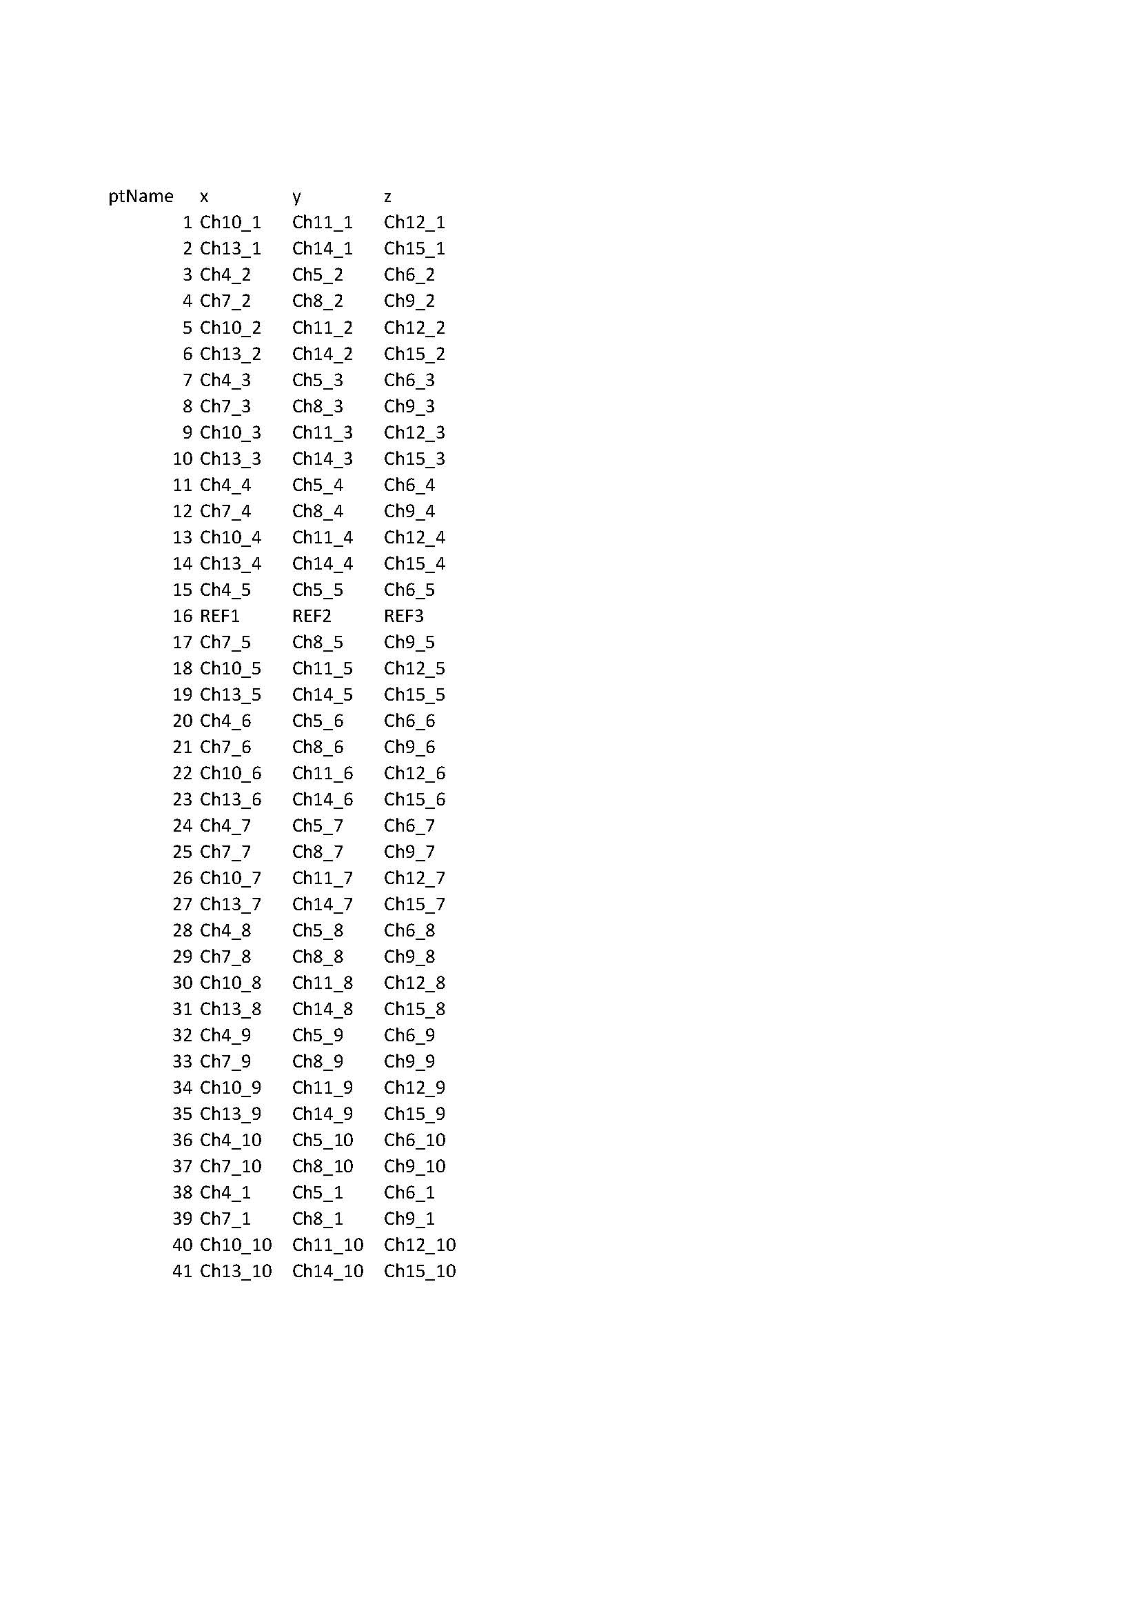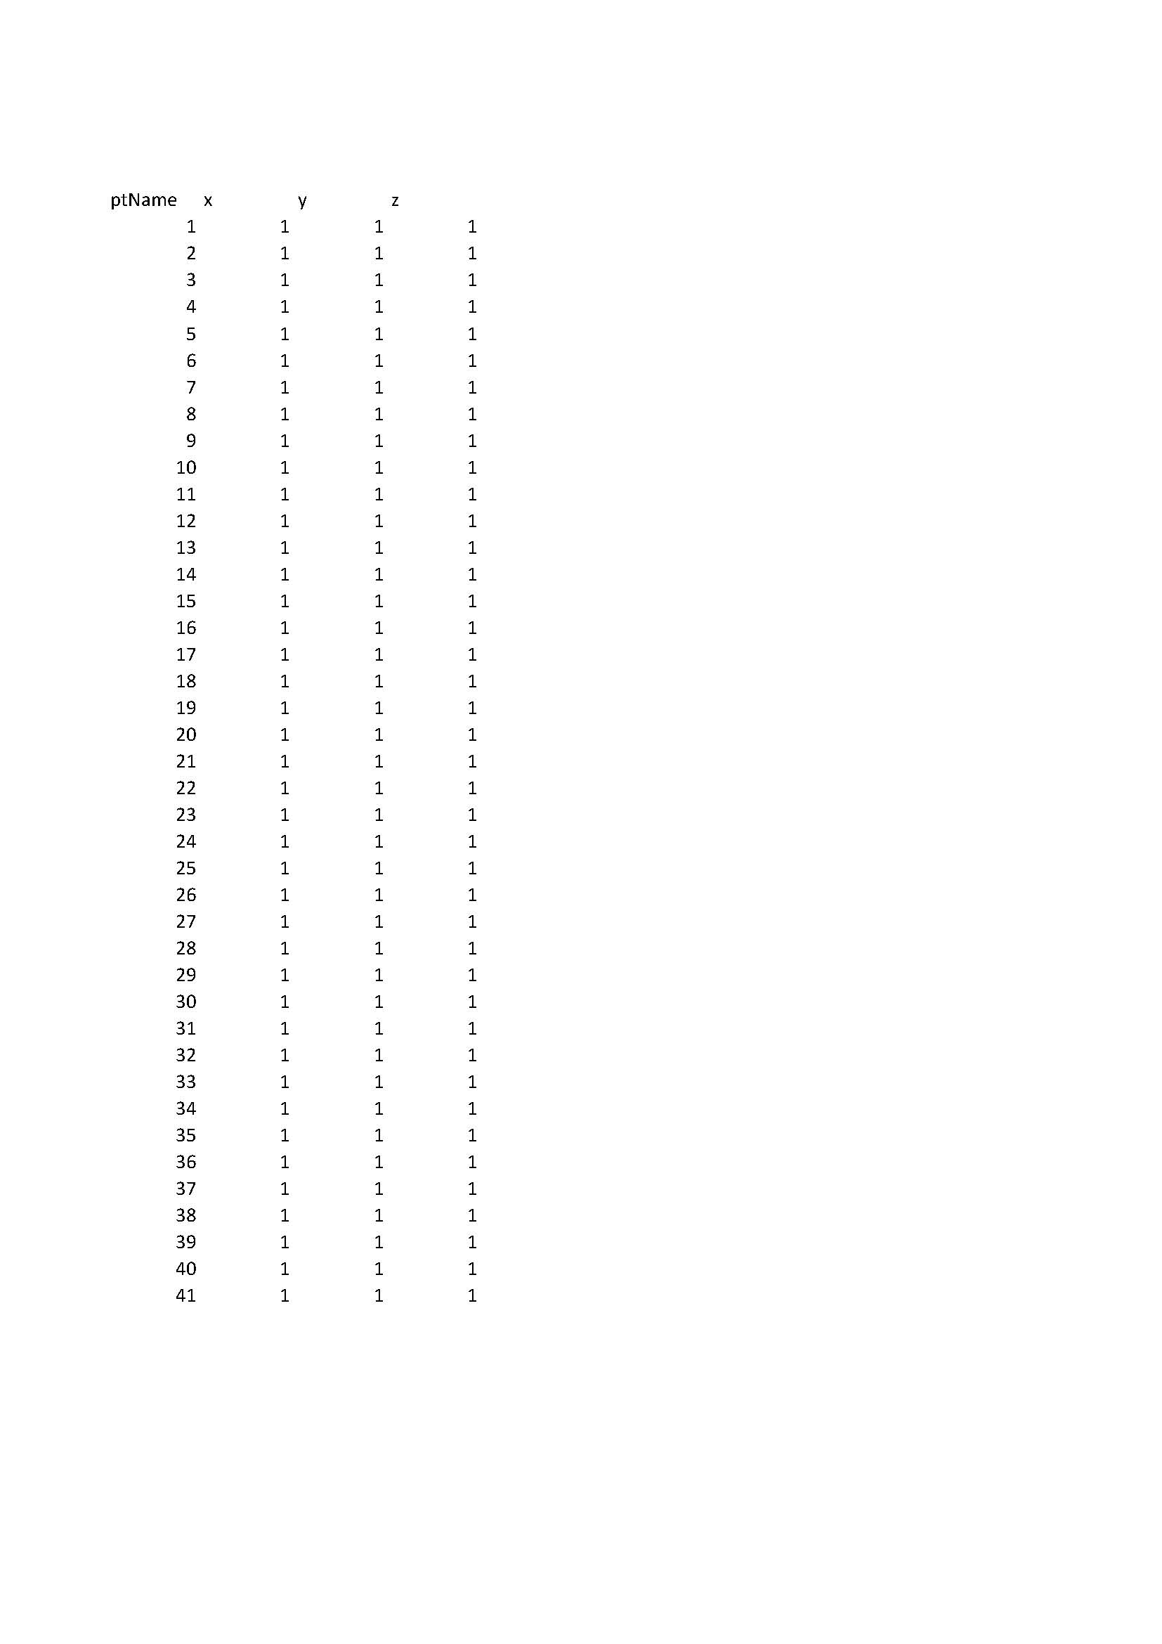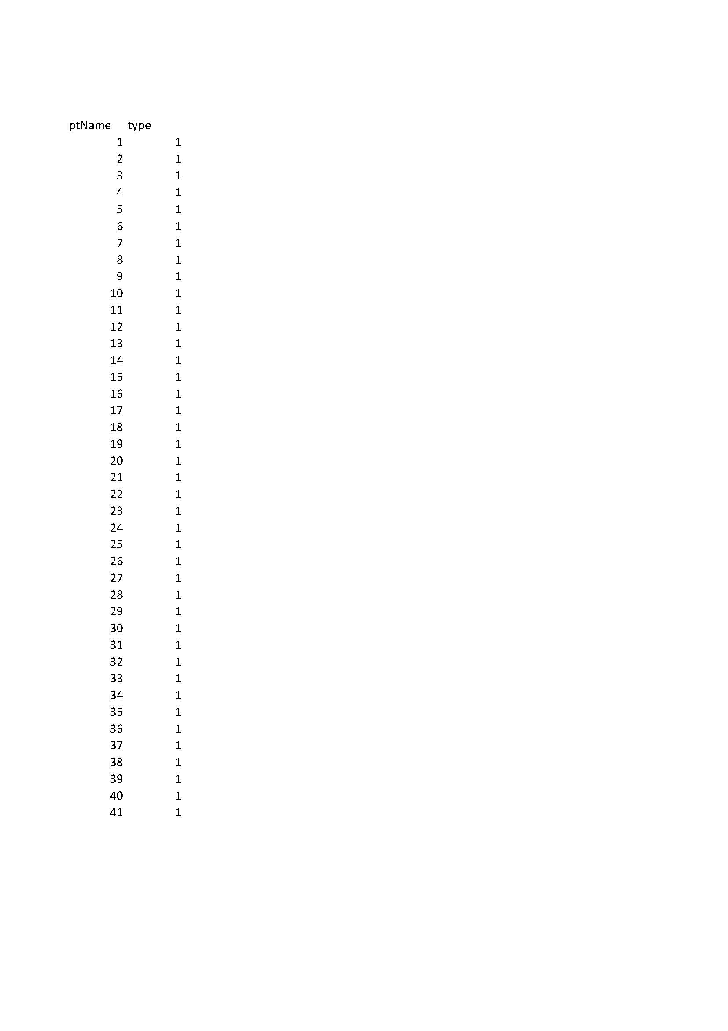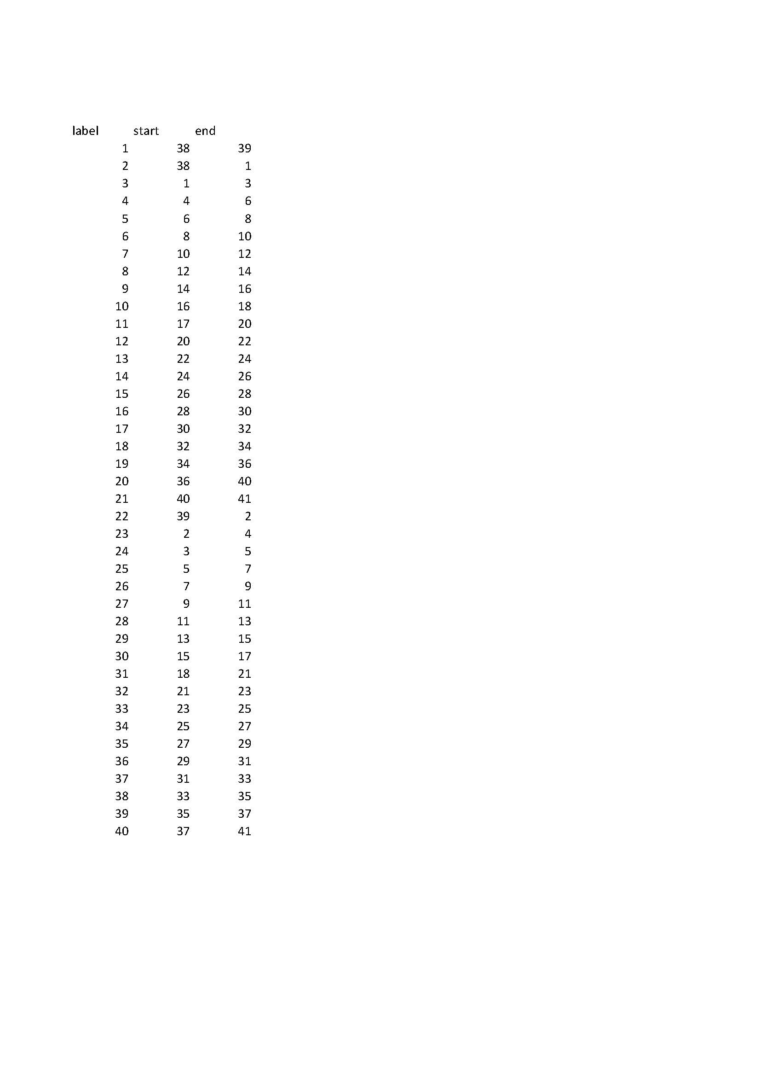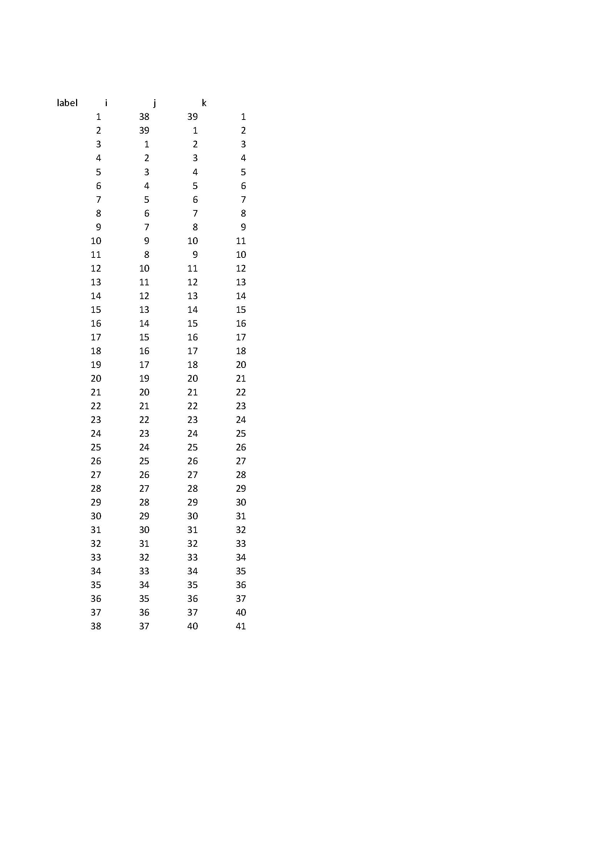

Sample PDF Report

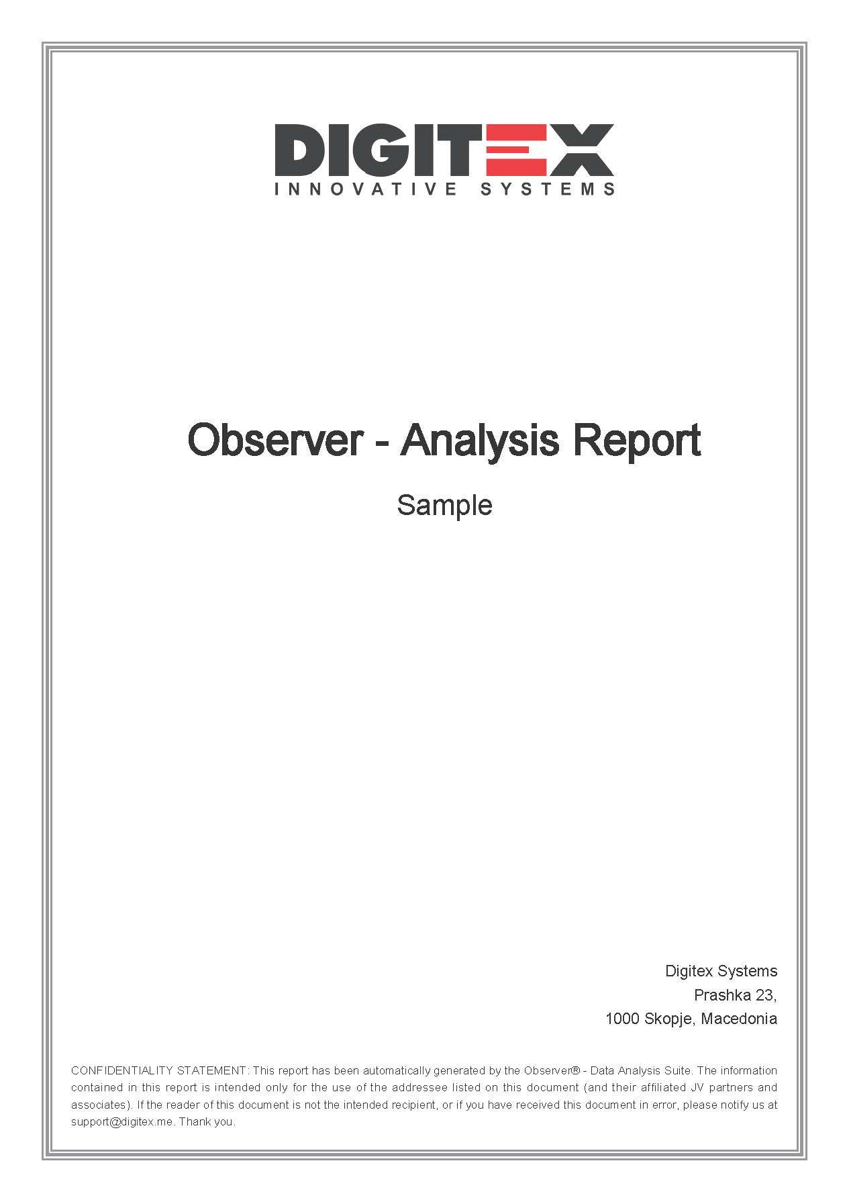
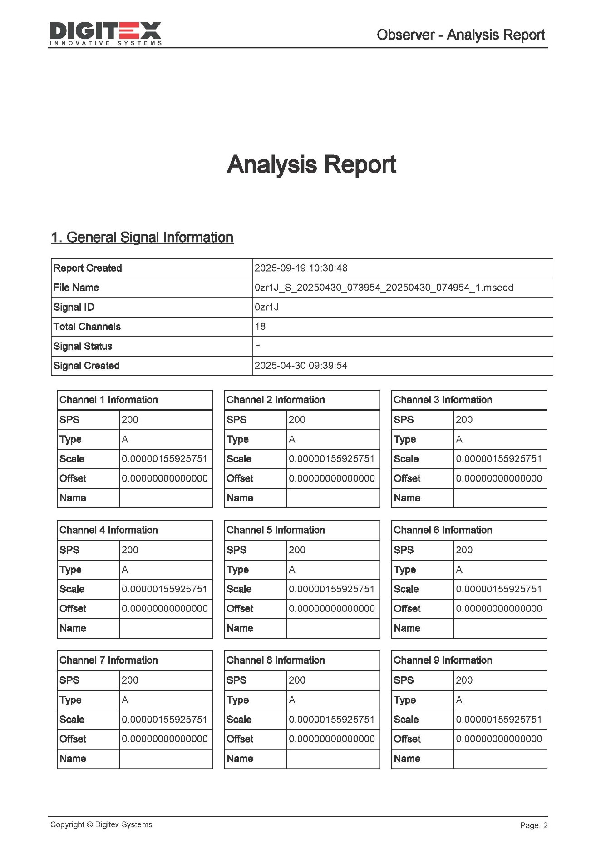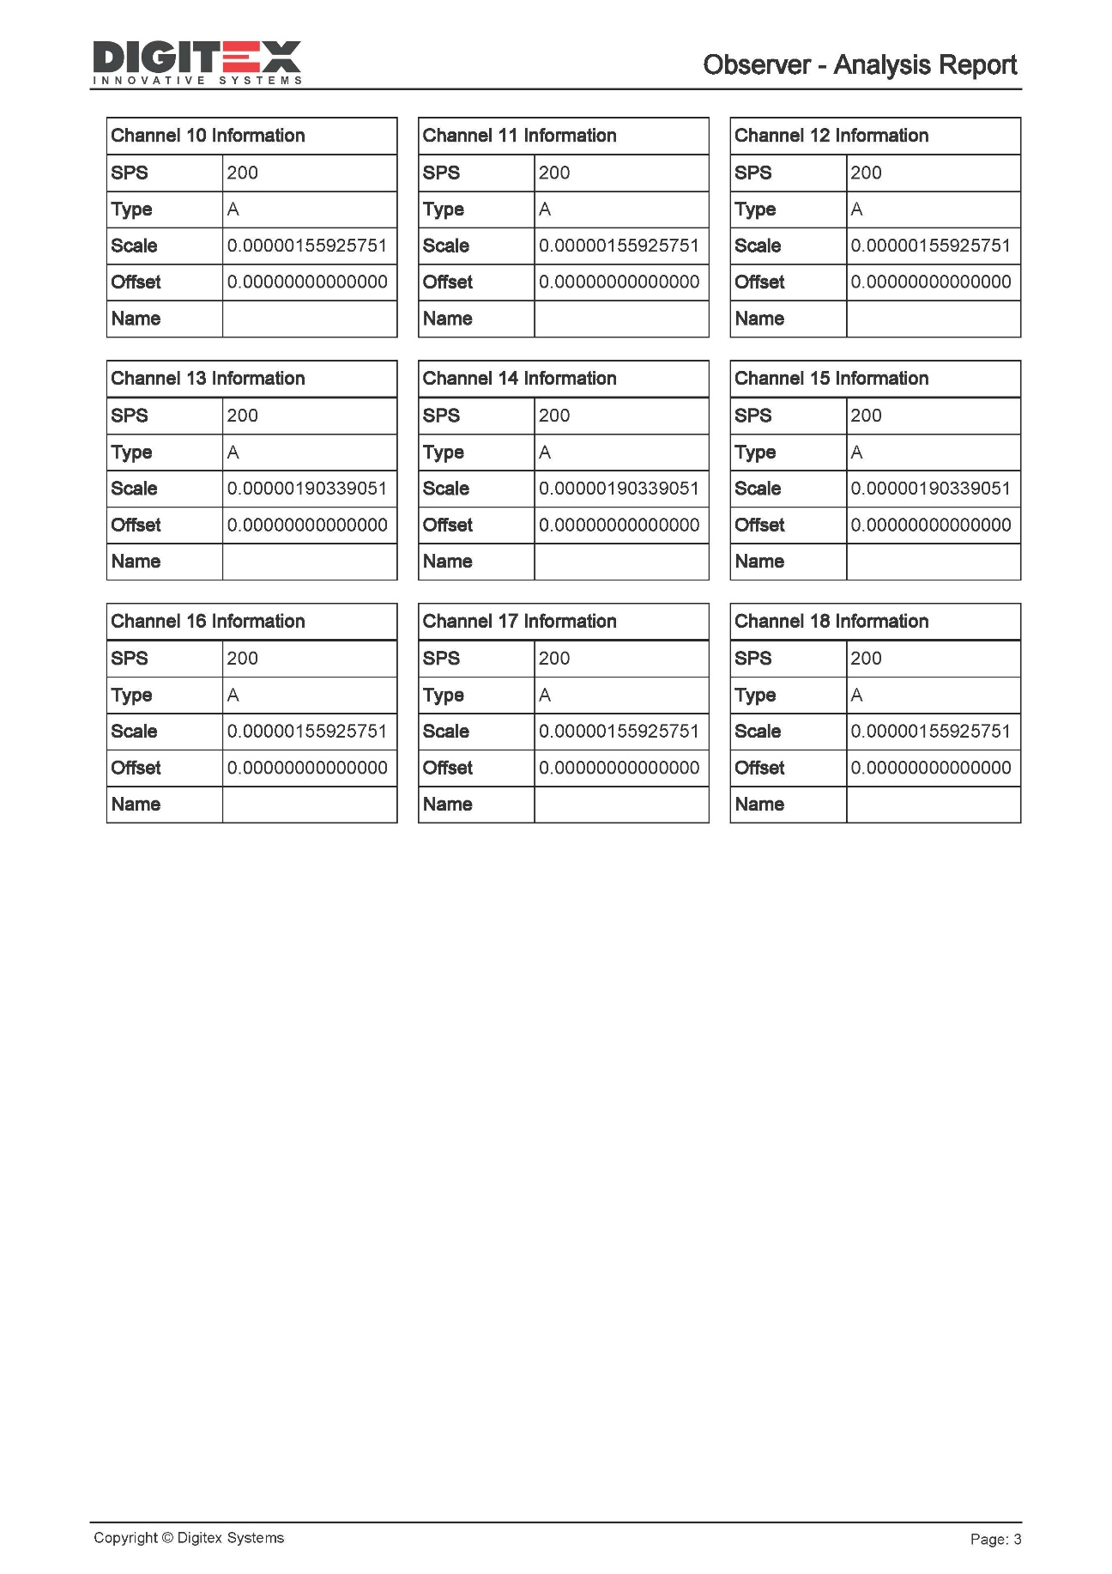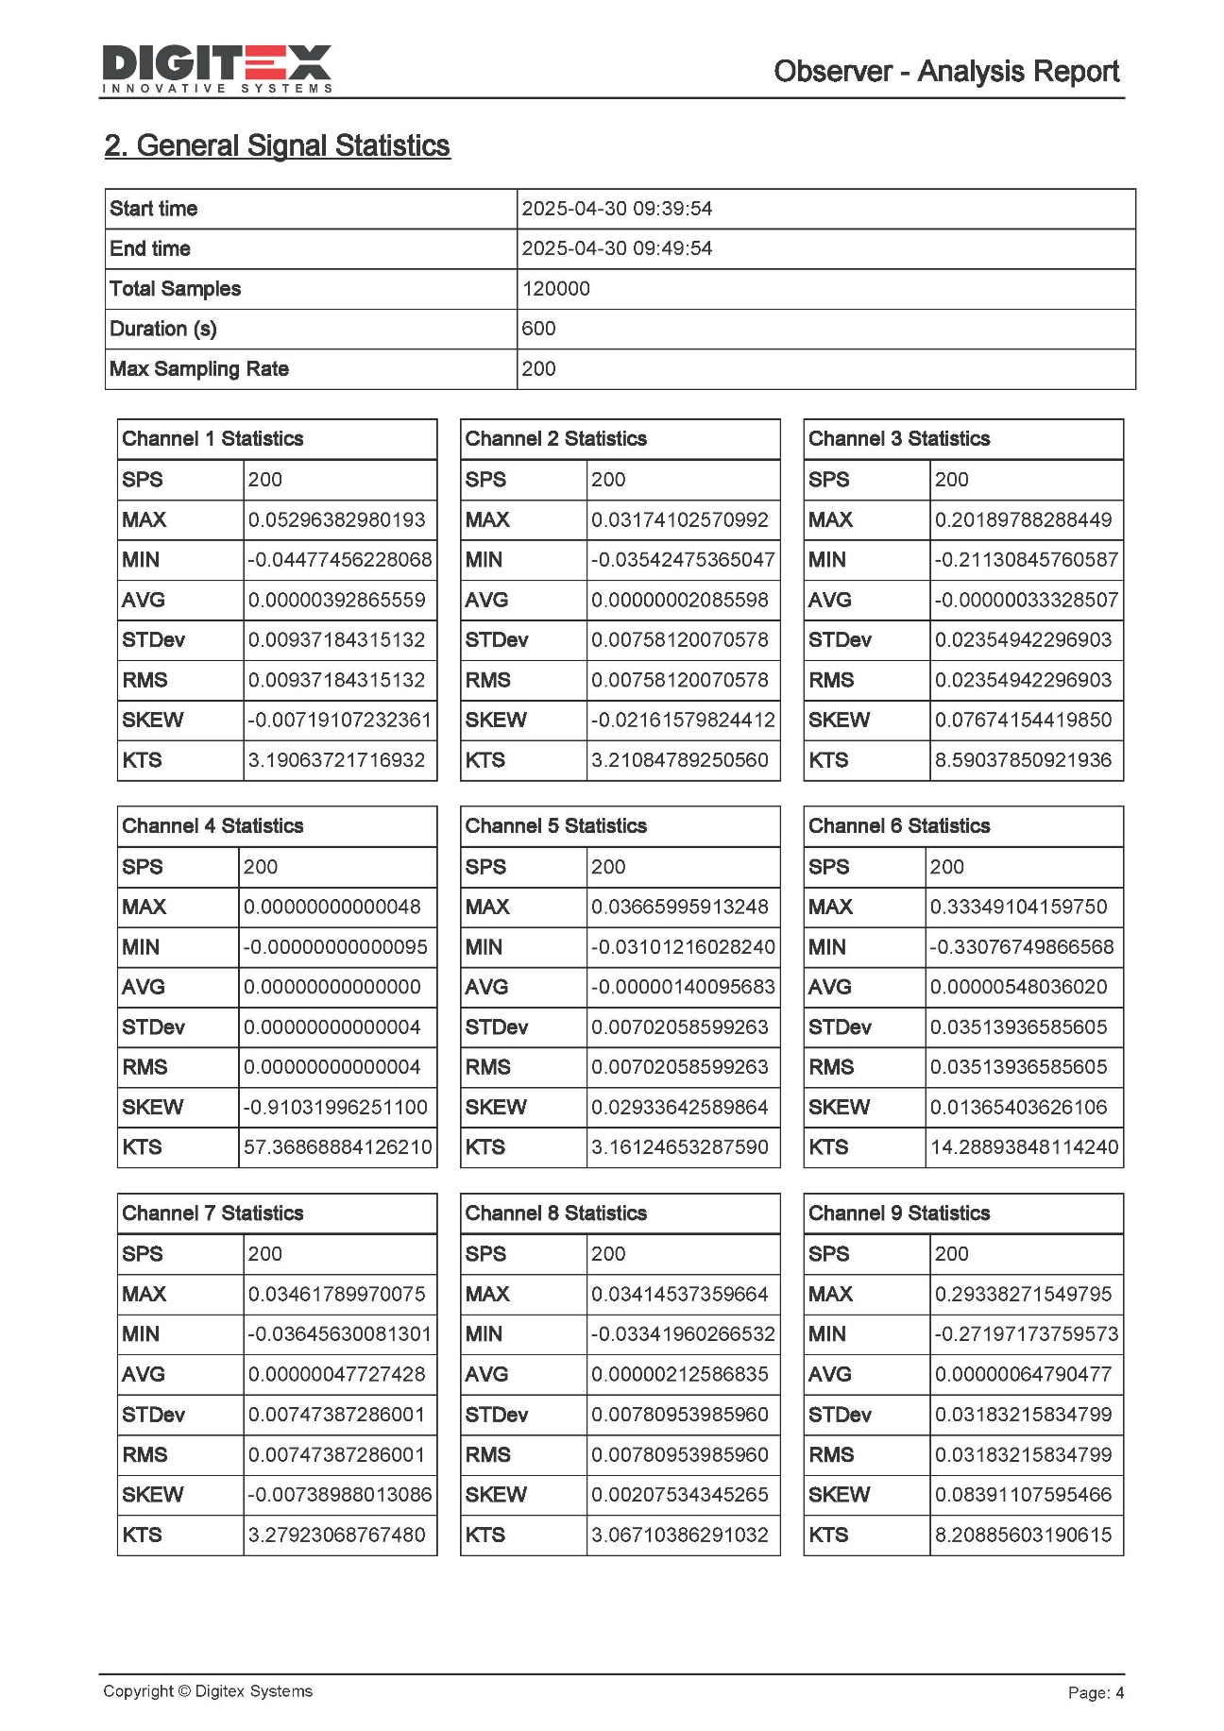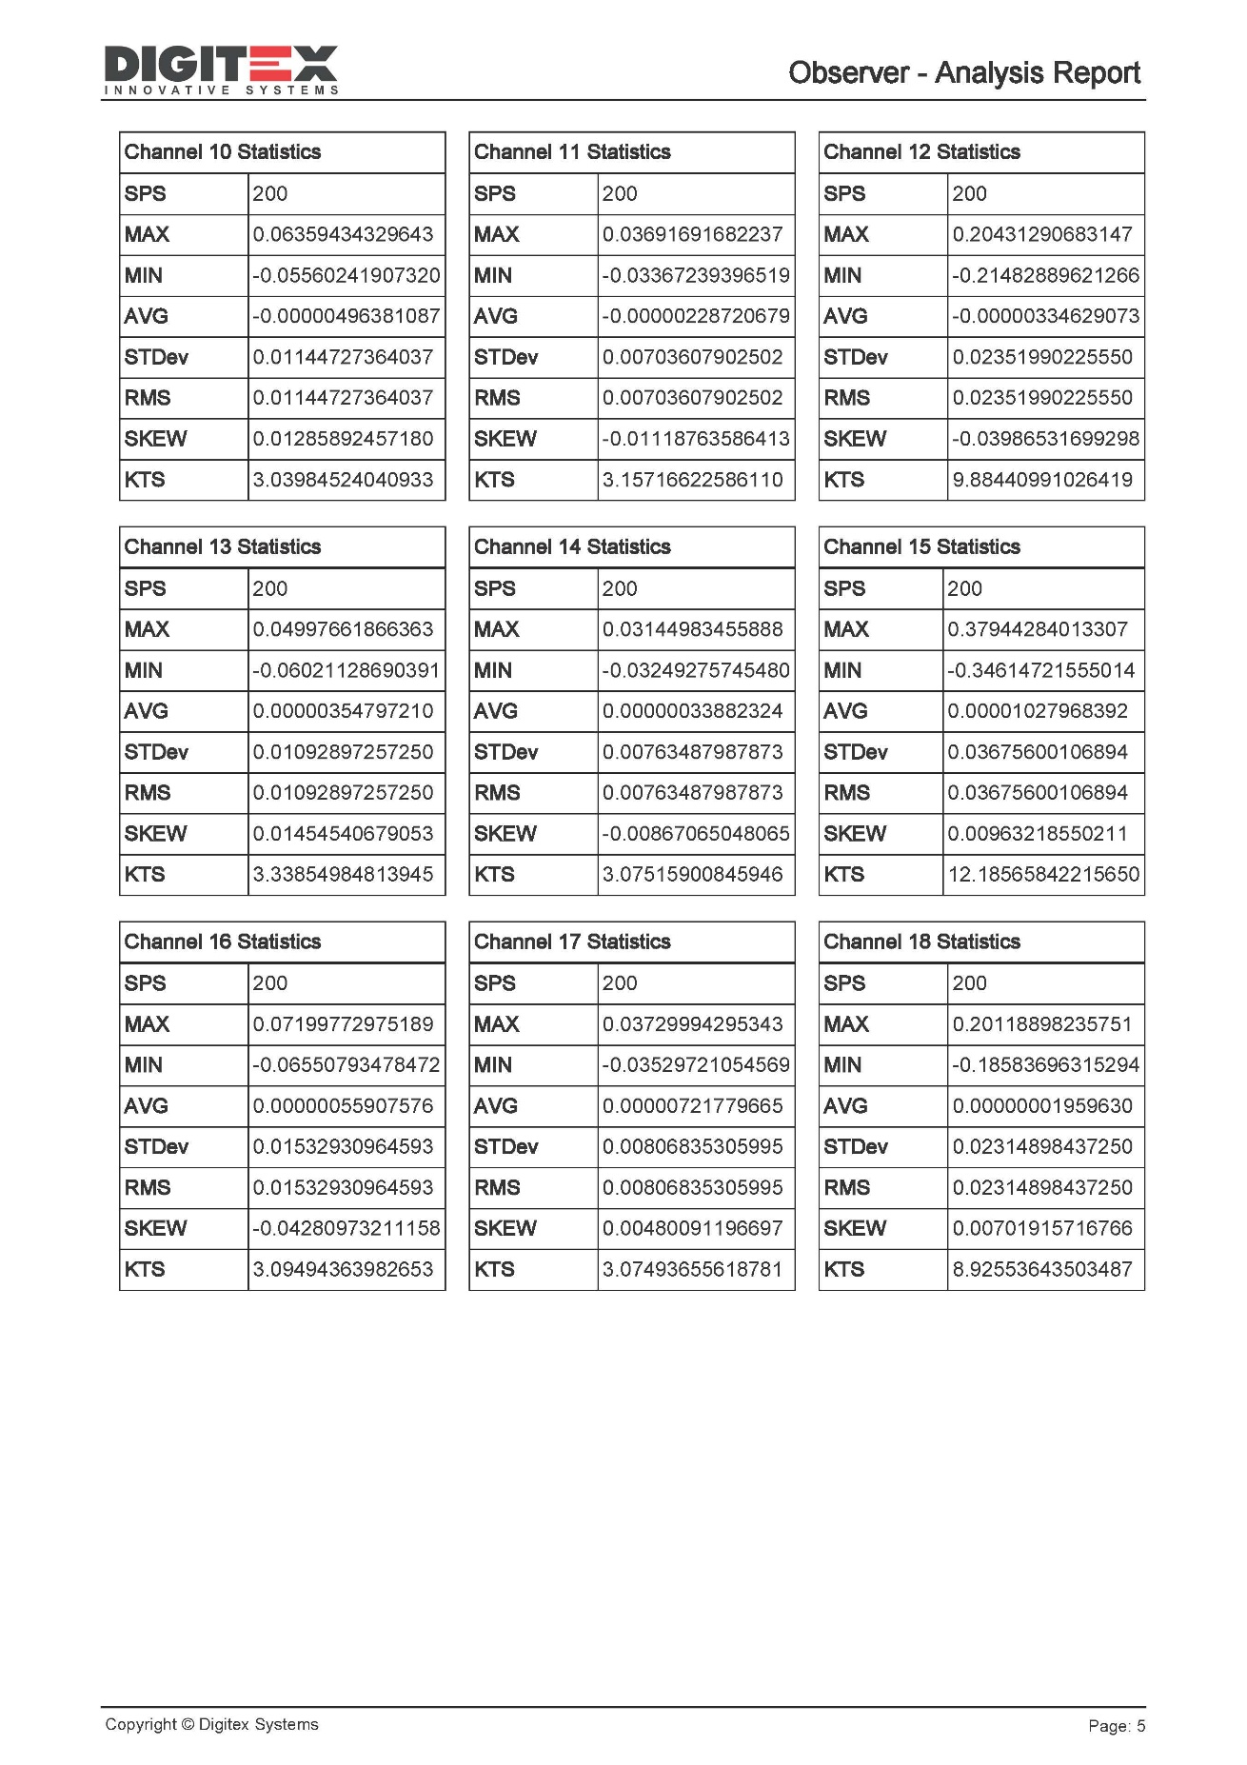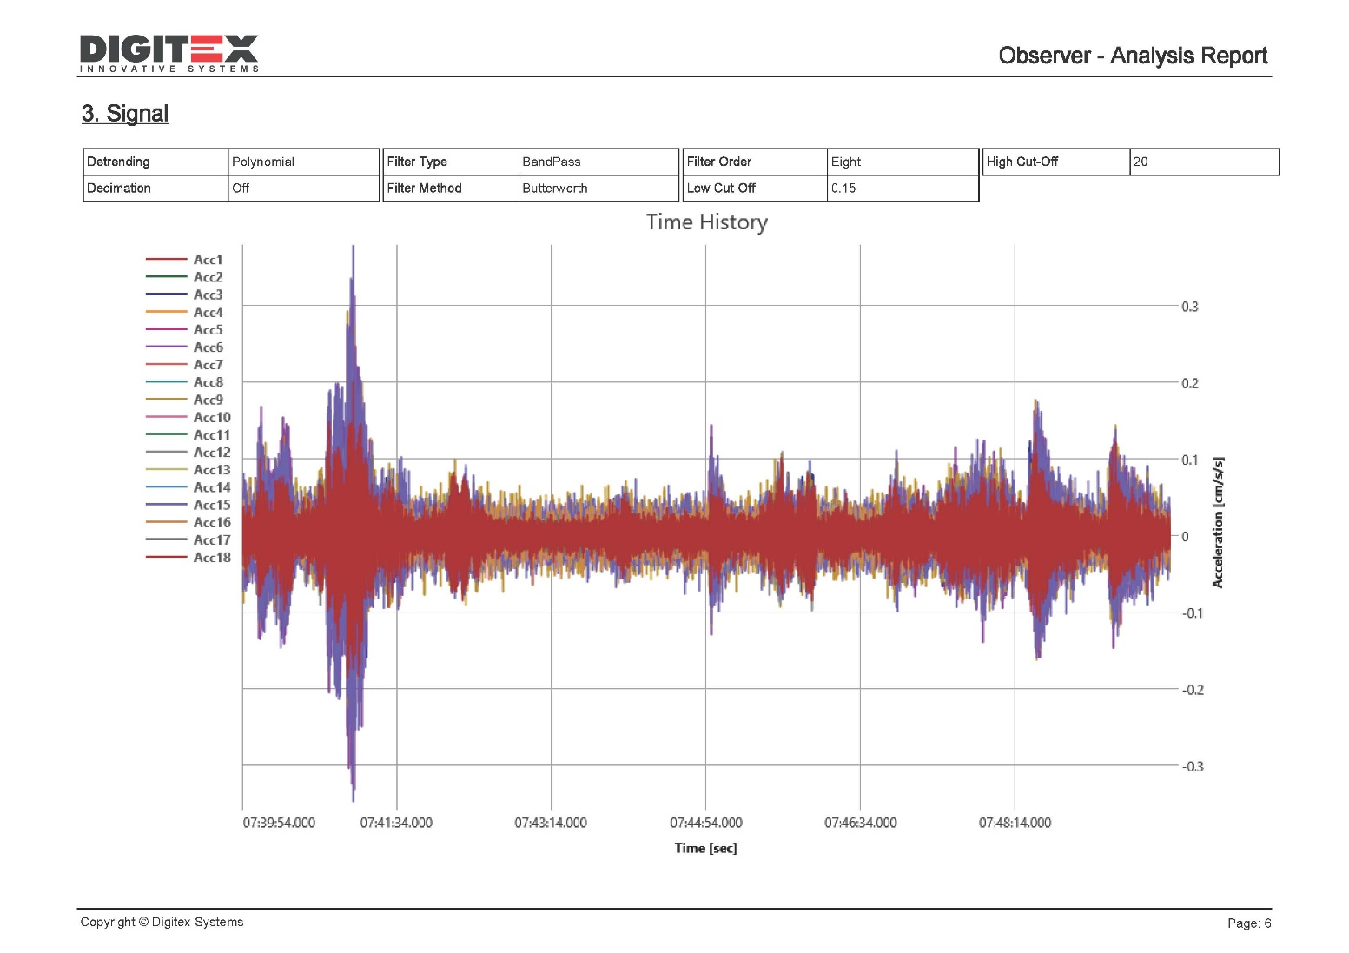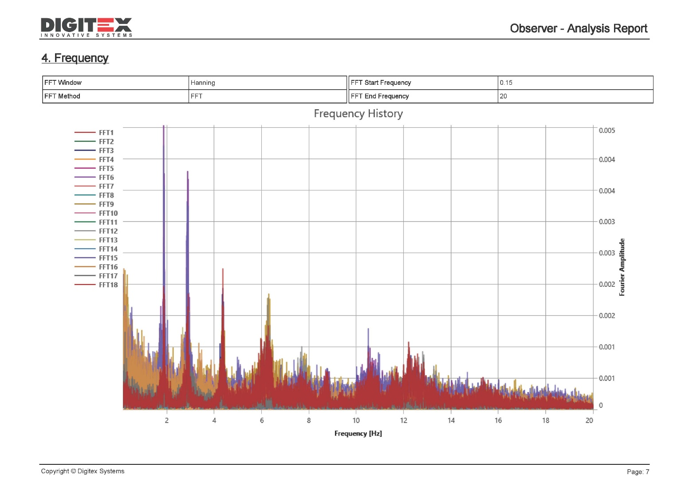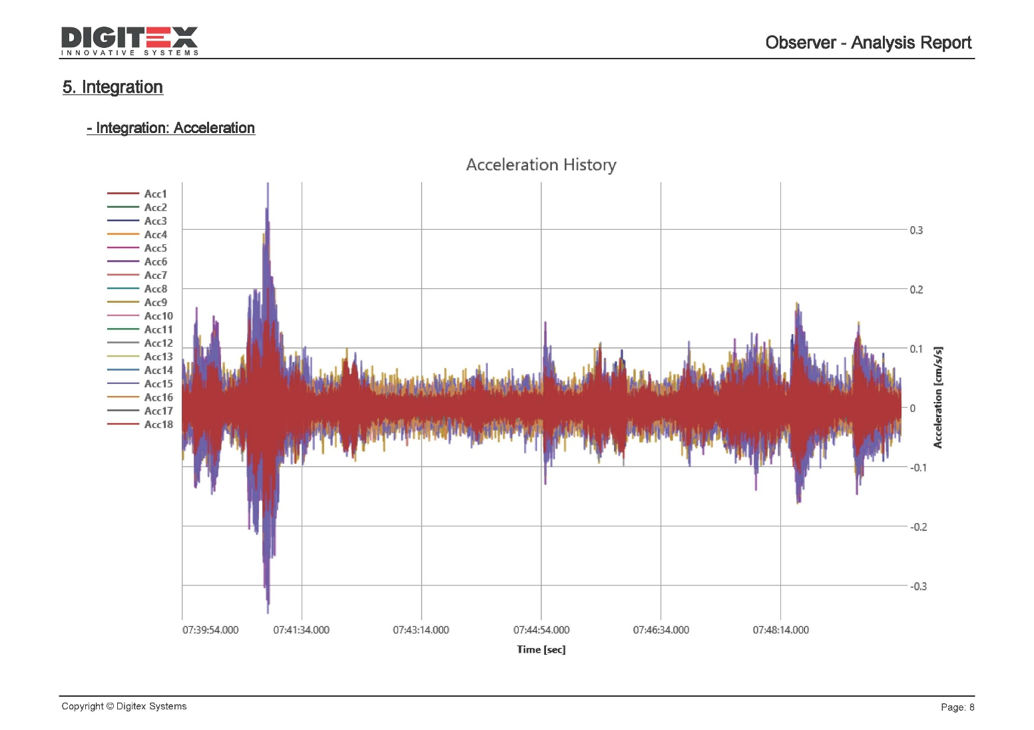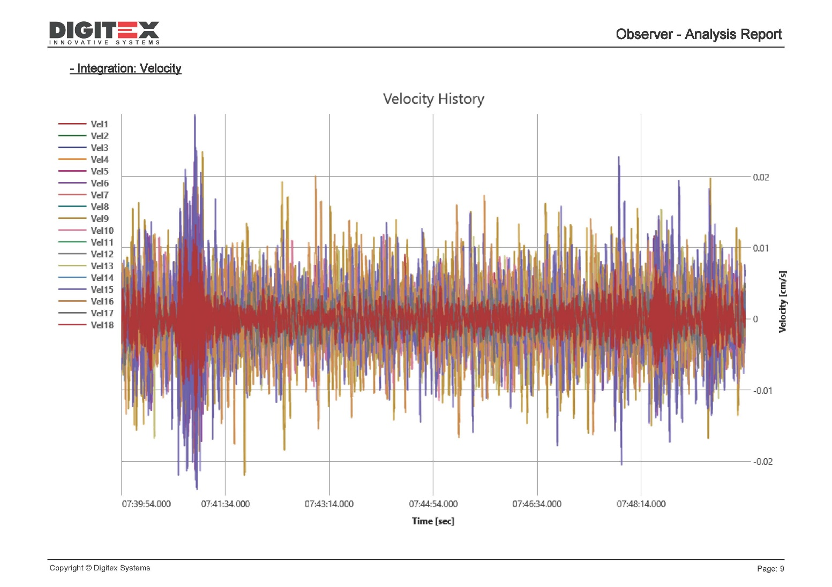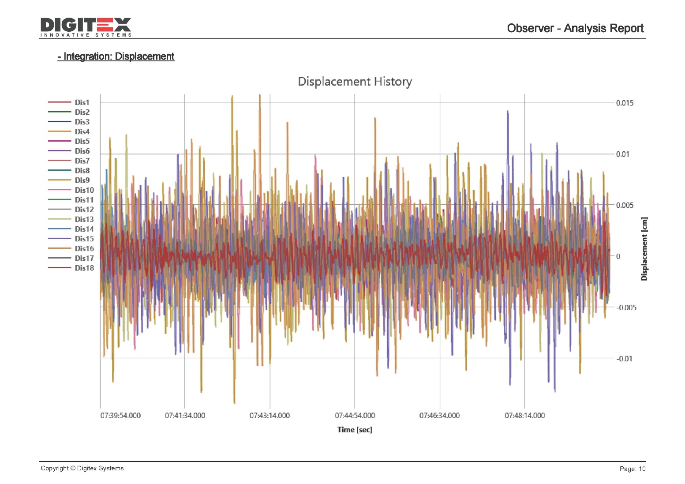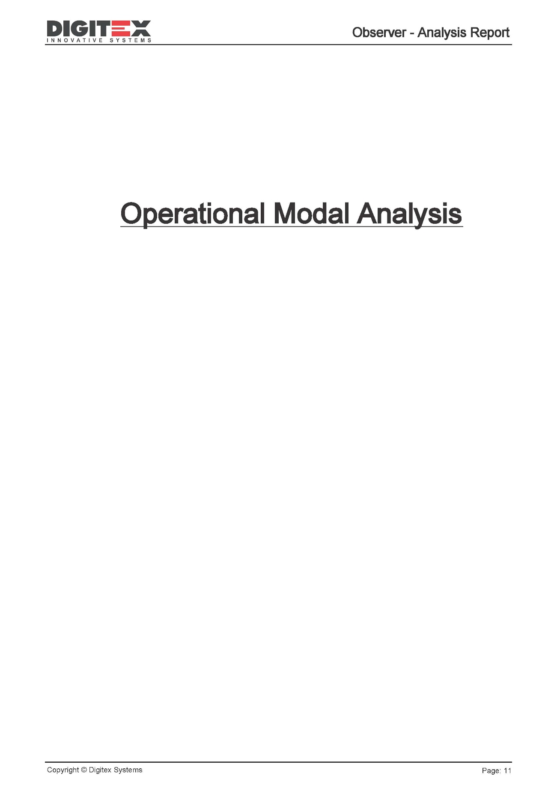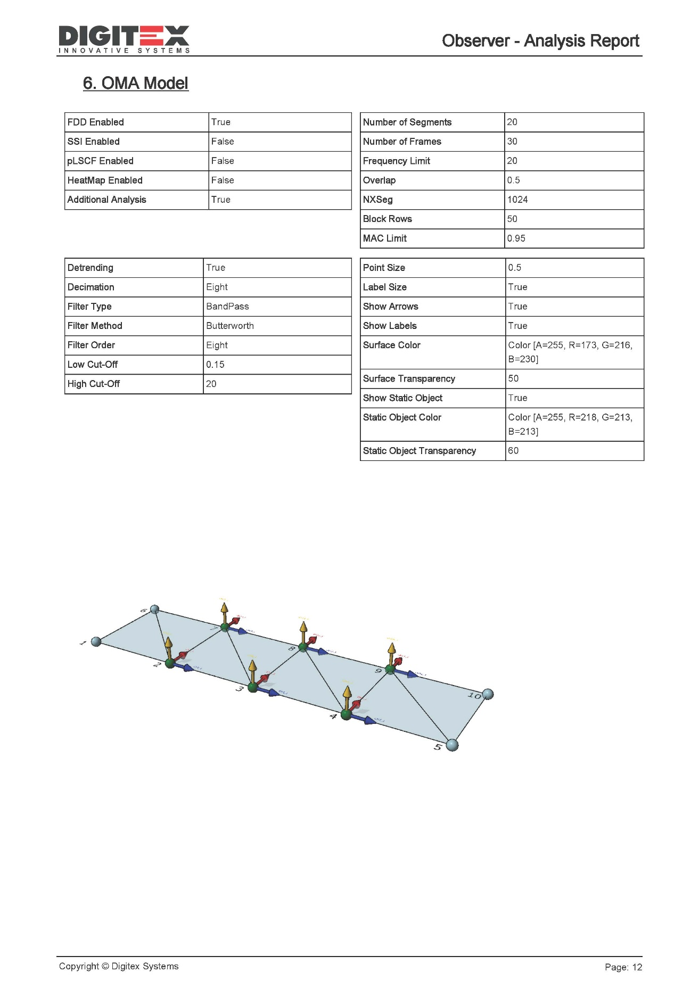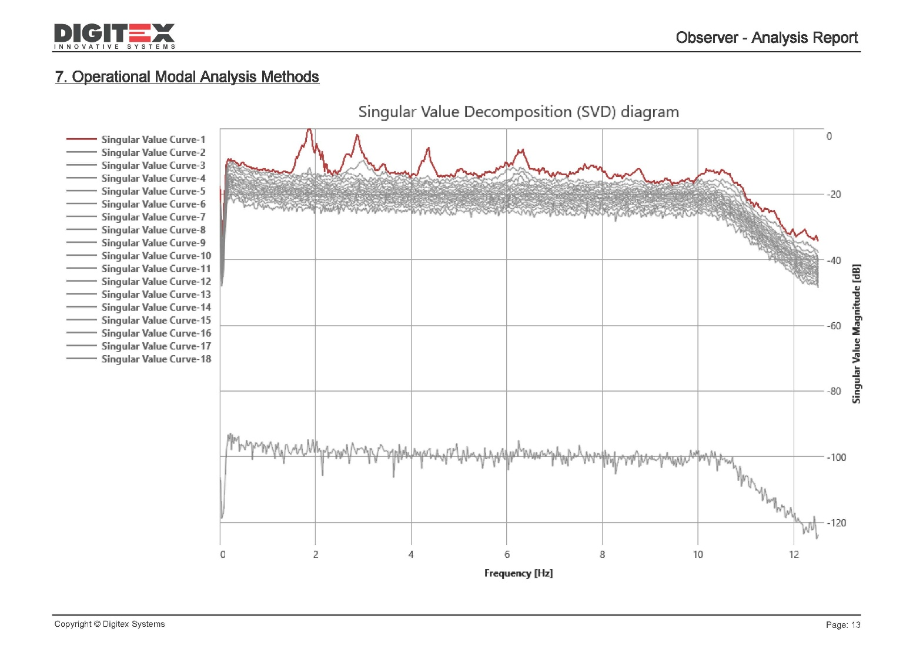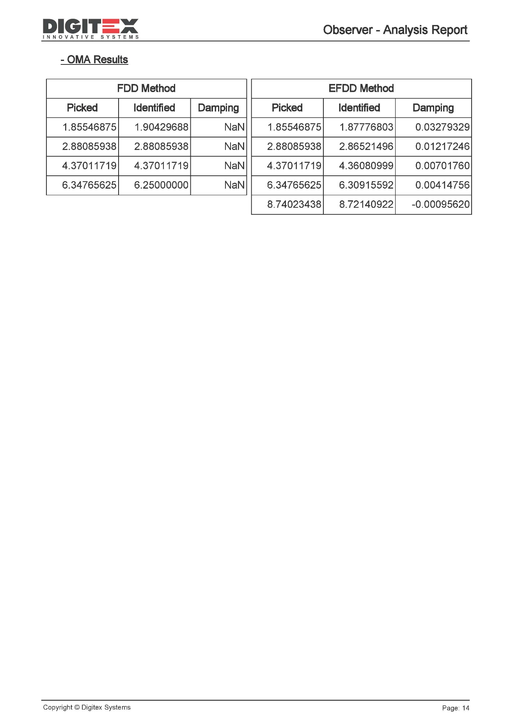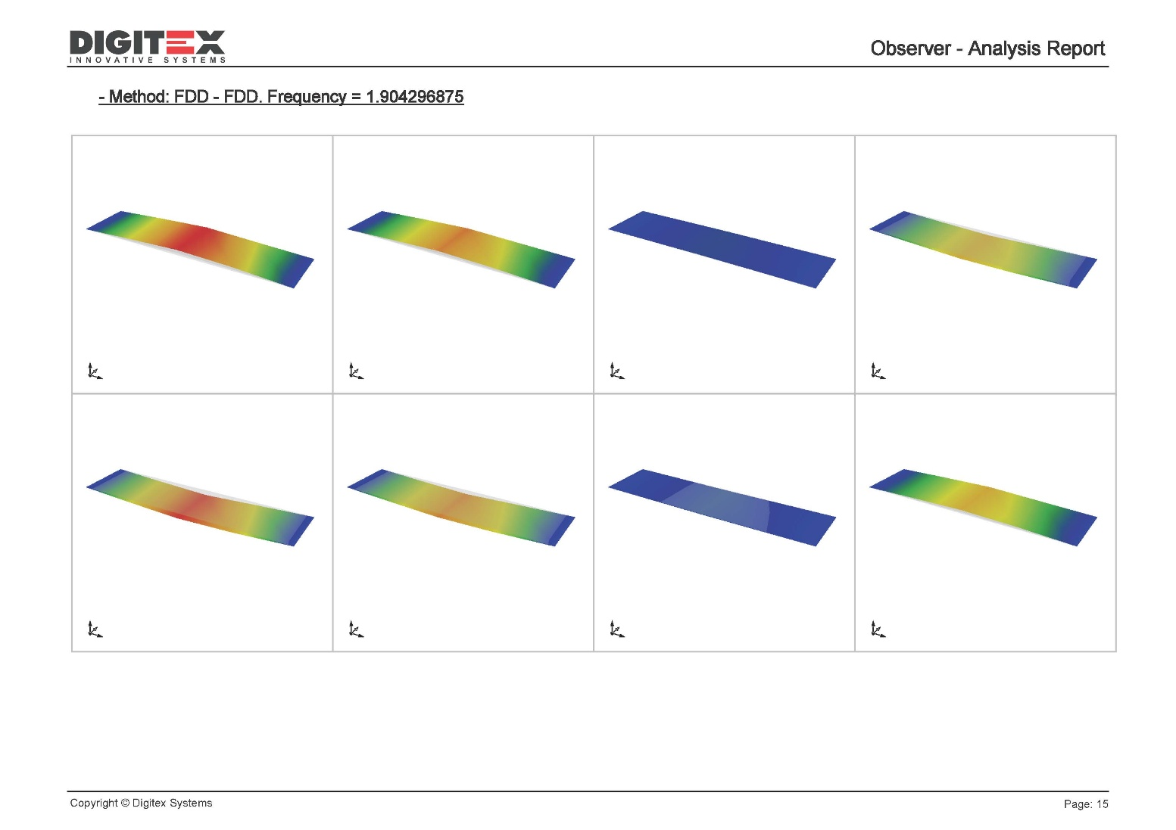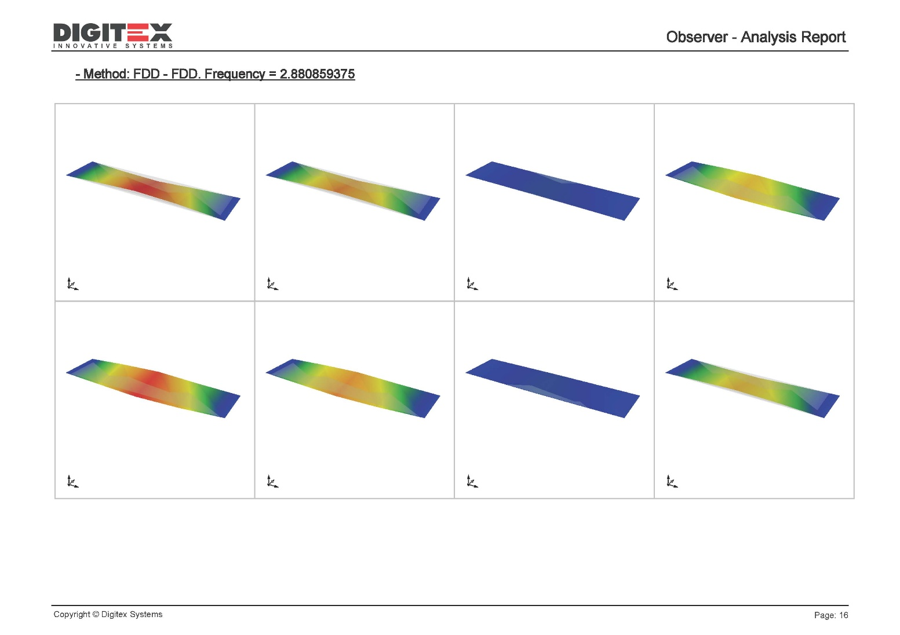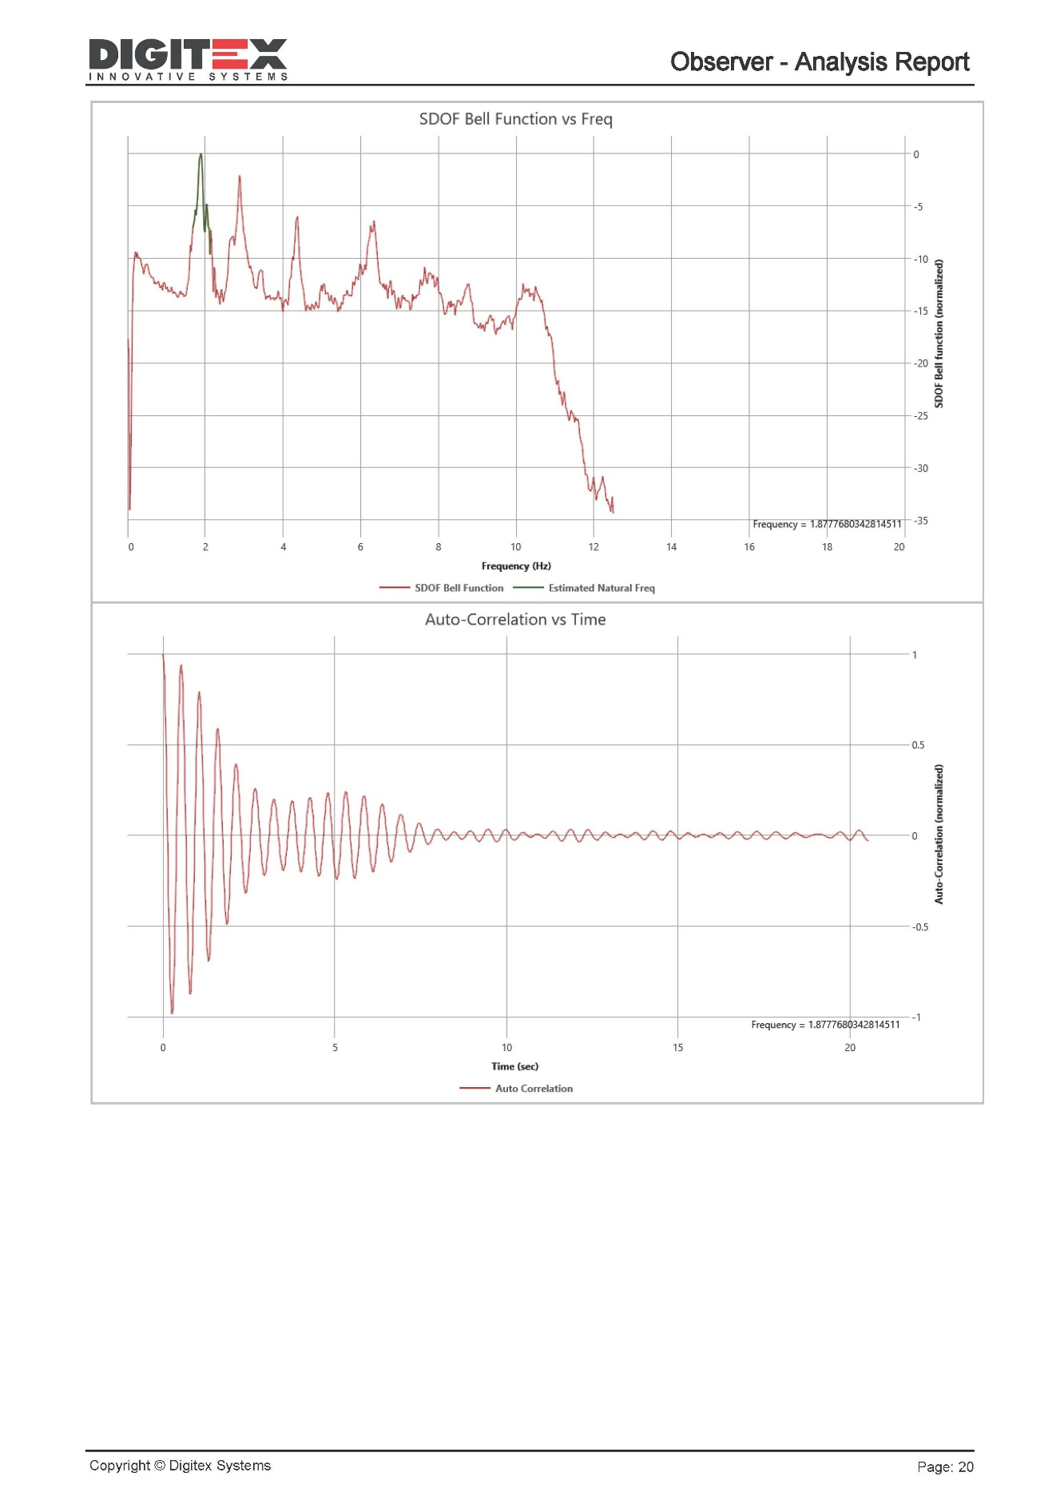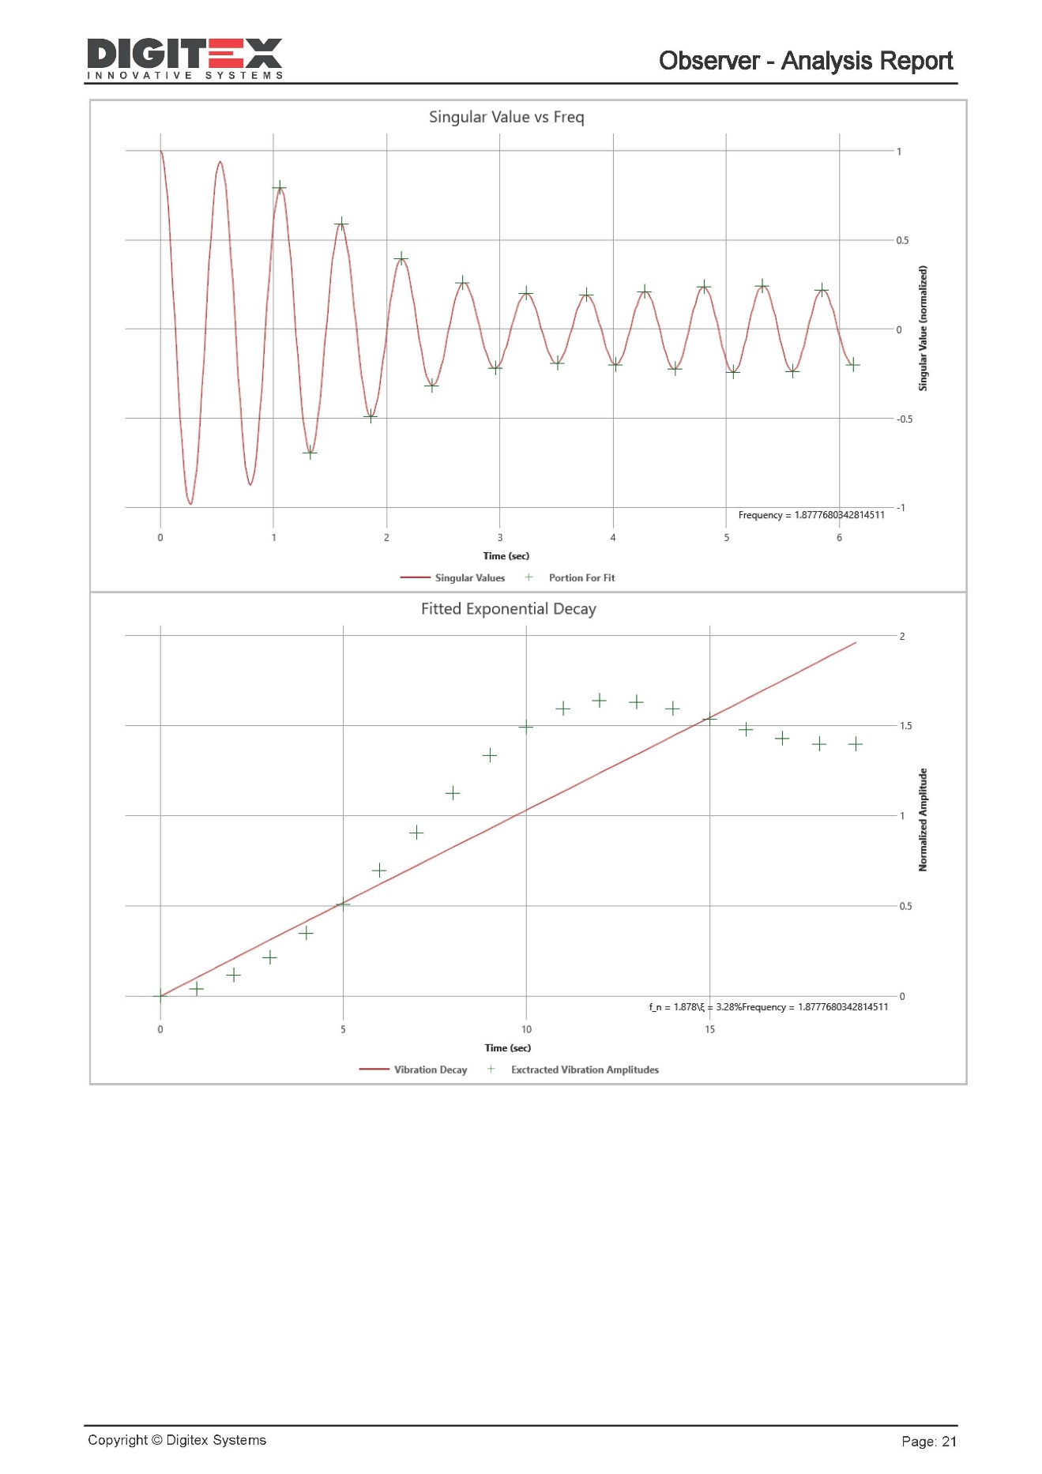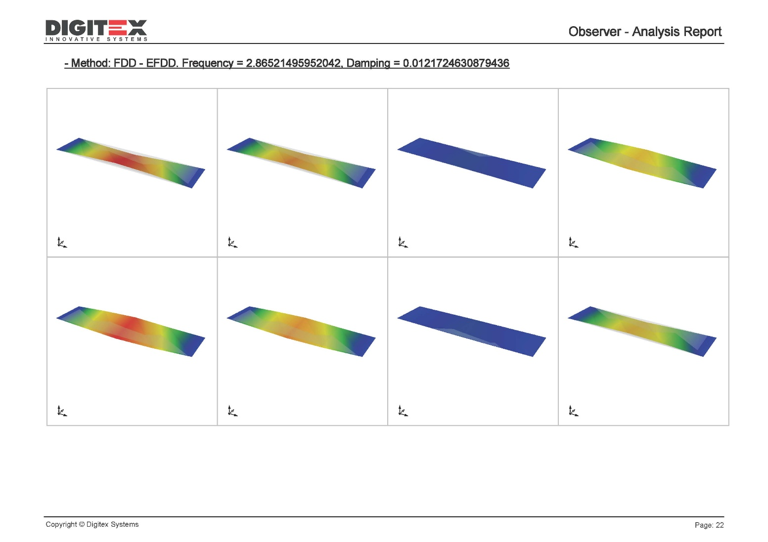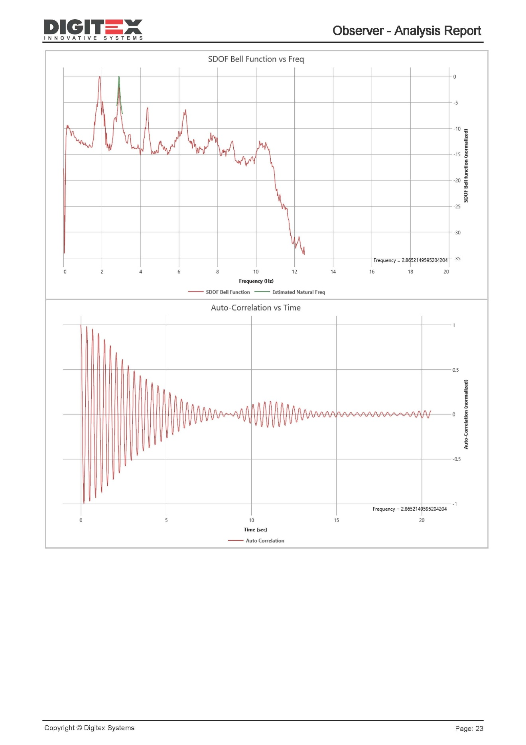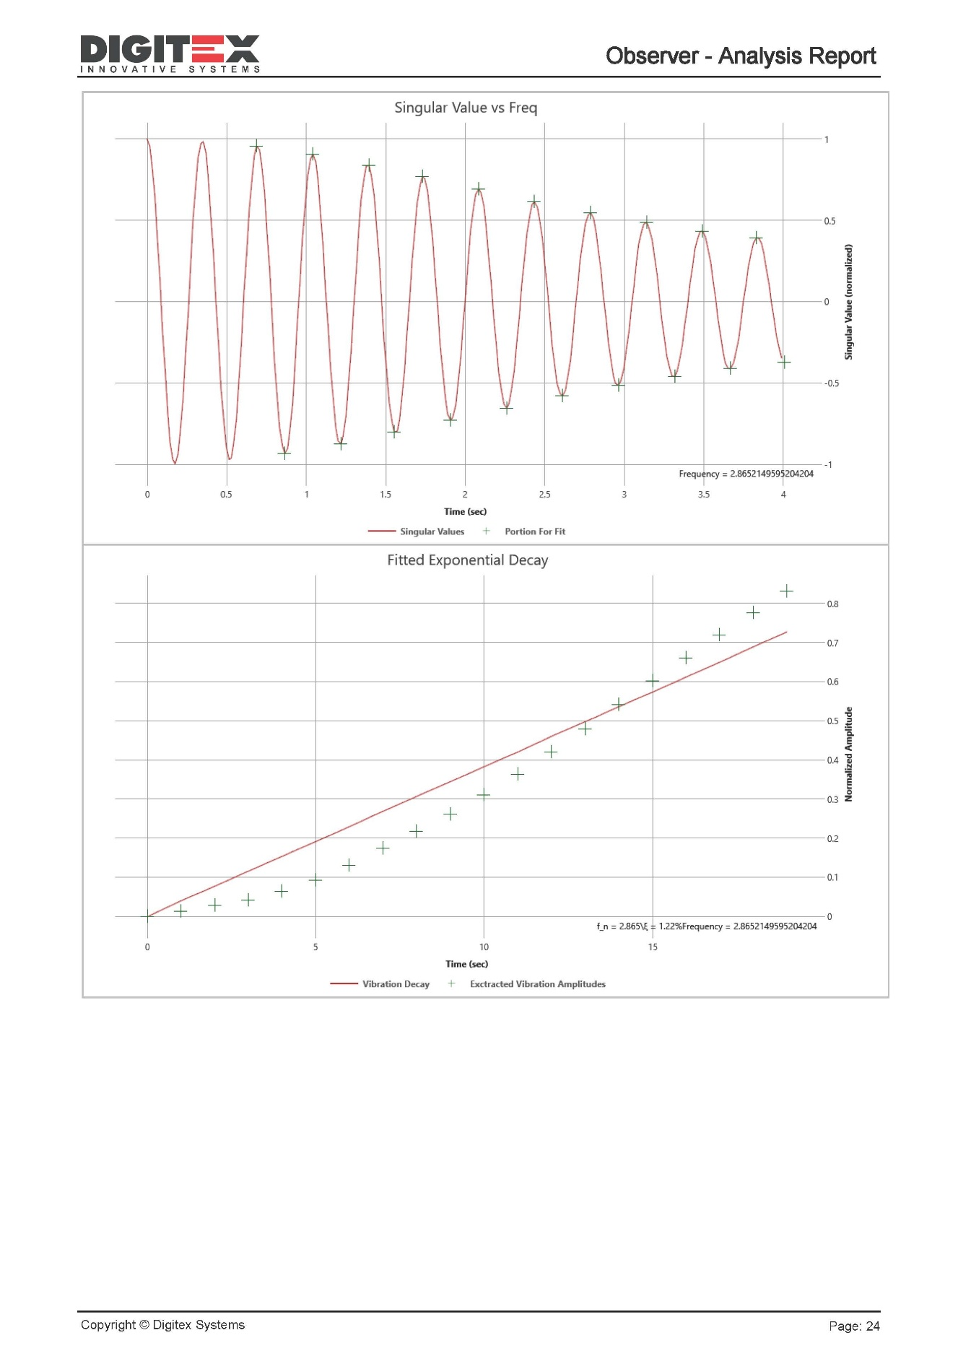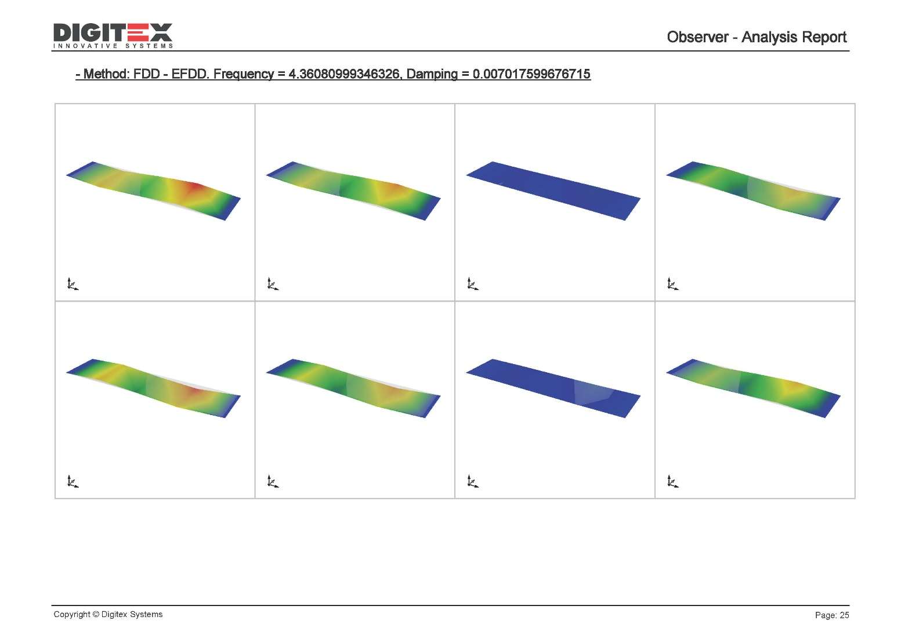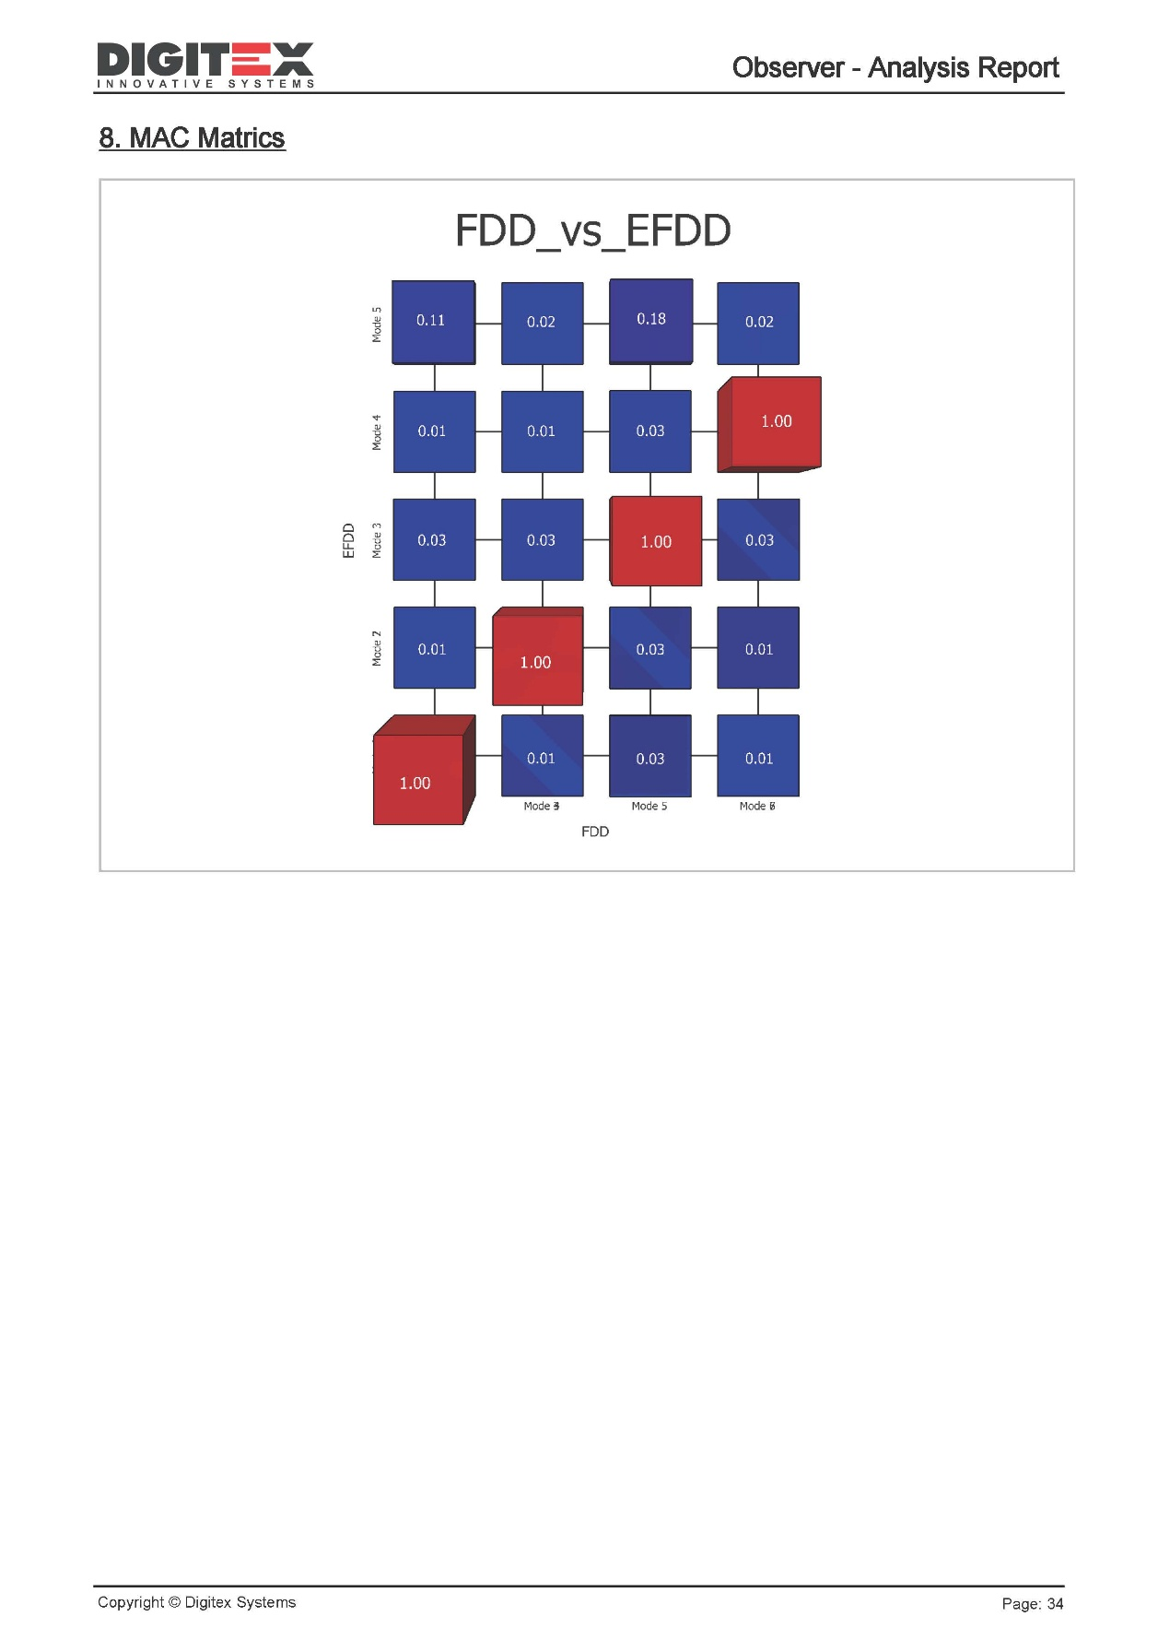

Algorithm References

The Observer Data Analysis Suite implements well-established algorithms from the field of Operational Modal Analysis (OMA) and Structural Health Monitoring (SHM). These methods are widely recognized in both research and industry for their accuracy, robustness, and applicability to civil, mechanical, and aerospace structures.

Frequency-Domain Methods
- Frequency Domain Decomposition (FDD): An intuitive and widely used method that applies Singular Value Decomposition (SVD) to the cross-spectral density matrix of measured signals to identify natural frequencies and mode shapes.
- Enhanced Frequency Domain Decomposition (EFDD): An extension of FDD that estimates damping ratios by transforming selected spectral peaks into the time domain.
- Frequency-Spatial Domain Decomposition (FSDD): Improves separation of closely spaced modes by combining spectral decomposition with spatial filtering.
- Polyreference Least Squares Complex Frequency (pLSCF): A frequency-domain method that fits frequency response functions simultaneously at multiple reference points, particularly effective for complex or densely modal structures.

Time-Domain Methods
- Stochastic Subspace Identification – Data (SSI-Data): Builds state-space models directly from measured time-series data. Robust for closely spaced modes and noisy environments.
- Stochastic Subspace Identification – Covariance (SSI-Cov): Similar to SSI-Data but based on estimated covariance functions, offering improved numerical stability and computational efficiency.

Supporting Algorithms
- Fast Fourier Transform (FFT): Converts signals from the time to frequency domain, forming the basis for spectral estimation.
- Power Spectral Density (PSD): Provides a statistical measure of vibration energy distribution across frequencies.
- Singular Value Decomposition (SVD): A mathematical decomposition technique used in frequency-domain methods for extracting modal information.

References
- Brincker, R., Zhang, L., & Andersen, P. (2000). Modal identification from ambient responses using frequency domain decomposition. Proceedings of the 18th International Modal Analysis Conference (IMAC).
- Peeters, B., & De Roeck, G. (2001). Stochastic system identification for operational modal analysis: A review. Journal of Dynamic Systems, Measurement, and Control, 123(4), 659–667.
- Brincker, R., & Ventura, C. (2015). Introduction to Operational Modal Analysis. Wiley.
- Ljung, L. (1999). System Identification: Theory for the User (2nd ed.). Prentice Hall.
- Ewins, D. J. (2000). Modal Testing: Theory, Practice and Application (2nd ed.). Research Studies Press.

